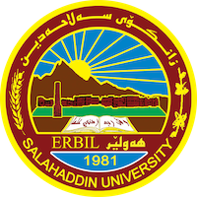
Academic Curriculum Vitae
Personal Information:
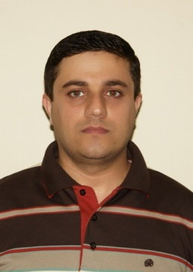
Full Name: Hemin Qassim Rahman
Academic Title: Assist. Lecturer
Email: hemin.rahman@su.edu.krd
Mobile:07504791291

Education:
2) M. Sc. in Mathematics. Mathematics Department - College of Science - Salahaddin University –Erbil in 2009.
3) B. Sc. in Mathematics, Mathematics Department - College of Education - Salahaddin University -Erbil in 2003.
Employment:
- Teaching assistant at the College of Science / Soran University, Erbil, on 2009-2014.
- I have been teaching in the Department of Mathematics, College of Basic Education, Salaheddin University, Erbil, since 2014 until now.

Teaching experience:
(B. Sc.) students
- Differential Equation
- Calculus
- Ordinary Differential Equation
- Numerical Analysis
- Finite Mathematical
- Computar
- Probability & Statistics
- Statistical inference
- Foundation of mathematics
- Application of Differential equation
- system of Differential Equation
- introduction to Algebra
- LANGUAGES
- Good on English, very good in Arabic, and Kurdish (Mother Language).
Professional Social Network Accounts:

- https://www.researchgate.net/profile/ Hemin-Qassim https://scholar.google.com/citations?user=MbXmAQ4AAAAJ
- Hemin Qassim Rahman (0009-0008-6388-1470) (orcid.org)

‬

