A) separable differential Equation
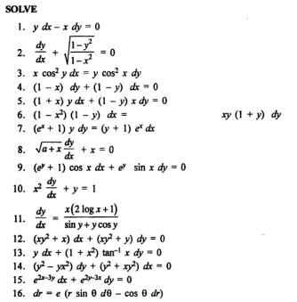
B) Homogeneous different ion Equations
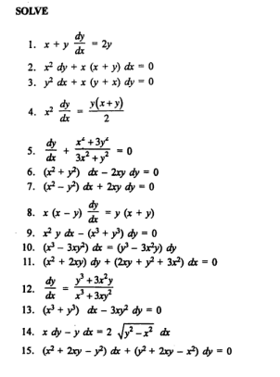
c)Non-homog. DE
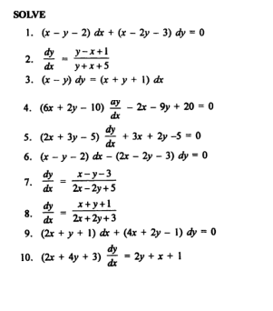
D ) First order linear DE
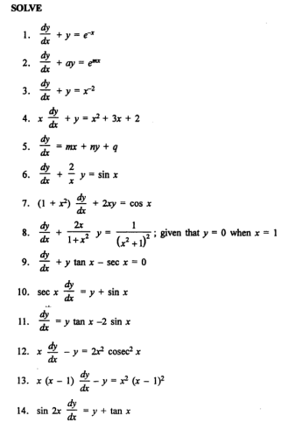
D) Bernoulli’s DE
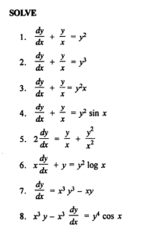
E) Exact DE
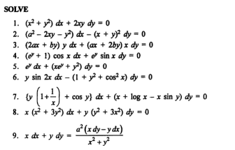
F) Non-exact DE
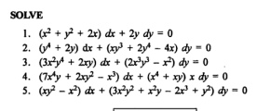

Q1/ Find general solution of the DE $yp^{2}-yp+xp-x=0$

Q2/Find the orthogonal trajectories of the family of curves $r=a(1-cosθ)$

Q3/ Solve the simultaneous differential equations
$\frac{dx}{dt}+3x=5y and \frac{dy}{dt}=3y$

Q4/ solve the Pfaffian Differential Equation$\left(yz+z^{2}\right)dx-xzdy+xydz=0$

Q5/ Solve the initial value problem $y^{''}=3x+\frac{2 }{x} ,where y'\left(1\right)=-2 and y\left(1\right)=1$

Q6/ Find a curve in the xy-plane that passes through ( 1 , -2 ) , and has the slope is $\frac{-y}{x}+3$
Q7/ solve the Pfaffian Differential Equation$xyze^{-3x} dx+zydy+xy\left(1-z^{2}\right)dz=0$
Q8/ A point moves on the x-axis,the function of velocity is ( $t^{2}-t+\frac{1}{t}$ ) m/s ,the find
1)The acceleration at t=2 . 2)The position function at 10m in the t=1 .

Q9/ Solve the initial value problem $y^{''}=3x+\frac{2 }{x} ,where y'\left(1\right)=-2 and y\left(1\right)=1$
Q10/ solve the Pfaffian Differential Equation$\left(yz+z^{2}\right)dx-xzdy+xydz=0$

