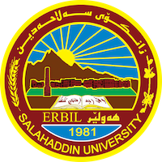
Academic Curriculum Vitae
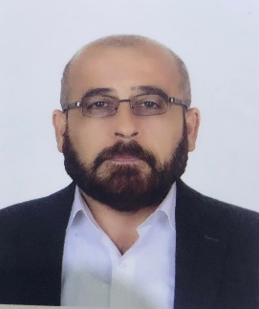
Personal Information:
Full Name: Hemn Khalid Ali
Academic Title: Assistant Lecturer

Email: hemn.ali@su.edu.krd
Mobile: 07504603120

Education:
Certificate | Place | Year | specialization
Bachelor | Salahaddin University | 2010 | Law
Master | Hartford International | 2014 | Private Law

Employment:
I graduated from the College of Law and Political sciences, Salahaddin University Erbil in 2010 as a first in my class in that year. I worked for a year in the same college, the College of Law, as Assistant Researcher. I obtained a Master of Laws, and LLM in Commercial Law from Hertfordshire University, UK, in 2014. Currently, I am a member of the academic staff at the Department of Law, College of Law, Salahaddin University-Erbil.

Qualifications
1. Teaching methods (2015)
2. IELTS (5) (2013)
Teaching experience:
Subject | Level
Public International Law | Third
Implementation law | Fourth
Administration Law | Second
Commercial paper | Fourth

Research and publications
- Compulsory License and Patent Protection
- Anticipatory of Self-Defense in International Law

Conferences and courses attended
- Give details of any conferences you have attended, and those at which you have presented delivered poster presentations.

Funding and academic awards
- List any bursaries, scholarships, travel grants or other sources of funding that you were awarded for research projects or to attend meetings or conferences.

Professional memberships
- List any membership you hold of any professional body or learned society relevant to your research or other life activities.

Professional Social Network Accounts:

https://scholar.google.com/citations?view_op=list_works&hl=en&user=giH7rSoAAAAJ

https://www.researchgate.net/profile/Hemn-Ali-3

