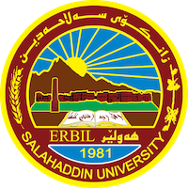

**Academic Curriculum Vitae**

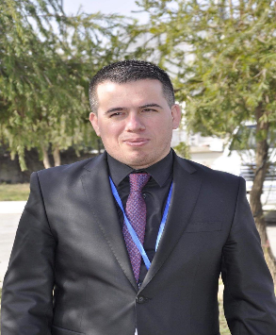

**Personal Information:**

Full Name: Dr. Herdn Ibrahim Ahmed

Academic Title: Lecturer

Email: herdn.ahmed@su.edu.krd

Mobile:+9647504521563

**Education:**

* Received a bachelor's degree from Salahaddin University-Erbil for the academic year 2008-2009
* Master's degree in Sociology from Bingöl University, Turkey (2017)
* Doctorate in Cultural Anthropology, Salahaddin University, Erbil (2022)

**Employment:**

* My first employment was on 16-1-2006 as an employee at the Presidency of Salahaddin University
* I am currently a lecturer in the Department of Psychology at the College of Arts/Salahaddin University

**Teaching experience:**

* (Listening) in the first and second stage of the Department of Turkish Language / College of Language / Salahaddin University
* (Sociology) in the first stage / Department of Psychology / College of Arts / Salahaddin University - Erbil
* (Philosophy) in the second stage / Department of Psychology / College of Arts / Salahaddin University - Erbil
* (Philosophy of Psychology) in the second stage / Department of Psychology / College of Arts / Salahaddin University - Erbil
* (Social Psychology) in the second stage / Department of Psychology / College of Arts / Salahaddin University - Erbil
* (Anthropology) in the second stage / Department of Psychology / College of Arts / Salahaddin University - Erbil
* (Civil Psychology) in the second stage / Department of Psychology / College of Arts / Salahaddin University - Erbil

**Research and publications**

* [Kurdish Human Personalities and Values in The Kurdistan Region of Iraq](https://scholar.google.com/citations?view_op=view_citation&hl=en&user=ZR2DcFQAAAAJ&authuser=2&citation_for_view=ZR2DcFQAAAAJ:9yKSN-GCB0IC)

IAH Rashad Miran, Katarína Slobodová Nováková

Research World International Conference, Oslo, Norway, 73-77

* [Culture and values in Kurdish society in the Kurdistan Region of Iraq](https://scholar.google.com/citations?view_op=view_citation&hl=en&user=ZR2DcFQAAAAJ&authuser=2&citation_for_view=ZR2DcFQAAAAJ:2osOgNQ5qMEC)

R Miran, DMKS Novakova, HI Ahmed

مجلة الفنون والأدب وعلوم الإنسانيات والاجتماع, 354-363

* [Coffee Houses Culture in Erbil: A Review](https://scholar.google.com/citations?view_op=view_citation&hl=en&user=ZR2DcFQAAAAJ&authuser=2&citation_for_view=ZR2DcFQAAAAJ:d1gkVwhDpl0C)

HI Ahmed

QALAAI ZANIST SCIENTIFIC JOURNAL 3 (4), 897-903

* [تأثير مقاهي اربيل على الرأي العام‎](https://scholar.google.com/citations?view_op=view_citation&hl=en&user=ZR2DcFQAAAAJ&authuser=2&citation_for_view=ZR2DcFQAAAAJ:u-x6o8ySG0sC)

هیردن ابراهیم احمد

مجلة الفنون والأدب وعلوم الإنسانيات والاجتماع 29 (2414-3383), 519-531

* قەبارەى خێزان لە کۆمەڵگاى کوردییدا و پەیوەندى بە کولتوور و پەروەردەوە(توێژینەوەیەکى سۆسیۆکولتوورییە لە شارى هەولێر)

هێردن ابراهیم احمد؛ هونەر کمال قادر

مجلة العراقیە، بالعدد (١٨) اذار ٢٠٢٣ ( 2663- 7502(

**Conferences and courses attended**

-Member of the Preparatory Committee of the International Conference of the College of Arts entitled ( The Question of Loyalty and the challenges of Nation Building Process In Kurdistan Region of Iraq).