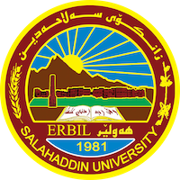
Academic Curriculum Vitae
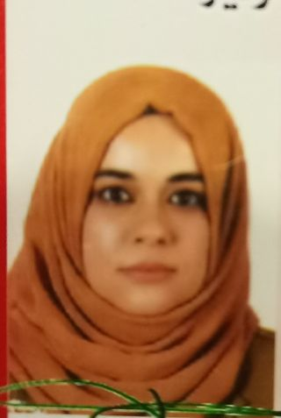
Personal Information:
Full Name: Hero Muhyaddin Muhammad
Academic Title: Assistant lecture
Email: (university email) hero.muhammad@su.edu.krd
Mobile:07507731662

Education:
B.Sc plant protection department college of agriculture engineering science
M.Sc Entomology in plant protection department college of agriculture engineering science

Employment:
Assist lecture in plant protection department Salahaddin University = Erbil, College of Agricultural Engineering Sciences

Qualifications
- Teaching qualifications, 3 years of teaching in Plant protection Department, related to insect subjects
- IT qualifications: Microsoft word, Word, Excel, Power point
- Language qualifications such as IELTS: 5
Kurdish: Mother language
Arabic: medium
English: Good

Teaching experience:
- Horticultor insect 4th stage plant protection
- Forest insect 2nd stage

Research and publica
- Molecular identification and morphological study of European Hover fly Erstalis pertenax(scopoli,1763) (Diptera: Syrphidae) from erbil governorate Kurdistan region- Iraq, 2022. Chinese journal of medical genetics, 32 (4) :710 – 716).
- Molecular identification and morphological study of Ground beetle,Cyminds andrea,menetries,1832 (coleoptera:carabidae) from erbil governorate Kurdistan region- Iraq. 2022. Annals Forest research, 65 (1): 4808-4818
- Molecular identification of some aphid species (Homoptera: Aphididae) based on RFLP_PCR technique. 2022. Mesopotamia Journal of Agriculture, 50(4): 107-116

Professional Social Network Accounts:

- https://www.researchgate.net/profile/Hero-M-Muhammad
- https://scholar.google.com/citations?hl=en&pli=1&user=Oa_9USwAAAAJ

