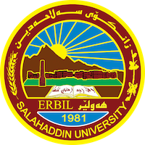
Academic Curriculum Vitae

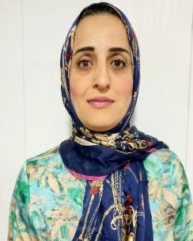
Personal Information:
Full Name:Hero abdlrahman mustafa
Academic Title:teacher,phd
Email:hero.mustafa@su.edu.krd
Mobile:07504928480

Education:
B.A: 2005 /Kurdish languages and literature / University of Salahaddin .
m.A: 2009 / Kurdish Literature /University of Salahaddin.
PHD: 2023/ Kurdish Literature /University of Salahaddin.
Employment:
2010-till now -Academic staff at soil and water department-college of Agriculture engineering Sciences.
Qualifications
- IT qualifications
- Word
- Excel
- Power point
- Zoom meeting

- Language qualifications such as TOEFL, IELTS or any equivalent
Language writing speaking comprehension
- Kurdish ecellent excellent ecellent
- Arabic Good Good Good
- English Good Good Good

- You could put any professional courses you have attended

I have participated in academic English course In Language and Translation Center-Salahaddin University Erbil
I did IELTS exam
Teaching experience:
- Kurdish studies
- Methods of teaching
Research and publications
- ASS.Hero Abdulrahman Mustafa and D. Safya Muhammed Ahmed ,the opposite analysis in Nali s poems, journal of koya university, humanitis,iss.2073-0713,38/2016.

- ASS.P. Safya Muhammed Ahmed and ASS.Hero Abdulrahman Mustafa ,the basics in the language of Dildars poetry , third Conferences of koya famous,2018,

- Hero Abdulrahman Mustafa and Idrees Abdulla Mustafa, Style and Stylistics, Journal of University of Raparin ,E-ISSN: 2522 – 7130 P-ISSN: 2410 – 1036, DOI:https://doi.org/10.26750/Vol(8).No(4).Paper9 http://journal.uor.edu.krd/index.php/JUR Vol.8. No.4,December.2021

- Hero Abdulrahman Mustafa and Idrees Abdulla Mustafa, The Basic Properties of Children's Poetry, Journal of University of Raparin, E-ISSN: 2522 – 7130 P-ISSN: 2410 – 1036, Original Article / Doi: 10.26750/Vol(9).No(4).Paper20.

- Hero Abdulrahman Mustafa and omer mohammed salih, (Theatre and Theatrical Poetry in Teaching). Shwan Ahmad's theatrical poems are taken as an example,

- Hero Abdulrahman Mustafa, Anti-values in (Children's Book) by Latif Halmat, , Journal of University of Raparin(Vol.12 – No.2),29/4/2025.

Conferences and courses attended
- Give details of any conferences you have attended, and those at which you have presented delivered poster presentations.

Funding and academic awards
- List any bursaries, scholarships, travel grants or other sources of funding that you were awarded for research projects or to attend meetings or conferences.

Professional memberships
- Fello of the Kurdistan teachers syndicate- erbil.
Professional Social Network Accounts:

- https://www.facebook.com/hero.koye?mibextid=ZbWKw

