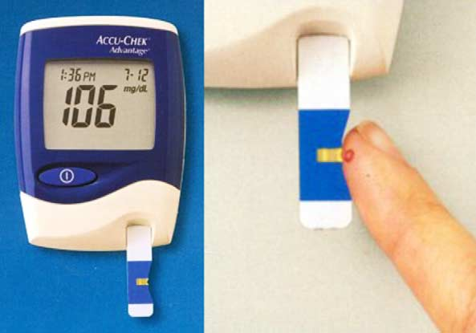  overview of a glcouse biosensor | Salahaddin university  College of science  Physics’ department  Supervised by : Dr.Hersh Ahmed  Prepared by : razaw amer , sara masoud

Table of Contents

Introduction 2

Historical Perspectives of Glucose Biosensors 3

Generations of Glucose Biosensor 5

The first-generation enzymatic glucose biosensors 5

The second-generation enzymatic glucose biosensors 6

The third -generation enzymatic glucose biosensors 6

The fourth- generation non enzymatic glucose biosensors 7

Basic principle of biosensor 8

Characteristics of a biosensor 9

Conclusion: 11

Reference 12 ,16

Introduction
Biosensors have made their way from the labs into the daily lives of millions of people all over the world during the past several decades. They were initially designed, like some other sensors, for the detection of certain low-molecular species, such as metabolites or disease biomarkers, which were crucial for clinical diagnostics, pharmacy, and the healthcare sector. The application of biochemical components (enzymes, antibodies, nucleic acids) that served a similar function to litmus paper in pH measurement or mercury in the clinical thermometer was one factor that contributed to the distinctiveness of biosensors [1]. A biological response is transformed into an electrical signal by biosensors, which are analytical tools. Ideally, biosensors should be reusable, highly selective, and unaffected by physical factors like pH and temperature (2). The term "biosensor" was first used by Cammann [3], and the IUPAC provided its definition [4].
The biosensor is made up of an analyte, which is a substance of interest that needs to be detected, a bio receptor, which is a molecule that specifically recognizes the analyte, a transducer, which transforms the bio-recognition event into a measurable signal (a process known as signalization), electronics, which processes the transducer signal and prepares it for display, and finally, a display. Depending on the needs of the end user, the output signal on the display may be numeric, graphic, picture, or tabular [5].
The medical industry has recently focused more on recognizing basic risks, preventing various diseases, creating new healthcare treatments, emphasizing the significance of people taking care of their health, and the kind of therapy. The quality of medical care has recently increased as a result of significant developments in science and technology, including wireless communication, biomedical sciences, information technology, and the introduction of numerous wearable biosensors. These biosensors are used to provide care for preterm infants, people who need to be constantly monitored, and people who reside in rural places with limited access to medical services. (6)

A metabolic disease called diabetes occurs when the pancreas either produces too little or no insulin. People with diabetes have a lack of glucose in their cells, and as a result, blood sugar levels rise. This is because cells require insulin to absorb blood sugar (glucose) for their energy requirements. The illness is a serious issue for global health. Around 170 million diabetics are thought to exist in the world [7].
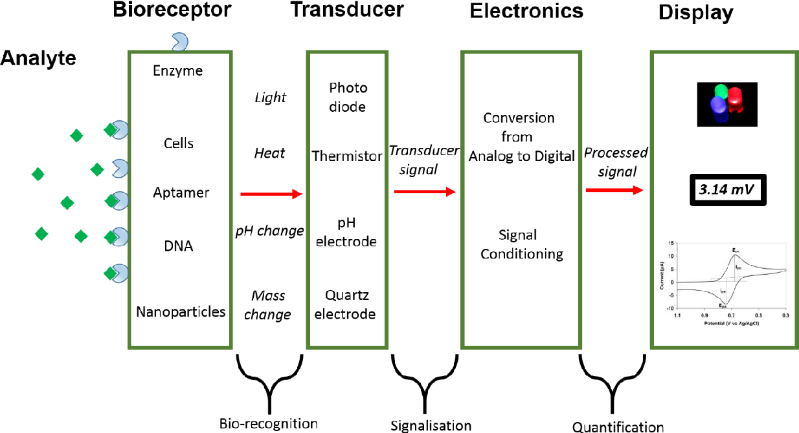
Diabetes patients are diagnosed and managed using a variety of laboratory tests. The primary diagnostic criterion for diabetes with an elevated HbA1c level is blood glucose concentration, which is also a helpful tool for patient monitoring [8]. Blood glucose self-monitoring (SMBG) has been proven to be an effective strategy for managing diabetes [9]. In order to slow or even stop the course of microvascular (retinopathy, nephropathy, and neuropathy) and microvascular consequences, the objective of SMBG is to assist the patient in achieving and maintaining normal blood glucose concentrations (stroke and coronary artery disease).

Fig. (1). General schematic diagram of a biosensor's working principle

Historical Perspectives of Glucose Biosensors

The idea of a glucose enzyme electrode was proposed in 1962 by Clark and Lyons from the Children Hospital in Cincinnati [10]. Their first device relied on a thin layer of GOx entrapped over an oxygen electrode (via a semipermeable dialysis membrane), and monitoring the oxygen consumed by the enzyme-catalyzed reaction:
Glucose+ oxygen→ gluconic acid + hydrogen peroxide
Clark’s original patent [11] covers the use of one or more enzymes for converting electro inactive substrates to electroactive products. The effect of interferences was corrected by using two electrodes (one covered with GOx) and measuring the differential current. Clark’s technology was subsequently transferred to Yellow Spring Instrument Company that launched in 1975 the first dedicated glucose analyzer (the Model 23 YSI analyzer) for the direct measurement of glucose in 25 mL samples of whole blood. Updike and Hicks [12] developed further this principle by using two oxygen working electrodes (one covered with the enzyme) and measuring the differential current for correcting for the oxygen background variation in samples. Guilbault and Lubrano [13] described in 1973 an enzyme electrode for the determination of blood glucose based on amperometric (anodic) monitoring of the liberated hydrogen peroxide:
H2O→O2+2$H^{+}$+${2e}^{-}$

For 100 mL blood samples, good precision and accuracy were attained. Since then, a large variety of amperometric enzyme electrodes have been described, each with a unique electrode design or material, membrane composition, or immobilization strategy.
Biosensors rose to prominence in the 1980s as interest in biotechnology increased. During this decade, significant efforts were made to build mediator-based "second-generation" glucose biosensors [14, 15], introduce commercial strips for blood glucose self-monitoring [16, 17], and use modified electrodes to improve sensor performance [18]. The development of minimally invasive subcutaneously implantable devices [20, 21] and the construction of electrical connectivity between the GOx redox center and the electrode surface were both highly active in the 1990s. In the table below summarizes major historical landmarks in the development of electrochemical glucose biosensors
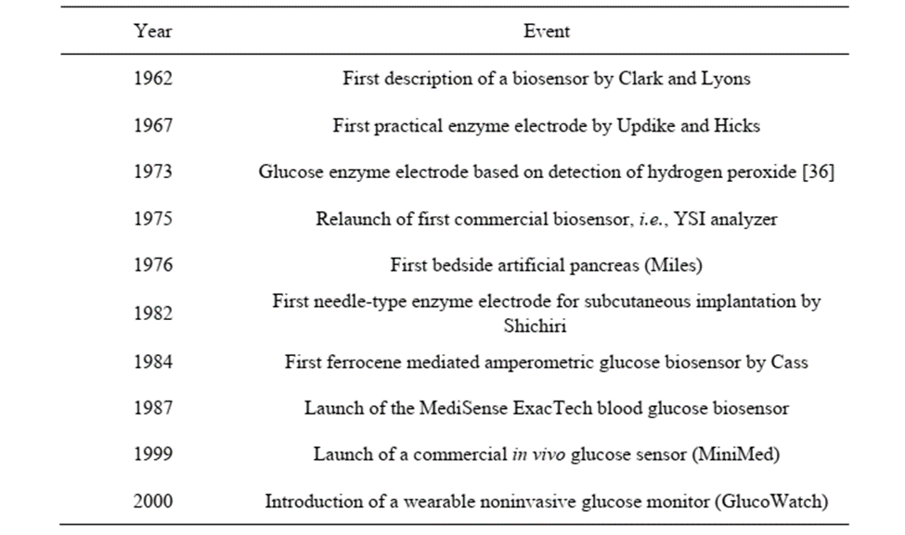
Table (1). History of glucose biosensors.

Generations of Glucose Biosensor
According to the electron transfer mechanism, there are generally four primary generations of glucose biosensors. The enzymatic glucose biosensor is represented by three generations, while the non-enzymatic glucose biosensor is represented by one generation.

The first-generation enzymatic glucose biosensors
The first-generation enzymatic glucose biosensors determine the amount of glucose in the analyte sample by generating H₂O₂ or by reducing the quantity of oxygen (O₂) as a natural co-substrate [22]. In order to catalyze the conversion of D-glucose (C₆H₁₀O₆) into gluconolactone (C₆H1₂O₆), which produces H₂O₂ and water as byproducts, the immobilized GOx utilizes molecular O₂ as an electron acceptor. Gluconic acid (C6H₁₂O₇) is produced as gluconolactone (C6H10O6) continues to hydrolyze. FAD, an active redox center of GOx, functions as a catalyst [23, 24], acting as the first electron acceptor and reducing to FADH2 in the presence of glucose. The oxidized version of the enzyme FAD is produced by reoxidizing FADH2 with free oxygen. The content of glucose is typically compared to the amount of electrochemical oxidation of the product H₂O₂ or O₂ is reduced electrochemically at the working electrode [25]. The quantity of glucose molecules present is exactly related to the amount of electron flow since the counter electrode can identify and gather the transferred electrons [22].

The second-generation enzymatic glucose biosensors
Using mediated glucose biosensors, or second-generation glucose sensors, the aforementioned shortcomings of the first-generation glucose biosensors were resolved. Redox mediators, which can transport electrons from the enzyme to the surface of the working electrode in place of oxygen, were used to replace oxygen in order to achieve the improvements [26]. Instead of hydrogen peroxide, a reduced mediator is created, which is subsequently reoxidized at the electrode to produce an amperometric signal and regenerate the oxidized form of the mediator [27]. Ferrocenes meet all requirements for an effective mediator, including not reacting with oxygen, remaining stable in both the oxidized and reduced states, being pH independent, exhibiting reversible electron transfer kinetics, and reacting quickly with the enzyme [28].
In 1970 [29], it was shown for the first time that blood glucose could be measured amperometrically utilizing a redox couple-mediated, GOx-catalyzed process. This study, however, did not result in the quick adoption of amperometry in SMBG in the domestic context [30]. In the 1980s, commercial screen-printed strips for SMBG were introduced, mediator-based second-generation glucose biosensors were produced, and customized membranes and modified electrodes were used to improve sensor performance [31, 32]. Exactas, the first pen-sized electrochemical blood glucose monitor for diabetes patients to self-monitor their blood sugar levels, was introduced in 1987 by Medisense Inc. It made use of a ferrocene derivative and GDH-PQQ [33]. The treatment of diabetic patients underwent a revolution as a result of its success. Many glucose biosensors for self-monitoring are based on the use of ferrocene or ferricyanide mediators.

The third -generation enzymatic glucose biosensors
The third-generation glucose biosensors do not use mediators, but rather an enzyme and an electrode directly transfer electrons. As a result of the lack of mediator use, they are the least hazardous. Here, electron transfer between enzymes (GOx-GDH-PQQ) and boron-doped diamond electrode is mediated by conducting organic salts, such as tetrathiafulvalene-tetracyanoquinodimethane. The needle-shaped third-generation glucose biosensors provide the highest selectivity and capacity for continuous in vivo blood glucose monitoring. Market sales of third generation glucose biosensors have been made by businesses like Roche Diagnostics, MediSense, and Bayer [34].

The fourth- generation non enzymatic glucose biosensors
The fourth generation of glucose biosensors, also referred to as non-enzymatic glucose biosensors, uses direct electron transfer by electro-oxidizing glucose to gluconic acid at the nanomaterial matrix with significant electrocatalytic activity [35]. Atoms from nanomaterials serve as an electrocatalyst in the glucose reaction in the non-enzymatic glucose biosensor [36]. Several studies have recently concentrated on the non-enzymatic glucose biosensor, which modifies the electrode using a variety of nanomaterials and nanocomposite materials. However, a number of difficulties, including as low selectivity and the requirement for an alkaline state during analysis, limit the adoption of fourth-generation glucose biosensors for commercial usage in monitoring patients with diabetes.
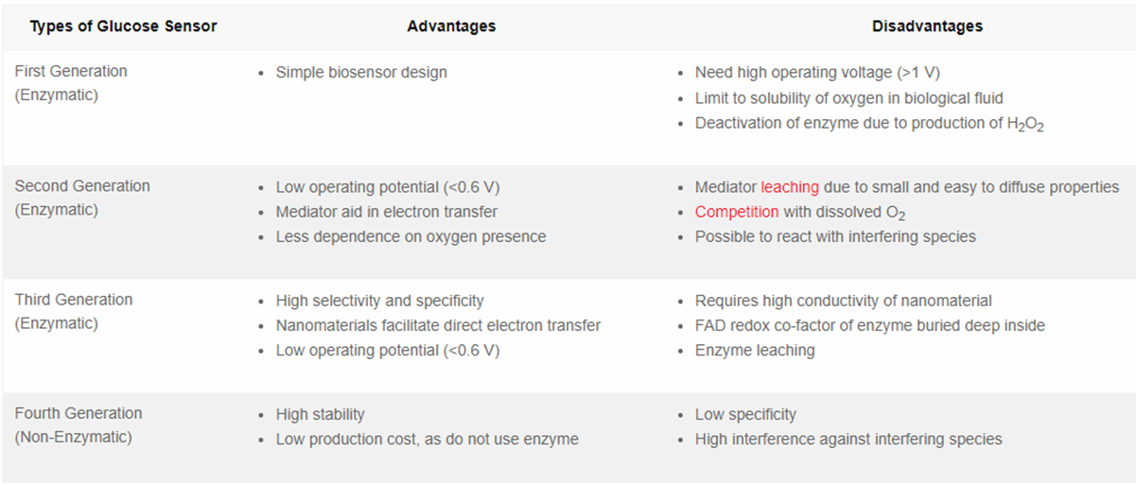
Table (2): The advantages and disadvantages of all generations of glucose biosensor.

Basic principle of biosensor
The definition of a biosensor is "compact analytical device or unit comprising a biological or biologically derived sensitive recognition element integrated or coupled with a physio-chemical transducer" [37]. A biosensor consists of these three components: The biological recognition components I that distinguish the target molecules from other substances ii) a transducer that transforms a biorecognition event into a quantifiable signal, and iii) a signal processing system that transforms the signal into a readable form [38–39]. Included among the molecular recognition components are receptors, enzymes, antibodies, nucleic acids, bacteria, and lectins [40,41]. Electrochemical, optical, thermometric, piezoelectric, and magnetic transducers are the five main kinds of transducers [42]. Due to their higher sensitivity, reproducibility, ease of maintenance, and low cost, electrochemical glucose biosensors make up the majority of the market today. Potentiometric, amperometric, and conductometric types of electrochemical sensors can be found [43–44].
The majority of commercially available devices are enzymatic amperometric glucose biosensors, which have been the subject of extensive research in recent years. When electrons are transferred directly or indirectly between a biological system and an electrode, amperometric sensors measure the currents that are produced [45, 46]. Hexokinase, glucose oxidase (GOx), and glucose-1-dehydrogenase (GDH) interactions are typically used as the basis for glucose assays [47, 48]. In many clinical laboratories, the hexokinase test is the go-to technique for spectrophotometric measurements of glucose [49]. GOx and GDH are the two enzyme families on which the majority of glucose biosensors for SMBG are based. Redox potentials, cofactors, turnover rates, and glucose selectivity are different between these enzymes [50]. The typical enzyme for biosensors is called GOx, and it has a comparatively better selectivity for glucose. Since GOx is accessible, affordable, and more resistant to temperature, ionic strength, and pH extremes than many other enzymes, it can be manufactured under less strict circumstances and stored under relatively lax standards for usage by non-experts who use biosensors [50, 51]. The principle of the glucose biosensor is that immobilized GOx catalyzes the oxidation of -D-glucose by molecular oxygen, resulting in the production of gluconic acid and hydrogen peroxide [52]. Flavin adenine dinucleotide is a redox cofactor that GOx needs in order to function as a catalyst (FAD). When reduced to FADH2, FAD serves as the first electron acceptor.
Glucose+ GOx-FA$D^{+}$→Glucolactone+ GOx-FADH2
The cofactor is regenerated by reacting with oxygen, leading to the formation of hydrogen peroxide
GOx-FADH2+O2→ GOx-FAD+H2O2
Hydrogen peroxide is oxidized at a catalytic, classically platinum (Pt) anode. The electrode easily recognizes the number of electron transfers, and this electron flow is proportional to the number of glucose molecules present in blood [53].
H2O2→2$H^{+}$+O2+2e
For the electrochemical sensing of glucose, there are three primary methods used: detecting oxygen consumption, quantifying the quantity of hydrogen peroxide created by the enzyme activity, or utilizing a diffusible or immobilized mediator to transmit the electrons from the GOx to the electrode. Recently, there has been an increase in the quantity and variety of GDH-based amperometric biosensors.
Both GDH-nicotinamide-adenine dinucleotide (NAD) and GDH-pyrroquinolinequinone (PQQ) are members of the GDH family [54, 55]. The enzymatic reaction of GDH is independent of the dissolved oxygen. The quinoprotein GDH recognition element uses PQQ as a cofactor
Glucose+PQQ (ox) →PQQ (red)
This mechanism requires neither oxygen nor NAD+. GDH-PQQ is a particularly efficient enzyme system, with a rapid electron transfer rate, but it is relatively expensive [56]. GDH with NAD as a cofactor produces NADH rather than H2O2. NAD is a major electron acceptor in the oxidation of glucose, during which the nicotinamide ring of NAD+ accepts a hydrogen ion and two electrons, equivalent to a hydride ion. The reduced form of this carrier generated in this reaction is
Called NADH, which can be electrochemically oxidized
Glucouse+NA$D^{+}$→ gluconolactone+NADH
NADH→ NA$D^{+}$+$H^{+}$+2e

Characteristics of a biosensor

1. Selectivity:
The most essential factor of a biosensor is likely selectivity. The capacity of a bio receptor to identify a particular analyte in a sample that contains various admixtures and pollutants is known as selectivity. The relationship between an antigen and an antibody provides the best illustration of selectivity. Traditionally, antibodies function as bio receptors and are immobilized on the transducer's surface. The antigen-containing solution is then exposed to the transducer, where antibodies only interact with the antigens. The solution is typically a buffer including salts. Selectivity is the primary factor to be taken into account when choosing bio receptors for a biosensor (57).

2. Reproducibility:
The biosensor's reproducibility refers to its capacity to produce the same results under identical testing conditions. The transducer and electronics in a biosensor are precise and accurate, which defines reproducibility. When a sample is tested more than once, accuracy refers to the sensor's capability to offer a mean value that is close to the true value while precision refers to the sensor's ability to produce identical findings every time. Reliable and robust inferences about a biosensor's reaction are made possible by reproducible signals (58).

3. Stability:
The biosensing system's stability refers to how susceptible it is to environmental disturbances inside and outside of it. A biosensor under measurement may experience a drift in its output signals as a result of these disruptions. This may result in a concentration measurement inaccuracy and compromise the biosensor's precision and accuracy. In applications where a biosensor needs lengthy incubation periods or ongoing monitoring, stability is the most important component. The reaction of electronics and transducers may be temperature-sensitive, which could affect a biosensor's stability. To achieve a steady response from the sensor, proper tuning of the electronics is necessary [59].
4. Sensitivity:
A biosensor's limit of detection (LOD) or sensitivity is determined by the smallest amount of analyte that it can detect. A biosensor is necessary to confirm the presence of traces of analytes in a sample in a number of medical and environmental monitoring applications where analyte concentrations as low as ng/ml or even fg/ml must be detected. For instance, prostate cancer is linked to blood levels of the prostate-specific antigen (PSA) of 4 ng/ml, and doctor’s advice performing biopsy testing for this condition. Hence, sensitivity is regarded as a key characteristic of a biosensor.

5. Linearity:
According to the equation y=mc, where c is the analyte concentration, y is the output signal, and m is the sensitivity of the biosensor, linearity is the property that demonstrates the accuracy of the observed response to a straight line for a set of measurements with various analyte concentrations. The range of analyte concentrations being tested as well as the biosensor's resolution can both affect the sensor's linearity. The smallest variation in an analyte's concentration necessary to affect the biosensor's response is known as the resolution of the biosensor. In most biosensor applications, in addition to analyte detection, concentrations of various substances must also be measured, hence a good resolution may be necessary depending on the application [60].

Conclusion:
For the past few years, biosensors have undergone significant miniaturization. Microbial cells with high enzyme behaviors may be required in order to keep up with such advancements. Microorganisms are inexpensive, have a long lifespan, and may be used for a variety of things.
The biosensing component of biosensors has frequently been used in conjunction with a proper PH and temperature. So, in order to reap significant benefits in the future, it is important to employ biosensors properly.

Reference

- Mehrotra, P., 2016. Biosensors and their applications–A review. Journal of oral biology and craniofacial research, 6(2), pp.153-159.
- Cammann, K., 1977. Bio-sensors based on ion-selective electrodes. Fresenius Zeitschrift für Analytische Chemie, 287(1), pp.1-9.
- Thevenot, D.R., Toth, K., Durst, R.A. and Wilson, G.S., 1999. Electrochemical biosensors: recommended definitions and classification. Pure and applied chemistry, 71(12), pp.2333-2348.
- Bhalla, N., Jolly, P., Formisano, N., & Estrela, P. (2016). Introduction to biosensors. Essays in biochemistry, 60(1), 1–8. https://doi.org/10.1042/EBC20150001
- Sharma, A. and Guleria, V., BIOSENSORS IN BIOINFORMATICS, BIOTECHNOLOGY, AND HEALTHCARE.
- World Health Organization, 2004. Diabetes action now: an initiative of the World Health Organization and the International Diabetes Federation.
- Forouhi, N.G. and Wareham, N.J., 2010. Epidemiology of diabetes. Medicine, 38(11), pp.602-606.
- Poolsup, N., Suksomboon, N. and Rattanasookchit, S., 2009. Meta-analysis of the benefits of self-monitoring of blood glucose on glycemic control in type 2 diabetes patients: an update. Diabetes technology & therapeutics, 11(12), pp.775-784.
- Matthews, D.R., Holman, R.R., Bown, E., Steemson, J., Watson, A., Hughes, S. and Scott, D., 1987. Pen-sized digital 30-second blood glucose meter. Lancet, 1(8536).
- Wang, J., 2001. Glucose biosensors: 40 years of advances and challenges. Electroanalysis: An International Journal Devoted to Fundamental and Practical Aspects of Electroanalysis, 13(12), pp.983-988.
- S. Updike, G. Hicks, Nature 1967, 214, 986
- Guilbault, G.G. and Lubrano, G.J., 1973. An enzyme electrode for the amperometric determination of glucose. Analytica chimica acta, 64(3), pp.439-455.
- Cass, A.E., Davis, G., Francis, G.D., Hill, H.A.O., Aston, W.J., Higgins, I.J., Plotkin, E.V., Scott, L.D. and Turner, A.P., 1984. Ferrocene-mediated enzyme electrode for amperometric determination of glucose. Analytical chemistry, 56(4), pp.667-671.
- Frew, J.E. and Hill, H.A.O., 1987. Electrochemical biosensors. Analytical chemistry, 59(15), pp.933A-944A.
- Hilditch, P.I. and Green, M.J., 1991. Disposable electrochemical biosensors. Analyst, 116(12), pp.1217-1220.
- Matthews, D.R., Holman, R.R., Bown, E., Steemson, J., Watson, A., Hughes, S. and Scott, D., 1987. Pen-sized digital 30-second blood glucose meter. Lancet, 1(8536).
- Murray, R.W., Ewing, A.G. and Durst, R.A., 1987. Chemically modified electrodes. Molecular design for electroanalysis. Analytical Chemistry, 59(5), pp.379A-390A.
- Wang, J., 2001. Glucose biosensors: 40 years of advances and challenges. Electroanalysis: An International Journal Devoted to Fundamental and Practical Aspects of Electroanalysis, 13(12), pp.983-988.

- Willner, I., Heleg-Shabtai, V., Blonder, R., Katz, E., Tao, G., Bückmann, A.F. and Heller, A., 1996. Electrical wiring of glucose oxidase by reconstitution of FAD-modified monolayers assembled onto Au-electrodes. Journal of the American Chemical Society, 118(42), pp.10321-10322.

- Bindra, D.S., Zhang, Y., Wilson, G.S., Sternberg, R., Thevenot, D.R., Moatti, D. and Reach, G., 1991. Design and in vitro studies of a needle-type glucose sensor for subcutaneous monitoring. Analytical chemistry, 63(17), pp.1692-1696.

- .Schmidtke, D.W., Freeland, A.C., Heller, A. and Bonnecaze, R.T., 1998. Measurement and modeling of the transient difference between blood and subcutaneous glucose concentrations in the rat after injection of insulin. Proceedings of the National Academy of Sciences, 95(1), pp.294-299.

- Yoo, E.H. and Lee, S.Y., 2010. Glucose biosensors: an overview of use in clinical practice. Sensors, 10(5), pp.4558-4576.

- Bruen, D., Delaney, C., Florea, L. and Diamond, D., 2017. Glucose sensing for diabetes monitoring: recent developments. Sensors, 17(8), p.1866.

- Taguchi, M., Ptitsyn, A., McLamore, E.S. and Claussen, J.C., 2014. Nanomaterial-mediated biosensors for monitoring glucose. Journal of Diabetes Science and Technology, 8(2), pp.403-411.

- Vaddiraju, S., Burgess, D.J., Tomazos, I., Jain, F.C. and Papadimitrakopoulos, F., 2010. Technologies for continuous glucose monitoring: current problems and future promises. Journal of diabetes science and technology, 4(6), pp.1540-1562.

- Liu, J. and Wang, J., 2001. A novel improved design for the first-generation glucose biosensor. Food technology and biotechnology, 39(1), pp.55-58.

- Turner, A.P., Chen, B. and Piletsky, S.A., 1999. In vitro diagnostics in diabetes: meeting the challenge. Clinical chemistry, 45(9), pp.1596-1601.

- Chaubey, A. and Malhotra, B., 2002. Mediated biosensors. Biosensors and bioelectronics, 17(6-7), pp.441-456.

- Williams, D.L., Doig, A.R. and Korosi, A., 1970. Electrochemical-enzymatic analysis of blood glucose and lactate. Analytical Chemistry, 42(1), pp.118-121.

- Hu, J., 2009. The evolution of commercialized glucose sensors in China. Biosensors and Bioelectronics, 24(5), pp.1083-1089.

- Cass, A.E., Davis, G., Francis, G.D., Hill, H.A.O., Aston, W.J., Higgins, I.J., Plotkin, E.V., Scott, L.D. and Turner, A.P., 1984. Ferrocene-mediated enzyme electrode for amperometric determination of glucose. Analytical chemistry, 56(4), pp.667-671.

- Yoo, E.H. and Lee, S.Y., 2010. Glucose biosensors: an overview of use in clinical practice. Sensors, 10(5), pp.4558-4576.

- Matthews, D.R., Holman, R.R., Bown, E., Steemson, J., Watson, A., Hughes, S. and Scott, D., 1987. Pen-sized digital 30-second blood glucose meter. Lancet, 1(8536).

- Gray, C.J., Narang, J.S., Barker, S.A. and Hartmeier, W., 2016. Enzyme Immobilization Advances in Industry. Agriculture, Medicine, and the Environment.

- Si, P., Huang, Y., Wang, T. and Ma, J., 2013. Nanomaterials for electrochemical non-enzymatic glucose biosensors. RSC advances, 3(11), pp.3487-3502.

- Tian, K., Prestgard, M. and Tiwari, A., 2014. A review of recent advances in nonenzymatic glucose sensors. Materials Science and Engineering: C, 41, pp.100-118.

- Yoo, E.H. and Lee, S.Y., 2010. Glucose biosensors: an overview of use in clinical practice. Sensors, 10(5), pp.4558-4576.

- Zayats, M., Katz, E., Baron, R. and Willner, I., 2005. Reconstitution of apo-glucose dehydrogenase on pyrroloquinoline quinone-functionalized Au nanoparticles yields an electrically contacted biocatalyst. Journal of the American Chemical Society, 127(35), pp.12400-12406.

- Hiratsuka, A., Fujisawa, K. and Muguruma, H., 2008. Amperometric biosensor based on glucose dehydrogenase and plasma-polymerized thin films. Analytical Sciences, 24(4), pp.483-486.

- Chambers, J.P., Arulanandam, B.P., Matta, L.L., Weis, A. and Valdes, J.J., 2008. Biosensor recognition elements. Current issues in molecular biology, 10(1-2), pp.1-12.

- Iqbal, S.S., Mayo, M.W., Bruno, J.G., Bronk, B.V., Batt, C.A. and Chambers, J.P., 2000. A review of molecular recognition technologies for detection of biological threat agents. Biosensors and Bioelectronics, 15(11-12), pp.549-578.

- Barredo, J.L. and Barredo, J.L. eds., 2005. Microbial enzymes and biotransformations (pp. 1-319). New York: Humana Press.

- Habermüller, K., Mosbach, M. and Schuhmann, W., 2000. Electron-transfer mechanisms in amperometric biosensors. Fresenius' journal of analytical chemistry, 366, pp.560-568.

- Thevenot, D.R., Toth, K., Durst, R.A. and Wilson, G.S., 1999. Electrochemical biosensors: recommended definitions and classification. Pure and applied chemistry, 71(12), pp.2333-2348.

- Turner, A.P., Chen, B. and Piletsky, S.A., 1999. In vitro diagnostics in diabetes: meeting the challenge. Clinical chemistry, 45(9), pp.1596-1601.

- Heller, A., 1996. Amperometric biosensors. Current opinion in biotechnology, 7(1), pp.50-54.

- Price, C.P., 2003. Point-of-care testing in diabetes mellitus.

- D'costa, E.J., Higgins, I.J. and Turner, A.P.F., 1986. Quinoprotein glucose dehydrogenase and its application in an amperometric glucose sensor. Biosensors, 2(2), pp.71-87

- Slein, M.W., 1965. D-Glucose: Determination with hexokinase and glucose-6-phosphate dehydrogenase. In Methods of enzymatic analysis (pp. 117-130). Academic Press.

- Heller, A. and Feldman, B., 2008. Electrochemical glucose sensors and their applications in diabetes management. Chemical reviews, 108(7), pp.2482-2505.

- Bankar, S.B., Bule, M.V., Singhal, R.S. and Ananthanarayan, L., 2009. Glucose oxidase—an overview. Biotechnology advances, 27(4), pp.489-501.

- Weibel, M.K. and Bright, H.J., 1971. The glucose oxidase mechanism: interpretation of the pH dependence. Journal of Biological Chemistry, 246(9), pp.2734-2744.

- Guilbault, G.G. and Lubrano, G.J., 1973. An enzyme electrode for the amperometric determination of glucose. Analytica chimica acta, 64(3), pp.439-455.

- Jin, W., Wollenberger, U. and Scheller, F.W., 1998. PQQ as redox shuttle for quinoprotein glucose dehydrogenase. Biological Chemistry, 379(8-9), pp.1207-1211.

- Raitman, O.A., Patolsky, F., Katz, E. and Willner, I., 2002. Electrical contacting of glucose dehydrogenase by the reconstitution of a pyrroloquinoline quinone-functionalized polyaniline film associated with an Au-electrode: an in situ electrochemical SPR study. Chemical communications, (17), pp.1936-1937.

- Newman, J.D. and Turner, A.P., 2005. Home blood glucose biosensors: a commercial perspective. Biosensors and bioelectronics, 20(12), pp.2435-2453.

- Jha, A., 2021. Biosensors for Environmental Monitoring. In Basic Concepts in Environmental Biotechnology (pp. 103-118). CRC Press

- Usman, F., Ghazali, K.H., Muda, R., Dennis, J.O., Ibnaouf, K.H., Aldaghri, O.A., Alsadig, A., Johari, N.H. and Jose, R., 2023. Detection of Kidney Complications Relevant Concentrations of Ammonia Gas Using Plasmonic Biosensors: A Review. Chemosensors, 11(2), p.119.

- Rakesh, P., Pramod, P. and Sujit, P., 2019. Biosensors: Current tool for medication and diagnosis. Asian Journal of Pharmaceutical Research, 9(1), pp.27-34.

- Metkar, S.K. and Girigoswami, K., 2019. Diagnostic biosensors in medicine–a review. Biocatalysis and agricultural biotechnology, 17, pp.271-283.

