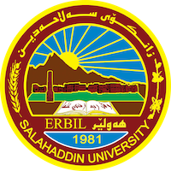
Academic Curriculum Vitae

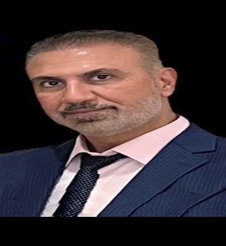
Personal Information:
Full Name:Hewa Jalal Salih

Academic Title: Lecturer
Email: (Hewa.salih@su.edu.krd)
Mobile:07518079086

Education:
- Salahaddin university/ physical education department/ Master,s degree in physical education / 2010
- Salahaddin university/ physical education department / Bachelor,s degree in physical education department / 2005-2006.
- Teacher institute/diploma degree/ physical education /1994
- Assistant Lecturer / physical education – salahaddin/ 22-11-2011
- Obtaining the scientific title Lecturer / Faculty of Education-Shaqlawa / 2022

Employment:
- Director of the sports activity in shaqlawa education 1998-2001
- Head of the sport unit- college of basic education,salhadin university (2006-2018)
- Assistant volleyball coach for the college of physical education (2008-2009)
- Member of the examination committee for undergraduate students in the basic college 2015-2011
- Member of the student disciplinary committee (2018-2019)
- Representative of the teaching staff in the college of basic education (2018-2019)
- Department decision 2019-2023

Qualifications
- Teaching Methods Course / Continuing Education Center / Salahaddin University 2013

Teaching experience:
- Kinesthetic Education / Bachelor’s Degree / Collage of Basic Education / kindergarten / Salahaddin University Erbil 2011-2019 /
- Scientific discussion / Bachelor’s Degree / Collage of Basic Education / Kindergarten/ Salahaddin University Erbil 2011-2017
- Scientific discussion / Bachelor’s degree / Collage of physical education / Salahaddin university / Shaqlawa Erbil 2019-2020
- Volleyball subject / bachelors Second stage / Collage of physical education / shaqlawa / salahaddin Erbil 2019-2023
- Volleyball subject / bachelors third stage / Collage of physical education / shaqlawa / salahaddin Erbil 2019-2023
- Volleyball subject / bachelors fourth stage / Collage of physical education / shaqlawa / salahaddin Erbil 2019-2023
- Swimming / bachelors first stage / Collage of physical education / shaqlawa / salahaddin Erbil 2019-2023
- Swimming / bachelors third stage / Collage of physical education / shaqlawa / salahaddin Erbil 2019-2023
- Table tennis / bachelors fourth stage / Collage of physical education / shaqlawa / salahaddin Erbil 2019-2023

Research and publications
- A comparative study in the critical regime and motivation of academic achievement in technical gymnastics among female students of the faculty of physical education and sports sciences
- The impact of using the (Think-Pair-Share) strategy in acquiring some basic skills and developing the direction towards volleyball lesson
- A comparative research of VAK model in the prevalent learning style of student’s department physical education in the collage of education / shaqlawa
Conferences and courses attende.
- Give details of any conferences you have attended, and those at which you have presented delivered poster presentations.

Funding and academic awards
- By prime minister no.(4)
- By Minister of education no. (4)
- By the president of university no. (10)
- By Dean no. (20)

Professional memberships
- List any membership you hold of any professional body or learned society relevant to your research or other life activities.

Professional Social Network Accounts:

- List your profile links of ReserchGate, LinkedIn, etc.

It is also recommended to create an academic cover letter for your CV, for further information about the cover letter, please visit below link:
https://career-advice.jobs.ac.uk/cv-and-cover-letter-advice/academic-cover-letter/

