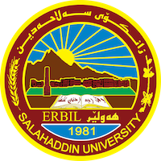
Academic Curriculum Vitae
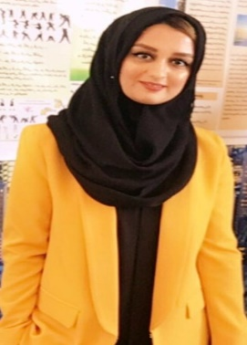

Personal Information:
Full Name: Hezha Hamid Mustafa
Academic Title: Assistant Lecturer
Email: (hezha.mustafa@su.edu.krd)
Mobile: 07509618696

Education:
- I have received MA degree in Linguistics (Semantics) in 2019.
- I have graduated with a very good (81.531) degree being among the top 5% of the graduates with a Bachelor’s degree in English Department / Salahaddin University/ (2008-2012).
- I have finished High School from Zozan School.

Employment:
- I have worked in the Ministry of Higher Education for three years in different departments inside the ministry. I have worked in (HCDP (Twanasazy) Department). I was contacting the abroad universities and the students who were studying in those universities about their tuition fees. Additionally, I have worked in the Equalization Certificates Department. In this department I worked with the committee who was equalizing the certificates and I was responsible about arranging every single candidate’s documents and certificates and also I had to introduce each candidate’s certificate and document to the committee members. I was also responsible about writing and computerizing the documents.
- The second and current employment position is at college of physical education and sport sciences. I teach general English and (ESP) for first year students.

Qualifications
- I have finished the course of pedagogy which lasted for seven months.
- Excellent in using Software programs like; Quick Basic, Word, Excel, PowerPoint…etc.
- Excellent in using internet and has been using internet on daily basis for the past 10 years.
- I have taken (PTE) test at (UKH) and I have got 67.
- I have received a certificate from U.S. Embassy about the English Instruction Capacity Building Course held from August 2009 to January 2010.
- I have got a certificate about the English Academic Writing Course at the Salahaddin University-Erbil / Language Center at 21st February to 13th April 2011.

Teaching experience:
- I have taught the first year students Academic Debate skills for two years.
- I have taught the same stage General English for two years.
Research and publications
- I have two research papers published in Zanko Journal. The first research is entitled
“The Semantic Field of Sport Collocations in English “. And the second research is entitled
“The Connotative Meaning of Emotional Words in Kate Chopin’s The Awakening”

Conferences and courses attended
- I have participated in the fourth conference of the best poster for Salahaddin University Students on 16/5/2022.
- I have participated in the conference of TISHK University on 2021.
Funding and academic awards
- Non.

Professional memberships
- Non.

Professional Social Network Accounts:
- Google Scholar (https://myaccount.google.com/?hl=ar).
- Research Gate (https://www.researchgate.net/profile/Hezha-Mustafa).
- Facebook (https://www.facebook.com/hezha.hamid).
- Google Account (https://myaccount.google.com/profile?pli=1).
- Linkedin (https://www.linkedin.com/feed/).

It is also recommended to create an academic cover letter for your CV, for further information about the cover letter, please visit below link:
https://career-advice.jobs.ac.uk/cv-and-cover-letter-advice/academic-cover-letter/

