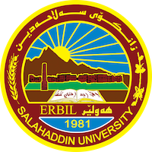
Academic Curriculum Vitae

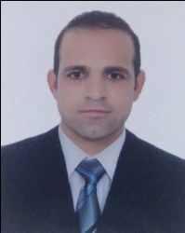
Full Name: Himdad Sardar Kareem
Academic Title: Assistant Lecturer
Mobile: +964 (0)750 491 4106

Education:
- Master Degree in Law (Specialization of Criminal Justice) Score (High Very Good), Salahaddin University, Hawler, Iraq, 2014 –2016.
- Bachelor Degree in Law, Score (High Very Good), Salahaddin University, Hawler, Iraq, 2007 – 2011. I was in 2nd of topic in my class by score obtained %87.62

Employment:
- Salahaddin University - College of Law and Political Science, Assistant researcher, Quality Assurance, Nov, 2011 – Nov, 2014.
- Salahaddin University - College of Law and Political Science, Jurist, Department of Law- 2017 – 8/2019.
- Salahaddin University – College of Law, Assistant Lecturer, 9/2019 till now.
- Bayan University – College of Law and International Relations 2019 _2020.

Qualifications
- Master qualifications in Law Department, Salahaddin University.
- Bachelor qualifications in Law Department, Salahaddin University.
- qualifications IELTS (5/5/2018), Language Center qualifications at Salahaddin university (17/3/2019)

Teaching experience:
- Diploma of Teaching (Teaching Methods and Research Methodology) at the Salhaddin University for the period Six Month (from 29/01/2017 to 15/09/2017), total Score (% 89) Rank(23) out of(141), Date of qualification Issue: 1/11/2017.

Research and publications
- State all researches, publication you made.

Conferences and courses attended
- Give details of any conferences you have attended, and those at which you have presented delivered poster presentations.

Funding and academic awards
- List any bursaries, scholarships, travel grants or other sources of funding that you were awarded for research projects or to attend meetings or conferences.

Professional memberships
- List any membership you hold of any professional body or learned society relevant to your research or other life activities.

Professional Social Network Accounts:

- List your profile links of ReserchGate, LinkedIn, etc.

It is also recommended to create an academic cover letter for your CV, for further information about the cover letter, please visit below link:
https://career-advice.jobs.ac.uk/cv-and-cover-letter-advice/academic-cover-letter/

