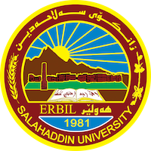
Academic Curriculum Vitae

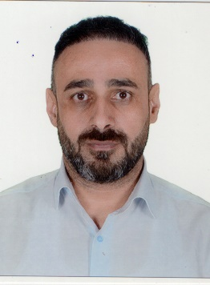
Personal Information:
Full Name: Hewa Mahmood Hasan
Academic Title: Lecturer
Email: (hiwa.hasan@su.edu.krd)
Mobile: +9647504018954

Education:
- MBA Accounting ( Cost & Managerial Accounting )

Employment:
- Lecturer at Salahaddin University from Jun 23, 2012

Qualifications
- Teaching qualifications
- IT qualifications
- Language qualifications (Salahaddin University – Center of Language – Intermediate)

Teaching experience:
- Financial Mathematics
- Accounting Principles
- Computer (Microsoft Windows & Word).
- Accounting Application using MS Excel.
- Cost Accounting
- Intermediate Accounting
- Bachelor Students Research Supervising

Research and publications
- State all researches, publication you made.

Conferences and courses attended
- Local Students Grants Conferences (Best Students Research and Ideas).

Professional memberships
- Syndicate of Auditing & Accountants
- Kurdistan United Teachers

Professional Social Network Accounts:
- Facebook: (https://www.facebook.com/Hiwa.Mahmoud.Hasan)
- Linkedin: (https://www.linkedin.com/in/hiwa-mahmoud-82971798/)
- Researchgate: https://www.researchgate.net/profile/Hiwa-Hasan
- Google Scholar: https://scholar.google.com/citations?hl=en&user=nEJVtIwAAAAJ
- Google+: (https://currents.google.com/u/0/100159371697751789167)

It is also recommended to create an academic cover letter for your CV, for further information about the cover letter, please visit below link:
https://career-advice.jobs.ac.uk/cv-and-cover-letter-advice/academic-cover-letter/

