

Kurdistan Regional Government-Iraq

Ministry of Higher Education & Scientific Research

Salahaddin University-Erbil (SUE)

College of Science

Department of Chemistry

**Spectrophotometric Determination of Cotinine** in Plasma, Saliva, and Urine **by High Performance Liquid Chromatography**

Research Project

submitted to the department of (chemistry) in partial fulfillment of the requirement for the degree of BSc. In (Chemistry)

**Prepared by**

Rezhna Rzgar Mohammad Sofi

**Supervisor**

Mrs. Huda Ali Ibrahim

2022 – 2023

ABES65

أَلَمْ تَرَوْا أَنَّ اللَّهَ سَخَّرَ لَكُمْ مَا فِي السَّمَاوَاتِ وَمَا فِي الْأَرْضِ وَأَسْبَغَ عَلَيْكُمْ نِعَمَهُ ظَاهِرَةً وَبَاطِنَةً وَمِنَ النَّاسِ مَنْ يُجَادِلُ فِي اللَّهِ بِغَيْرِ عِلْمٍ وَلَا هُدًى وَلَا كِتَابٍ مُنِيرٍ

# صدق الله العظيم

# سورة لقمان

الآية (19- 20 )

**Dedication**

I would like to dedicate this research to my parents, who gives me the life and the hope...

To my lecturers who illuminated the road by their science to me,

I dedicate this research to my supervisor who becomes very tired with me till completed this project, very special thanks and Appreciation for...

Mrs. Huda Ali Ibrahim

**AKNOWLEDGEMENT**

I give me great honor to offer thanks to all those who helped me in my project. I would like to extend my sincere thanks and gratitude Mrs. Huda for acting as a supervisor during entire project.

List of Contents

|  |  |  |
| --- | --- | --- |
| NO. | Title | Page |
| 1. | Introduction | 1 |
| 1.1 | Cotinine | 4 |
| 1.2 | **Pharmacokinetics and Pharmacodynamics** | 5 |
| 1.3 | **Cotinine Factsheet** | 6 |
| 1.4 | **How People are Exposed to Cotinine.** | 6 |
| 1.5 | **How Environmental Tobacco Smoke Affects People’s Health.** | 6 |
| 1.6 | **Cotinine pharmacokinetic** | 6 |
| 1.7 | **Cotinine Pharmacodynamic Effects** | 7 |
| 1.8 | **Nicotine, and cotinine concentrations in serum and milk of nursing smokers.** | 7 |
| 2.1 | **High - Performance Liquid Chromatography** | 8 |
| 2.2 | Types of HPLC | 8 |
| 2.3 | Instrumentation | 9 |
| 3.1 | **Experimental** | 11 |
| 3.1.1 | **Reagents and standards** | 11 |
| 3.1.2 | **Results**  **Assay validation** | 11 |
| 3.1.4 | **Materials and Methods** | 12 |
| 3.1.5 | sample *analysis for HPLC* | 12 |
| 3.1.6 | *Saliva-urine collection and Analysis* | 12 |
| 3.2 | **Conclusion** | 14 |
|  | **References** | 15 |

List of Figures

|  |  |  |
| --- | --- | --- |
| NO. | Content | page |
| 1. | Metabolism of Nicotine. |  |
| 2. | Metabolites of cotinine. |  |
| 3. | Schematic diagram of HPLC instrumentation. |  |

Abstract

Smoking tobacco can have major negative effects and contains a number of dangerous ingredients Cotinine levels in biological fluids are a reliable indicator of the presence of nicotine. In this paper, a simple and sensitive high performance liquid chromatography (HPLC) procedure for the determination of cotinine in urine following liquid–liquid extraction with dichloromethane in an alkaline medium is described. Calibration curves show linearity over the 50 to 3000 ng/mL range with low intra- and interlay variability as well as good selectivity and specificity.

1. Introduction

Smoking tobacco can have major negative effects and contains a number of dangerous ingredients (Taujenis et. al, 2015).

An alkaloid made up of pyridine and pyrrolidine ring, nicotine impacts a wide range of biological processes, including gene expression, hormone secretion control, and enzyme activity (Justyna et. al, 2017).

In addition to being extremely addictive, nicotine has negative effects on a variety of systems, including the heart, reproductive system, lungs, and kidneys (Peace et. al, 2016). Nicotine is a toxin that affects organs quickly, particularly the peripheral and central neurological systems.

With the fatal dose of 30-40 mg/m3 for 30 min, assuming a breathing rate of 50 L per minute and 100% absorption, tremors, prostration, cyanosis, dyspnea, convulsion, progression to collapse and coma, and even death may result from respiratory muscle paralysis and/or central respiratory failure in severe poisoning. (Hajek, et. al, 2019)

Several analytical methods, such as gas chromatography with flame ionization detectors (GC- FID) and gas chromatography-mass spectrometry (GC-MS), have been used to determine the concentration of nicotine. Due to the fact that LC is a workhorse technique employed for time- consuming yet effective analytical operations (Zinjad, et. al, 2020).

Liquid chromatography-mass spectrometry (LC-MS), as well as HPLC with photodiode array detection (HPLC-PDA), have both been used successfully to quantify nicotine in e- liquids. The goal of this study was to develop and validate an easy and straightforward HPLC method for the quick determination of nicotine content in 11 of the most popular e-liquid

brands available in the Jordanian market and to compare the levels of actual tobacco with the labeled packaging to investigate both safety and quality because the goal of our research group is to seek pharmaceutical products safety (Ala, et. al, 2019).

The primary water-soluble alkaloid found in tobacco (Nicotiana tabacum) is nicotine, which serves as a stimulant for smoking dependency. Rats can produce twelve different types of nicotine metabolites (Placeholder2) (Kyerematen GA, 1988). The main metabolite of nicotine among them is cotinine, whose half-life (T1/2) is substantially longer (10–20 h) than that of nicotine (24–84 min).

In order to confirm passive smoking, the qualitative of cotinine in saliva and urine is being done as markers for smoking during abstinence therapy. In Japan, domestic mishaps involving the ingestion of cigarettes or their butts occur often. The amount of nicotine in one cigarette ranges from 7 to 24 mg. (Fukumoto M, 1997)

This is sufficient to kill a newborn, however, fatalities from such accidental intake are uncommon due to its vomiting-stimulating effect or slow absorption. However, many patients are being transported to critical care hospitals after ingesting nicotine sulfate solution (an insecticide) or cigarette extract solution made by boiling cigarettes; in such circumstances, they may be lethal without appropriate and prompt treatment. Methods by GC (Hengen N, 1978), GC/MS, and HPLC were reported for the detection of nicotine and cotinine in blood and/or urine. This chapter describes how to analyze nicotine and cotinine in blood using GC/MS and how to analyze nicotine in tobacco extract solutions using HPLC (UV detection). (Feyerabend C, 1979)

About 4000 different substances, including nicotine, carbon monoxide, polycyclic aromatic hydrocarbons, benzo(a)pyrene, and heavy metals, are in the mixture of gases, uncondensed vapors, tar, and particulate phase (A. Masaadeh, 2003).

Natural alkaloid nicotine is found in Nicotine tobacco leaves as a tertiary amine made up of pyridine and pyrrolidine rings. Cotinine is the main metabolite of nicotine (A.S. Xu, 1996). The enzymes cytochrome P4502A6 (CYP2A6) and cytosolic aldehyde oxidase are in charge of converting nicotine to cotinine in the human liver. Cotinine has a half-life of around 20 hours, whereas nicotine has a half-life of about 2 hours (johan,1983). Figure 1 depicts nicotine metabolism. The genuine smoking status is determined by cotinine and nicotine levels in body fluids, which rely on parameters such as sex, age, food, and variances in racial and ethnic groups, among many others. Smoking increases the risk of periodontal disease, which results in tooth and bone loss (C. Graham, 2000). Lung cancer, lungs damage, and heart disorders are all made more likely by smoking cigarettes.

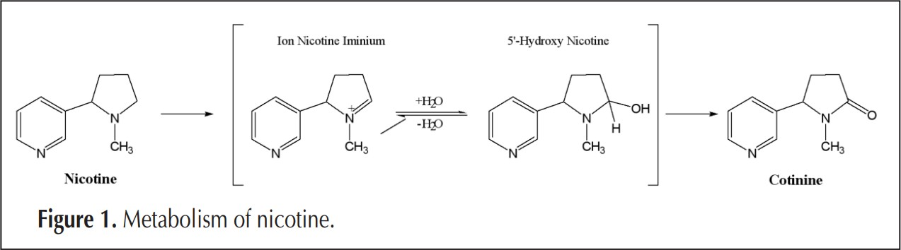

In addition, smoking cigarettes can lead to a variety of other illnesses, including malignant tumors of the bladder, pancreas, renal pelvis, and respiratory and digestive systems. (Feyerabend C, 1979)

Analyses of nicotine and cotinine in bodily fluids like blood, urine, and other biological indicators have grown to be a crucial part of determining whether someone has been exposed to tobacco smoke directly or indirectly. Different instrumental methods can be used to find nicotine and cotinine in biological samples. For instance, a variety of laboratory techniques, such as high-performance liquid chromatography (HPLC) with a UV detector or mass spectrometry detector (MS), have been developed to assess nicotine and its metabolites (Enrico. Davoli et. al, 1998). Additionally, other researchers have used gas chromatography (GC)-MS and/or HPLC to measure the levels of nicotine and/or cotinine in smokers' and nonsmokers' blood ([David L. Heavner, Et. al](https://pubmed.ncbi.nlm.nih.gov/?term=Heavner+DL&cauthor_id=15651085), 2005). over high range, recovery, and no interference peaks. (N. Lena, 1997)

The various varieties of smokeless tobacco products consumed by adults are addressed by state-wide tobacco control and prevention initiatives.

Oral mucosal diseases and use of smokeless tobacco are related (Hallikeri K, 2018). Young individuals with lower education levels and poverty levels were more likely to smoke cigarettes. Smokeless tobacco use is linked to the emergence of oral potentially cancerous conditions, and pancreatic, esophageal, and oral malignancies have all been reported (Sanjay G.,2018).

Adults older than 18 are more likely than younger adults to use smokeless tobacco, which includes chewing, snus, snuff, and dissolvable tobacco. Smokeless tobacco extract (STE) usage is rising quickly, and it has been linked to a number of illnesses in humans, such as diabetes, inflammation, and various cancers (Li L, 2018).

One of the most important public health issues in the world is addiction to cigarette smoking. The majority of studies (Knight JM, 1996) examining the health effects of environmental tobacco smoke (ETS) on children have used reported ETS exposure or the presence of smokers in the child's household to define exposure. Nicotine in cigarettes ranges from 7 to 24 mg, which is a fatal amount for young infants (Moore J, 1990)

The biggest drawback of the GC approach is how challenging it is to measure and indirectly identify the polar metabolites of tobacco. When employing GC-MS, sample preparation might be time-consuming. The fact that some polar components break down at the high temperatures used in the analysis is another issue. To get over the drawbacks of the aforementioned techniques, HPLC systems commonly connect to ultraviolet (UV), mass spectrometric, or electrochemical detectors for quantifying the main nicotine metabolites. Due to its simplicity and reduced price, utilizing a UV detector in HPLC is seen to be more practical than using mass or electrochemical defectors (Ghosheh et al, 2000).

The current study's goal was to use HPLC to measure the cotinine amounts in urine. Using a tiny volume of urine (2 mL), we offer a quick, easy, accurate, and selective HPLC approach to quantify the urinary cotinine concentration of kids who grew up in homes with at least one smoker. Our liquid-liquid extraction method was quick, easy, and didn't involve any sample preparation. (Sushobhan et. al., 2015)

* 1. **Cotinine**

is an alkaloid found in tobacco and is also the predominant metabolite of nicotine. An anagram of the word "nicotine", it is used as a biomarker for exposure to tobacco smoke. Cotinine is currently being studied as a treatment for depression, PTSD, schizophrenia, Alzheimer's disease and Parkinson's disease. Cotinine was developed as an antidepressantas a fumaric acid salt, cotinine fumarate, to be sold under the brand name ***Scotine*** but it was never marketed. Like nicotine, cotinine is able to induce dopamine release in smokers,

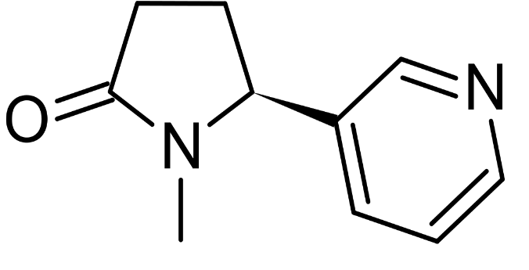

Name: Cotinine

Synonyms:1- methyl-5- pyridyl-2-pyrrolidinone

Molecular Formula: C10H12N2O

cotinine reduces heart rate, reduces aldosterone levels, reduces blood pressure, and reduces heart rate. Although some studies report behavioral alterations in animals, these were performed using supraphysiological doses of cotinine and one report suggests contaminants playing a role in behavioral changes. The presence of cotinine is sometimes used as an indicator for smoking: Active smokers typically have levels of cotinine that are higher (10-500ng/ml) than those of nonsmokers (1- 10 ng/ml). ( JP Gray,2014)

* 1. **Pharmacokinetics and Pharmacodynamics**

Cotinine is derived from the metabolism of nicotine. About 70 to 80 percent of the nicotine consumed by a person is converted to cotinine (Hukkanen, 2005). The first step is the conversion of nicotine to nicotine- iminium ion, which is mediated by CYP2A6 isoenzyme. The second step is the conversion of nicotine-iminium ion to cotinine, catalyzed by aldehyde oxidase enzyme in the cytoplasm.

Cotinine undergoes further metabolism (Figure 2). Only 10 to 15 percent of the cotinine is excreted as unchanged cotinine in the urine. The remaining part of cotinine is metabolized into *trans*-3′-hydroxycotinine, 5′-hydroxycotinine, cotinine N-oxide, cotinine methonium ion, cotinine glucuronide, and norcotinine. Some of these compounds are further metabolized. Conversion to *trans*-3′-hydroxycotinine is the major pathway of cotinine metabo­lism and is carried out by CYP2A6 isoenzyme. (Hukkanen et. Al ,2005)

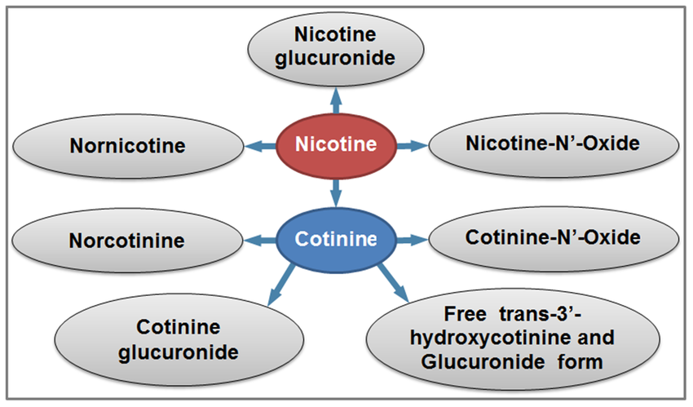

**Figure 2: -** Metabolites of cotinine

# **Cotinine Factsheet**

Cotinine is a product formed after the chemical nicotine enters the body. Nicotine is a chemical found in tobacco products, including cigarettes and chewing tobacco. Measuring cotinine in people’s blood is the most reliable way to determine exposure to nicotine for both smokers and nonsmokers exposed to environmental tobacco smoke (ETS). Measuring cotinine is preferred to measuring nicotine because cotinine remains in the body longer.

* 1. **How People are Exposed to Cotinine**

Nicotine enters people’s bodies when they smoke or chew tobacco. When exposed to ETS from nearby smokers, smaller amounts of nicotine enter the body of the nonsmoker. Workers who harvest tobacco and produce tobacco products can also be exposed through their skin.

* 1. **How Environmental Tobacco Smoke Affects People’s Health**

ETS increases the risk for lung cancer and heart disease in adults who do not smoke. Exposure to ETS also increases the risk for sudden infant death syndrome, asthma, bronchitis, and pneumonia in young children.

* 1. **Cotinine pharmacokinetic**

Cotinine is an alkaloid found in tobacco leaves and the main metabolite of nicotine. The active form of cotinine, the isomer S cotinine accumulates in the body after tobacco consumption. The pharmacokinetic profiles of cotinine administered orally or intravenously have been investigated in humans. These reports show that cotinine is well-absorbed orally (De Schepper et. al., [1987](https://www.ncbi.nlm.nih.gov/pmc/articles/PMC3467453/#B38)). uses cotinine is primarily used in research. Cotinine is a biomarker for the consumption of tobacco and other nicotine-containing products. ( DeSchepper,P.J et. al,1987).

* 1. **Cotinine Pharmacodynamic Effects**

Early studies of cotinine effects in humans showed that cotinine has a good safety profile (Borzelleca,J.F et. al,1962) One of these seminal studies demonstrated that daily doses of cotinine of up to 1,800mg for a period of 4 days did not induce deleterious side-effects in humans (Bowman, 1962). Another clinical study investigating the psychogenic effects of cotinine showed that when administered intravenously to absti- nent smokers, this compound reduced the self-reported irritability and tobacco cravings experienced by the participants (Benowitz et al., 1983). A follow-up phase II clinical study investigated the effects of cotinine on smoking cessation in an inpatient, 10-day study in abstinent cigarette smokers (Hatsukami et al., 1997). This study showed that oral cotinine treatment of up to 160 mg/day had no addictive, cardiovascular (e.g., heart rate and blood pres- sure), or behavioral effects in individuals between 21 and 42 years of age (Hatsukami et al., 1997). A follow-up study from the same research group also found that cotinine at the doses studied did not help with tobacco cessation and antagonized the reduction of the withdrawal symptoms induced by a nicotine patch.

* 1. **Nicotine, and cotinine concentrations in serum and milk of nursing smokers**

Nicotine, and cotinine concentrations in serum and milk of nursing smokers. The range of nicotine and cotinine concentrations as well as the milk/serum concentration ratios found in the 44 milk/serum sample pairs. indicate that the milk/serum concentration ratios of nicotine varied much more than those of cotinine. The nicotine concentrations in milk were higher than those in serum, while the cotinine concentrations in milk were lower than those in serum. All milk/serum concentration ratios of nicotine exceeded, while for cotinine most milk/serum concentration ratios were below 1. Further, there was no correlation between the Nicotine and cotinine in serum and milk. (LUCK. W, 1984).

**2.1- High - Performance Liquid Chromatography**

High Performance Liquid Chromatography (HPLC) was developed in the late 1960s and early 1970s. It was widely applied for separations and purifications in a variety of areas including pharmaceuticals, biotechnology, environmental, polymer and food industries (T. Kupiec, 2004). It was a type of liquid chromatography used to separate and quantify compounds that have been dissolved in solution, used to determine the amount of a specific compound in a solution, where the sample solution was in contact with a second solid or liquid phase, the different solutes in the sample solution will interact with the stationary phase. The differences in interaction with the column can help separate different sample components from each other (H. Sundaram et. al,2009). it was just one type of liquid chromatography, meaning the mobile phase was a liquid. The reversed phase HPLC was the most common type of HPLC, where the mobile phase was relatively polar and the stationary phase was relatively non-polar. Thus, non-polar compounds were more retained (*i.e.,* have longer retention times) than a polar compound. In general, HPLC was used for the separation of organic, inorganic, biological compounds and polymers compounds by qualitative and quantitative methods (R. Malviya,et. al,2010).

**2.2- Types of HPLC:**

There are following variants of HPLC, depending upon the phase system (stationary) in the process:

1. **Normal Phase HPLC**

This method separates analytes on the basis of polarity. NP-HPLC uses polar stationary phase and non-polar mobile phase. Therefore, the stationary phase was usually silica and typical mobile phases are hexane, methylene chloride, chloroform, diethyl ether, and mixtures of these.

1. **Reverse Phase HPLC**

The stationary phase was nonpolar (hydrophobic) in nature, while the mobile phase was polar liquid, such as mixtures of water and methanol or acetonitrile. It works on the principle of hydrophobic interactions hence the more nonpolar the material is, the longer it will be retained.

1. **Size-exclusion HPLC**

The column was filled with material having precisely controlled pore sizes, and the particles are separated according to its their molecular size. Larger molecules are rapidly washed through the column; smaller molecules penetrate inside the porous of the packing particles and elute later.

1. . **Ion-Exchange HPLC**

The stationary phase has an ionically charged surface of opposite charge to the sample ions. This technique was used almost exclusively with ionic or ignitable samples. The stronger the charge on the sample, the stronger it will be attracted to the ionic surface and thus, the longer it will take to elute. The mobile phase was an aqueous buffer, where both pH and ionic strength are used to control elution time.

2.3-  **Instrumentation: -**

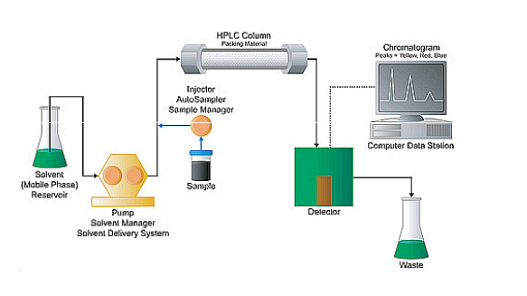

**Figure 3: *-*** Schematic diagram of HPLC instrumentation

As shown in the schematic diagram in Figure above, HPLC instrumentation includes a pump, injector, column, detector and integrator or acquisition and display system. The heart of the system was the column where separation occurs.

1. **Solvent Reservoir**

Mobile phase contents are contained in a glass reservoir. The mobile phase, or solvent, in HPLC was usually a mixture of polar and nonpolar liquid components whose respective concentrations are varied depending on the composition of the sample.

1. **Pump**

A pump aspirates the mobile phase from the solvent reservoir and forces it through the system’s column and detector. Depending on a number of factors including column dimensions, particle size of the stationary phase, the flow rate and composition of the mobile phase, operating pressures of up to 42000 kPa (about 6000 psi) can be generated.

1. **Sample Injector**

The injector can be a single injection or an automated injection system. An injector for an HPLC system should provide injection of the liquid sample within the range of 0.1-100 mL of volume with high reproducibility and under high-pressure (up to 4000 psi).

1. **Columns**

Columns are usually made of polished stainless steel, are between 50 and 300 mm long and have an internal diameter of between 2 and 5 mm. They are commonly filled with a stationary phase with a particle size of 3–10 μm. Columns with internal diameters of less than 2 mm are often referred to as microbore columns. Ideally the temperature of the mobile phase and the column should be kept constant during an analysis.

1. **Detector**

The HPLC detector, located at the end of the column detects the analytes as they elute from the chromatographic column. Commonly used detectors are UV-spectroscopy, fluorescence, mass-spectrometric and electrochemical detectors.

1. **Data Collection Devices**

Signals from the detector may be collected on chart recorders or electronic integrators that vary in complexity and in their ability to process, store and reprocess chromatographic data.

During the past three decades, there has been an increasing focus on cigarette smoking and the adverse health consequences associated with it. Nicotine is the primary causative agent in addiction to tobacco products. One cigarette contains an average of 8.4 mg of nicotine. In humans, nicotine is rapidly and extensively metabolized. It is mainly inactivated to cotinine, simple and sensitive high performance liquid chromatography (HPLC) procedure for the determination of cotinine in urine.

**3.1- Experimental**

**3.1.1- Reagents and standards**

The mother solution of cotinine was prepared by dissolving 64 mg in 100 mL methanol. Further dilutions with methanol were done. All stock solutions were protected from light and kept at –20°C. They were stable for at least six months. Urine calibration samples were prepared using an appropriate dilution of cotinine stock solutions with drug-free urine. The internal standard was tadalafil (stock solution of 56 mg in 100 cc of a 50:50 mixture of acetonitrile and water). The buffer for extraction was prepared by mixing 63 mL of solution A [boric acid (6.18 g)–potassium chloride (7.46 g) in 100 mL distilled water] with 37 mL of solution B (10.6 g).

**3.1.2- Results**

**Assay validation**

For assay validation, cotinine stock solutions were diluted with drug-free human urine to achieve concentration ranges of 50 to 3000 ng/mL, and each mixture was divided into several portions. The double extraction procedure was used for validation. Intraday variability was conducted using three sample series, and intraday variability was accomplished using four sample series on four separate days. The data indicate the accuracy, precision, and linearity of the assay. The calibration curves were linear over the concentration range studied (higher than 3000 ng/mL concentrations were not tested for linearity). Retention time was around 7 min for cotinine and 30 min for tadalafil. Figure 1 shows typical chromatograms for a urine control (A), a 550 ng/mL patient urine sample (B), and a urine standard at a concentration of 1000 ng/mL (C).

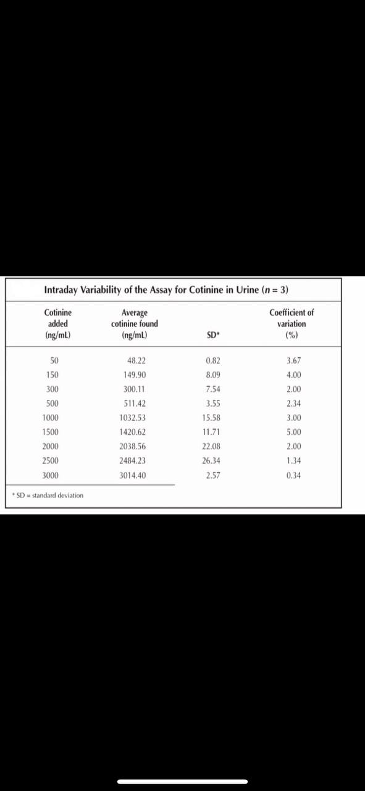

Table 1:- variability of the Assay for Cotinine in Urine (n=3).

**3.1.4- Materials and Methods**

Sixty human male volunteers were selected and each group consisted of thirty volunteers, aged between 18-30 years residing in Ananthapuramu town, Andhra Pradesh taking local diet. The baseline information for the category of SLT users was that individuals used SLT products (Blue bull, and raja brands of tobacco) habitually, at least > 4 times per day consists of 30 g during the last 3 years. Socio-demographic information was collected by an interviewer with the information on age, educational qualification, marital status, income, and occupational status. The inclusion criteria are the habitual use of only SLT packets by the users, and choose the unmarried and low economic status people. In the present study all volunteers were free from any chronic disease, with no smoking habit or alcohol drinking.

**3.1.5- Sample analysis for HPLC**

Plasma sample analysis was processed by the modified method (Massadeh et al., 2009). An aliquot of 0.1 mL plasma was placed into a glass test tube was alkalinized with 20 μl of 5.0M NaOH, and vortex mixed at 2800 rpm for 30s. An equal amount of dichloromethane-diethyl ether (1:1 v/v) was used for one-step single extraction, and then vortex mixed at 2800 rpm for 2 min. The organic layer, after being centrifuged at 3500 rpm for 3 min, was transferred to a new glass tube containing 4 μL of 0.25M HCl. The organic layer, centrifuged at 3,500 rpm for 3 min, was transferred to a new glass tube containing 4 μL of 0.25M HCl. The organic phase was then evaporated under a stream of nitrogen at 35ºC until dryness and reconstituted in 50 μL of mobile phase. An aliquot of 20μL was injected into HPLC for analysis.

**3.1.6- Saliva-urine collection and Analysis**

Five milliliters of unstimulated whole salivary samples were obtained by expectoration, in the absence of chewing movements, in dry plastic vials with the test subject sitting in a relaxed position. The collected saliva samples were centrifuged at 3,000 rpm for 10 min. The supernatants were stored at -70°C until further analysis. Two milliliters of urine samples in the morning were collected in a sterile flask covered with aluminum foil to keep out stray light and processed within 2 h of the collection. (Levine RL, et al, 1990).

3.2- Conclusion

The study demonstrated that the significant increase in the levels of nicotine and its metabolite cotinine in plasma, saliva, and urine of chewing tobacco users. Previous reports stated that salivary concentrations of nicotine and cotinine observed in gutkha and khaini users

(Begum., 2018). During the 2-year study, increase in the plasma nicotine and cotinine levels was detected in male and female Wistar Han rats exposed to similar concentrations as same as human exposure (Theophilus et al., 2015). Nicotine is able to cause an increased risk of cardiovascular, respiratory, gastrointestinal disorders, decreased immune response and disturbances on the reproductive health. It affects the cell proliferation, oxidative stress, apoptosis, and DNA mutation by various mechanisms which lead to cancer (Mishra et al ., 2015). Nicotine is the major component in all tobacco products that has a major role in the development of dependence and addiction.

References

A.S. Xu, L. P. (1996). Determination of nicotine and cotinine in human plasma by liquid chromatography–tandem mass spectrometry with atmospheric-pressure chemical ionization interface. *J. Chromatogr.*, pp. 249–257.DOI: [10.1016/0378-4347(96)00097-7](https://doi.org/10.1016/0378-4347(96)00097-7).

Adnan. M., Feras. A,Qasem J. (2003). Determination of copper and zinc in different brands of cigarettes in Jordan. Acta Chim. Slov., pp. 50: 375–381.

Ala A.Al., Samah A. A., Sawsan A Sh.(2019). The safety assessment of toxic metals in commonly used pharmaceutical herbal products and traditional herbs for infants in Jordanian market. *Biol. Rrace Elem. Res.*, pp. 187, 307–315. DOI: [10.1007/s12011-018-1367-1](https://doi.org/10.1007/s12011-018-1367-1).

Begum JA, Aust SD (1978). Microsomal lipid peroxidation. Methods Enzymol, 52, 302-310.

Benowitz, N. L., Kuyt, F., Jacob, P. III, Jones, R. T., and Osman, A. L. (1983). Cotinine disposition and effects. Clin. Pharmacol.Ther. 34, 604–611.

Borzelleca, J.F.,Bowman,E.R.,Mc,K. H. Jr.(1962).Studiesontherespi-Ratoryand cardio vascular effects of (-)-cotinine. J. Pharmacol.Exp.Ther. 137, 313–318.

Bowman,E.R.,and Mc,K.H.Jr.(1962). Studies on the metabolism of (-)- cotinine in the human. J. Pharmacol. Exp.Ther. 135, 306–311.

Brain K.E. & Allan V. P., (2019,). E-cigarettes were more effective than nicotine replacement for smoking cessation at 1 year. Ann. Internal Med, p. 170 -171. [doi.org/10.7326/ACPJ201905210-050](https://doi.org/10.7326/ACPJ201905210-050).

[David L Heavner](https://pubmed.ncbi.nlm.nih.gov/?term=Heavner+DL&cauthor_id=15651085), [Joel D Richardson](https://pubmed.ncbi.nlm.nih.gov/?term=Richardson+JD&cauthor_id=15651085), [Walter T Morgan](https://pubmed.ncbi.nlm.nih.gov/?term=Morgan+WT&cauthor_id=15651085), [Michael W Ogden](https://pubmed.ncbi.nlm.nih.gov/?term=Ogden+MW&cauthor_id=15651085). (2005). Validation and application of a method for the determination of nicotine and five major metabolites in smokers’ urine by solid-phase extraction and liquid chromatography–tandem mass spectrometry. Biomed. Chromatogr., pp. 312–328. DOI: [10.1002/bmc.463](https://doi.org/10.1002/bmc.463).

De Schepper, P.J., Van Hecken, A., Dae- nens, P., and Van Rossum, J. M. (1987). Kineticsofcotinineafteroral and intravenousadministrationto man. Eur. J. Clin. Pharmacol. 31, 583–588.

Enrico D., Luca S., Roberto F., Luisa D., Mario S. (1998). solid-phase extraction method for automated gas chromatographic–mass spectrometric determination of nicotine in plasma. J. Chromatogr. B , pp. 312–316.

Feyerabend C, Russell M. (1979). Improved gas chromatographic method and microextraction technique for the measurement of nicotine in biological fluids. J Pharm Pharmacol , pp. 73–76. [doi.org/10.1111/j.2042-7158.1979.tb13435.x](https://doi.org/10.1111/j.2042-7158.1979.tb13435.x).

Fukumoto M, Kubo. H. Ogamo A. (1997). Determination of nicotine content of popular cigarettes. Vet Hum Toxicol, pp. 225–227.

Graham C., Pamela N., Roger H., Gareth B, and Iain Ch. (2000). Near patient test for nicotine and its metabolites in saliva to assess smoking habit. Ann. Clin. Biochem, pp. 666–673. DOI: [10.1258/0004563001899717](https://doi.org/10.1258/0004563001899717)

H. Sundaram, N. Vijayalakshmi and KP. Srilatha, (2009), " High Performance Liquid Chromatography and its role in identification of mycobacteriae: An Overview", NTI Bulletin, Vol. 45, 1-4.

H.S. Shin, J. K. [Yoon-Jeong Sh.](https://pubmed.ncbi.nlm.nih.gov/?term=Shin+YJ&cauthor_id=11936690) [Sun Ha](https://pubmed.ncbi.nlm.nih.gov/?term=Jee+SH&cauthor_id=11936690) T.(2002). Sensitive and simple method for the determination of nicotine and cotinine in human urine, plasma and saliva by gas chromatography–mass spectrometry. J. Chromatogr. B, pp. 177–183. doi: 10.1016/s1570-0232(02)00007-7.

Hatsukami, D. K., Grillo, M., Pentel, P. R., Oncken, C., and Bliss, R. (1997). Safety of cotinine in humans: physiologic, subjective, and cognitive effects. Pharmacol. Biochem. Behav. 57, 643–650.

Hengen N, Hengen. M. (1978). Gas liquid chromatographic determination of nicotine and cotinine in plasma. Clin Chem, pp.24:50–53.

<http://laboratoryinfo.com/hplc.>

<https://www.cdc.gov/biomonitoring/pdf/cotinine_factsheet.pdf> (2023/1/4).

Hukkanen, J., Jacob, P., 3rd, & Benowitz, N. L. (2005). Metabolism and disposition kinetics of nicotine. Pharmacological Reviews, 57(1), 79–115. http://dx.doi.org/10.1124/pr.57.1.3.

John G.& Catherine S. B. (1983). Measurement in the Analysis and Treatment of Smoking Behavior. *National institution Drug Abuse Research Monograph 48, U.S. Department of Health and Human Services, Rockland, MD. pp 6-10.*

JP Gray and GJ Hall, U.S. Coast Guard Academy, New London, CT, USA, (2014), This article is a revision of the previous edition article by Sanjay Chanda and Harihara M. Mehendale, volume 1, pp 673–674.

[Justyna A.](https://pubmed.ncbi.nlm.nih.gov/?term=Aszyk+J&cauthor_id=28866252), [Paweł K.](https://pubmed.ncbi.nlm.nih.gov/?term=Kubica+P&cauthor_id=28866252), [Agata Kot-W.](https://pubmed.ncbi.nlm.nih.gov/?term=Kot-Wasik+A&cauthor_id=28866252), [Jacek Na.](https://pubmed.ncbi.nlm.nih.gov/?term=Namie%C5%9Bnik+J&cauthor_id=28866252), [Andrzej W.](https://pubmed.ncbi.nlm.nih.gov/?term=Wasik+A&cauthor_id=28866252)(2017). Comprehensive determination of flavoring additives and nicotine in e-cigarette refill solutions. Part I: Liquid chromatography-tandem mass spectrometry analysis. J. Chromatogr. A, pp. 15 - 19. DOI: [10.1016/j.chroma.2017.08.056](https://doi.org/10.1016/j.chroma.2017.08.056).

Knight J.M, [Eliopoulos](https://pubmed.ncbi.nlm.nih.gov/?term=Eliopoulos+C&cauthor_id=8620720) C., [Klein](https://pubmed.ncbi.nlm.nih.gov/?term=Klein+J&cauthor_id=8620720) J., [Greenwald](https://pubmed.ncbi.nlm.nih.gov/?term=Greenwald+M&cauthor_id=8620720) M., [Koren](https://pubmed.ncbi.nlm.nih.gov/?term=Koren+G&cauthor_id=8620720) G., (1996). Passive smoking in children. Racial differences in systemic exposure to cotinine by hair and urine analysis. Chest, pp. 446–450. DOI: [10.1378/chest.109.2.446](https://doi.org/10.1378/chest.109.2.446).

Kyerematen GA, T. L. (1988). Pharmacokinetics of nicotine and 12 metabolites in the rat. Application of a new radiometric high performance liquid chromatography assay. Drug Metab Dispos , pp. 16:125–129.

Lei L, [Xiaoqing Zh.](https://pubmed.ncbi.nlm.nih.gov/?term=Zhou+X&cauthor_id=30250574), [Yanran W.](https://pubmed.ncbi.nlm.nih.gov/?term=Wang+Y&cauthor_id=30250574) (2018). Smokeless tobacco extract inhibits proliferation and promotes apoptosis in oral mucous fibroblasts. Oncol Lett., pp. 66–74. DOI: [10.3892/ol.2018.9252](https://doi.org/10.3892/ol.2018.9252).

Levine RL, Garland D, Oliver CN, (1990). Determination of carbonyl content in oxidatively modied proteins. Methods Enzymol, 186, 464-78.

Luck.W & NAU .H, (1984), Nicotine and cotinine concentration in serum and milk of nursing smokers, The Journal of clinical pharmacology, Vol. 18, pp. 9-15.

Massadeh AM, Gharaibeh AA, Omari KW (2009). A single-step extraction method for the determination of nicotine and cotinine in Jordanian smokers’ blood and urine samples by RP-HPLC and GC–MS. J Chromatogr Sci, 47, 170-7.

Mishra A, Chaturvedi P, Datta S, (2015). Harmful effects of nicotine. Indian J Med Paediatr Oncol, 36, 24-31.

[Peter H.](https://pubmed.ncbi.nlm.nih.gov/?term=Hajek+P&cauthor_id=30699054), [Anna Ph.](https://pubmed.ncbi.nlm.nih.gov/?term=Phillips-Waller+A&cauthor_id=30699054), [Dunja](https://pubmed.ncbi.nlm.nih.gov/?term=Przulj+D&cauthor_id=30699054) P., [Francesca P.](https://pubmed.ncbi.nlm.nih.gov/?term=Pesola+F&cauthor_id=30699054), [Katie M. S.](https://pubmed.ncbi.nlm.nih.gov/?term=Myers+Smith+K&cauthor_id=30699054), [Natalie B.](https://pubmed.ncbi.nlm.nih.gov/?term=Bisal+N&cauthor_id=30699054), [Jinshuo Li](https://pubmed.ncbi.nlm.nih.gov/?term=Li+J&cauthor_id=30699054)., [Steve P.](https://pubmed.ncbi.nlm.nih.gov/?term=Parrott+S&cauthor_id=30699054), [Peter S.](https://pubmed.ncbi.nlm.nih.gov/?term=Sasieni+P&cauthor_id=30699054), [Lynne D.](https://pubmed.ncbi.nlm.nih.gov/?term=Dawkins+L&cauthor_id=30699054), [Louise R.](https://pubmed.ncbi.nlm.nih.gov/?term=Ross+L&cauthor_id=30699054), [Maciej G.](https://pubmed.ncbi.nlm.nih.gov/?term=Goniewicz+M&cauthor_id=30699054), [Qi Wu](https://pubmed.ncbi.nlm.nih.gov/?term=Wu+Q&cauthor_id=30699054) ., [Hayden J.M.](https://pubmed.ncbi.nlm.nih.gov/?term=McRobbie+HJ&cauthor_id=30699054),(2019). A randomized trial of e-cigarettes versus nicotine-replacement therapy. N. Eng. J. Med., pp. 629–637.DOI: [10.1056/NEJMoa1808779](https://doi.org/10.1056/nejmoa1808779).

R. Malviya, V. Bansal, O.P. Pal and P.K. Sharma, (2010), "High Performance Loquid Chromatography: A Short Review", Journal of Global Pharma. Technology, (5), 22-26.

Sanjay G. Ruchika. G, Dhirendra N. S. (2018). Relationship between type of smokeless tobacco and risk of cancer: A systematic review. Indian J Med Res., pp. 56–76. DOI:[10.4103/ijmr.IJMR_2023_17](http://dx.doi.org/10.4103/ijmr.IJMR_2023_17).

Sushobhan B., Krishnendu M., Amitava K., Anirban P., Aaveri S., Surajit B., Saurabh Gh. & Sanjit D. (2015). Smokeless tobacco consumption impedes metabolic, cellular, apoptotic and systemic stress pattern: A study on Government employees in Kolkata, India. Scientific Reports.p. 1-12, DOI: 10.1038/srep18284.

T. Kupiec, (2004), "Quality-Control Analytical Methods: High-Performance Liquid Chromatography", International Journal of Pharmaceutical Compounding, Vol. 8 No.3.

Taujenis, L., Olšauskaitė, V., & Padarauskas, A. (2015). Determination of nicotine and three minor alkaloids in tobacco by hydrophilic interaction chromatography-tandem mass spectrometry. Acta Chromatogr., pp. 27, 373–385. [doi.org/10.1556/achrom.27.2015.2.12](https://doi.org/10.1556/achrom.27.2015.2.12).

Theophilus EH, Hayes JR, Ayres PH, (2015). Toxicological evaluation of smokeless tobacco: 2-year chronic toxicity and carcinogenicity feeding study in Wistar Han rats. Exp Toxicol Pathol, 67, 539-350.

Zinjad, P., Gondhale, P., Kulkarni, S., Musmade, B., Bhope, S., & Padmanabhan, S. (2020). Development and validation of HPLC-UV method for the quantitative analysis of carcinogenic organic impurities and its isomers in the sodium polystyrene sulfonate polymer. Acta Chromatogr.: <https://doi.org/10.1556/1326.2020.00774>.