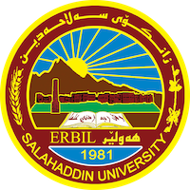
Academic Curriculum Vitae
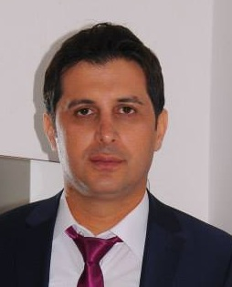
Full Name: Hunar Abdulrahman Saeed
Academic Title: Assistant lecturer
Email: hunar.saeed@su.edu.krd
Mobile: 07504546789

Education:
- I Degree Bachelor in law-College of law in university Saladin in 2003-2004
. I Degree Master in law –of V.N Karazin Kharkov National University in 2011
Employment:
I was employed for the first time in ( 13/10/2005) . I'm assists researcher in College of law in university Saladin I'm teaching lesson computer of first of stage of college of law I was personal manager in Collage of law for two years I'm worked as lawyer – legal affairs and court procedures .
Qualifications
- Teaching qualifications :- - I have a Certificate of teaching methods in 2012
- IT qualifications :- I'm participated in computer course in Korean military base (Zeiton )of level very good
- Language qualifications such as TOEFL, IELTS or any equivalent
- Any professional qualification :- I'm participated in level Language English course in university Jehan of level very good
- You could put any professional courses you have attended

Teaching experience:
- State all teaching courses you delivered, stating undergraduate or post graduate
- Courses, trainings, lab supervision, etc.,

Research and publications
I have a research published in the Qalaaizanist Journal in the name of the ( right to party participation as one of the political rights of citizens) in 2016
Conferences and courses attended
- Give details of any conferences you have attended, and those at which you have presented delivered poster presentations.

Funding and academic awards
- List any bursaries, scholarships, travel grants or other sources of funding that you were awarded for research projects or to attend meetings or conferences.

Professional memberships
- I'm manager in organization of Shkomand.
- I'm a member of the Union of Human Rights Watchers

Professional Social Network Accounts:

-https://academics.su.edu.krd/hunar.saeed
-https://www.facebook.com/hunarukrani
-https://scholar.google.com/citations?user=L986PAQAAAAJ&hl=en

