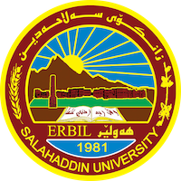
Academic Curriculum Vitae

Personal Information: 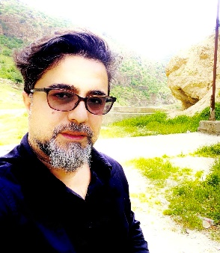
Full Name: idrees Omer mustafa
Academic Title: Lecture
Email: Idrees.mustafa@su.edu.krd
Mobile:0750461908

Education:
MA, PhD
Employment:
2004/3/4
Qualifications
- Teaching in Salaheddin University since 2012
- IT
- Language, IELTS level, 5
- Writer

Teaching experience:
- Political modern thought
- USA political system
- Media and public opinion
Research and publications
- Antagonism and Radical politics in Slavoj Zizek’s political philosophy
- Techno-power and depoliticization in Slavoj Zizek’s political philosophy

Conferences and courses attended
- I was a member of runner course with my colic about diversity education in 2017.
Funding and academic awards
-3 academic awards from
-2 award from minister of high education.
Professional memberships

Professional Social Network Accounts:

-google scholar
-LinkedIn
https://www.linkedin.com/in/idrees-mustafa-998191123
-Research gat
-Facebook
https://www.facebook.com/idris.sharafi
It is also recommended to create an academic cover letter for your CV, for further information about the cover letter, please visit below link:
https://career-advice.jobs.ac.uk/cv-and-cover-letter-advice/academic-cover-letter/

