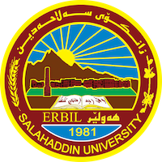
Academic Curriculum Vitae
Personal Information:
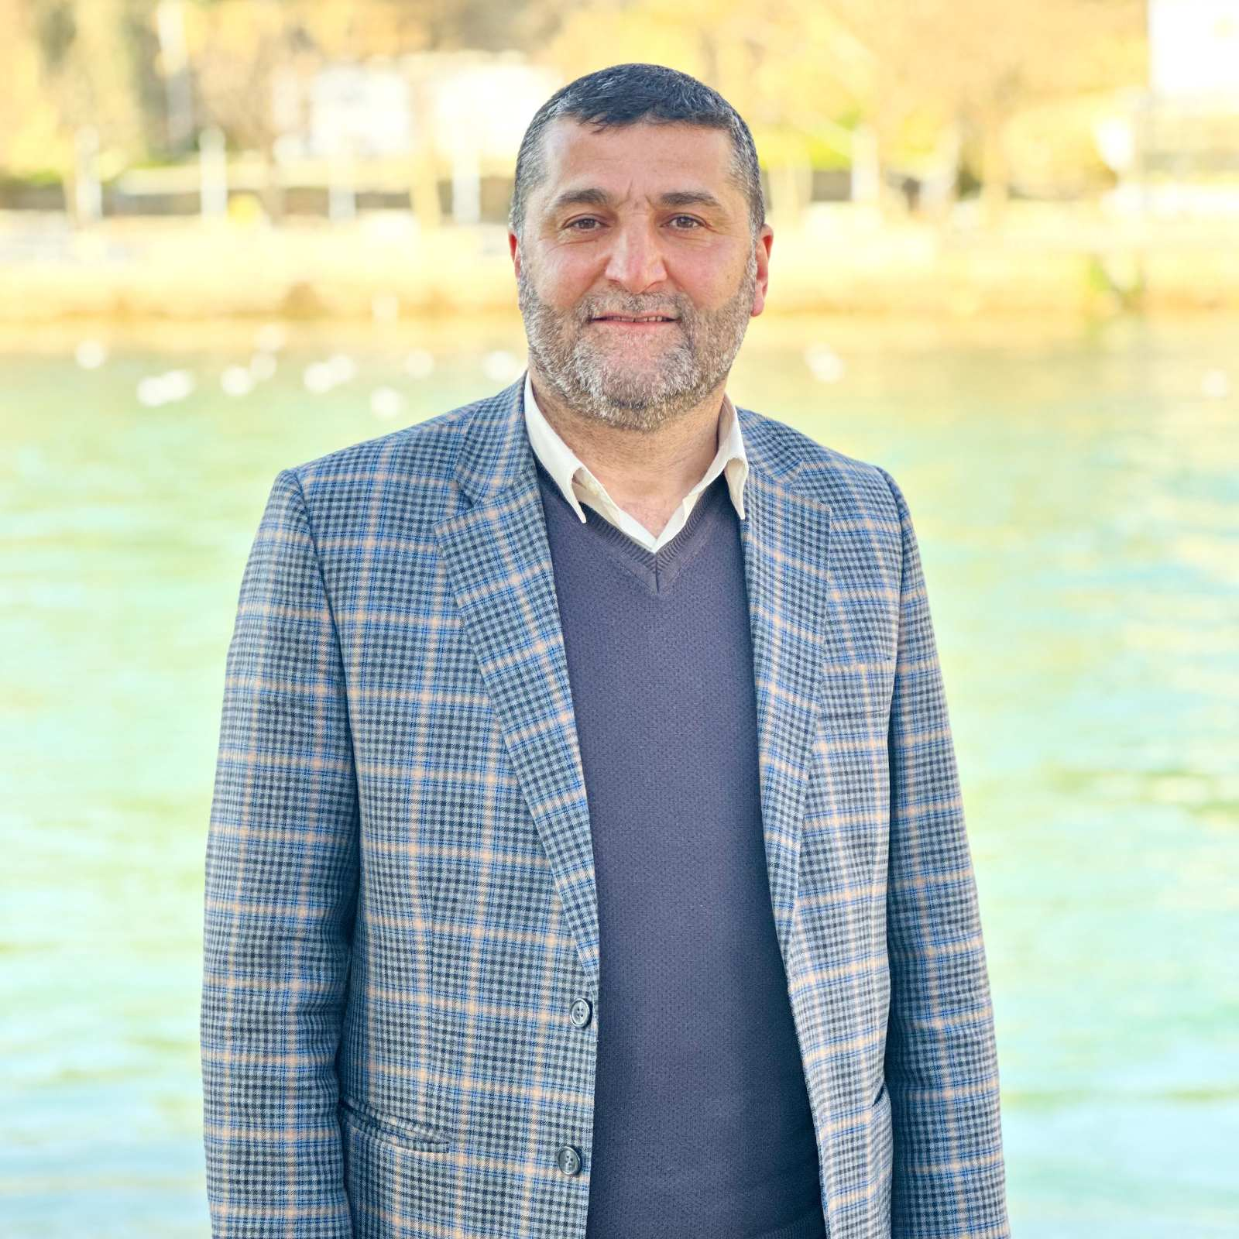
Full Name: Imad Ibrahim Ali
Academic Title: Lecurer
Email: Imad ali @su.edu.krd
Mobile:+964750 4775439

Education: PhD in Hadith and its science

Employment: College of Education/ Shaqlawa

Qualifications:

Teaching experience: 25years

Research and publications:

