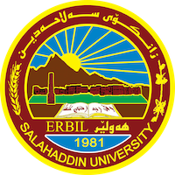
Academic Curriculum Vitae
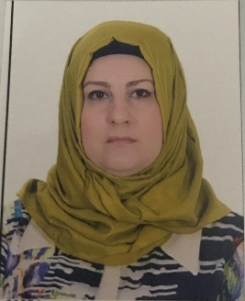
Personal Information:
Full Name: Iman Talaat AbdulRazaq AlDabagh
Academic Title: Teacher
Email: iman.abalrazak@su.edu.krd
Mobile: 07504700589

Education:
- Islamic History

Employment:
- Teacher of Islamic History

Qualifications
- Teacher
- English Academic language
- Master, Author
- English course
Teaching experience:
- Master, Phd Student
- English course
- The Iraqi society for manuscripts
Research and publications
- 1 Book; Mongols Systems Social, Religious and Military – House of Ghaida-Jordan
- 6 researches; Event Dirhams Of The Abbasid Caliph Al-Mu’tazid Billah – Journal Of Qalay Zanist – Lebanese French University, Policy of Sultan Jalaluddin Minkparti Towards the Kurds – Journal Of Art College – Baghdad University, The Buyids and The Calaphate In The View Of The Historian Miskawayh – Antalya Conference - Turkey, Mongols Social Systems The Seventh and Eith Centuries hejree – Al Hussain University - Jordan, Description Of The City Constantinapole and Its Importance Through The Books Of Travelers and Townspeople In The Middle Ages – Journal of University of Raparin-Erbil, Rare Coins From The Era Of Sultan Ahmed Tekodar – Antalya Conference - Turkey

Conferences and courses attended
International Conference – Istanbul - Aryam Jordanian Center for research and studies- Al Hussain University 14-16/9/2019

International Conference – Antalya – 28-1/11/2019

International Conference – Antalya – 29-31/10/2021

International Conference – Mosul – Mosul University 24-26/2/2022

International Conference – Dubai- Rammah Center for researches, Cihan Univeristy and Quran Al Kareem University – 15-17/3/2022

International Conference – Kirkuk- College education for Human Science- 15-16/3/2023

International Conference – Zaxo – University Of Zaxo Directorate of human resources – 2023-05-23
International Conference – Erbil – University of Salahaddin college of art – 1-2/03/2023

Funding and academic awards
- International Conference – Antalya – 28-1/11/2019
- International Conference – Antalya – 29-31/10/2021
- International Conference – Istanbul - Aryam Jordanian Center for research and studies- Al Hussain University 14-16/9/2019

Professional memberships
- Prof.Dr Nishtiman Muhammed Basheer
Prof.Dr. Iman Azzawi
Prof,Assistant.Dr. Juwan Ahmad

Professional Social Network Accounts:

- List your profile links of ReserchGate, LinkedIn, etc.

It is also recommended to create an academic cover letter for your CV, for further information about the cover letter, please visit below link:
https://career-advice.jobs.ac.uk/cv-and-cover-letter-advice/academic-cover-letter/

