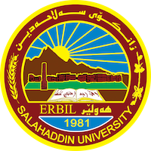
Academic Curriculum Vitae

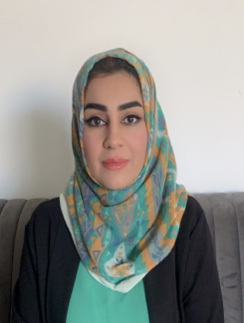
Personal Information:
Full Name: Iman Sherzad Ali
Academic Title: Assistant Lecturer
Email: iman.ali@su.edu.krd
Mobile: 07504818789

Education:
- 2014-2017: (M.Sc. in Fish Ecology). Department of Fish Resources and Aquatic Animals, College of Agricultural Engineering Sciences, Salahaddin University-Erbil, Kurdistan, IRAQ.
- 2008-2012: (B.Sc. in Animal resources). Department of Animal Resources, College of Agricultural Engineering Sciences, Salahaddin University-Erbil, Kurdistan, IRAQ.

Employment:
- 2018 to the date Assist. Lecturer in Fish Resources and Aquatic Animals department at College of Agricultural Engineering Sciences college - Salahaddin University Erbil.
- 2018 to the date Reporter of Fish Resources and Aquatic Animals department at College of Agricultural Engineering Sciences college - Salahaddin University Erbil.
- 2012- 2014 Administrator in Animal resources department at College of Agricultural Engineering Sciences college - Salahaddin University Erbil.
- Supervised fourth year under graduation projects (5 students).

Teaching experience:
- Water Quality and Quantity
- Aquatic Pollution
- Fish Ecology
- General Ecology
- Limnology
- Sea Bream Culture
- European and American Fish
- Student Projects
- Courses, Trainings, Lab supervision, etc.

Research and publications

- Assessment of Hepatic Mineral Composition in Sheep, Cattle, Chicken, and Fish in Erbil City, Kurdistan Region-Iraq. Kurdistan Journal of Applied Research. Vol. (6) No. (1) 2021.

Conferences and courses attended

- “1st ICAS 2019, 1st International Conference Agri. Sciences” held on November 6-7,2019 at college of Agriculture, Salahaddin University, Erbil- Kurdistan Region –Iraq.

Professional memberships
- Agricultural Engineers Syndicate- Iraq - Kurdistan
- Kurdistan teachers Union – Kurdistan - Erbil.
- Durbeen Organization for economic and politician.

Professional Social Network Accounts:
Academic Profile: https://academics.su.edu.krd/iman.ali/
Scholar Account: Iman Sherzad Ali‬ - Google Scholar‬

