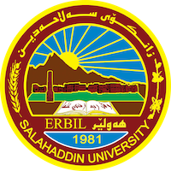
Academic Curriculum Vitae
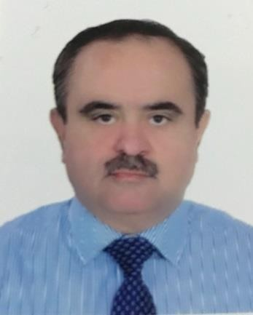
Personal Information:
Full Name: Dr.Isam Khalil Abdullah
Academic Title: Lecturer
Email: isam.abdullah@su.edu.krd
Mobile:009647504539092

Education:
2016 – PhD (Doctor of Philosophy) School of Physics and Astronomy Cardiff University / UK
Thesis title: Nanoscale Properties of Molecular and Oxide Based Thin film Devices Measured by SPM.

1992- MSc (Master of Science )
School of Physics
Salahaddin University/Erbil-Iraq
Thesis title: The Study of Radioactivity of Different Geological Layers of Al-Khazir Area.

1987 – BSc ( First Class Honours over School and College)
School of Physics
Salahaddin University/ Erbil-Iraq

Employment:
- Assistant lecturer at Salahaddin University-Erbil/ college of Science –department of physics 1992

Qualifications
- Teaching qualifications
I am an independent professional and self-motivated with good research and writing ability also I intend to grow up a positive relationship with peoples who works in high level research Centre gathered with special programming languages for solving more complicated problems in Nanotechnology and organic/inorganic device under operation. I was appointed as an assistant lecturer at department of Physics/Salahaddin University in 1992 (after master degree). From then, I am Demonstrated ability to develop my goals, objectives and implement strategies through lesson planning and teaching experience I enjoy keeping myself busy and put extra effort in my tasks. . Most recently, I was awarded a PhD from Cardiff University – UK in 2016 for work in Molecular Nano-Physics including Organic/inorganic materials gathered with exploring a new and attractive technique for Scanning Electrostatic Microscopy (EFM). I enjoy working with other and I have good communication skills with other researchers and academic staff. I speak more than 5 languages: English, Arabic, Kurdish, Turkey, Turkman, and a little of Persian. I regularly update myself with the latest information of my profession, I have many years of experience in teaching and researching so i can lead a team and manage problems that arise.
During my recruitment I taught these subjects:
Quantum Mechanics
Mathematical Physics
Differential equations
Linear Algebra
Nuclear Physics
Elementary Particles
Programming

- IT qualifications
- Python programming.

- Language qualifications such as TOEFL, IELTS or any equivalent

- IELTS AND TOEFL

- Any professional qualification

- Programming, research, and internationalization

- You could put any professional courses you have attended
Appraise course, OKP(orange knowledge programme), Mevlana, Erasmus+
Teaching experience:
- Nuclear physics: 4th year student
- Elementary particles and high energy physics: 4th year students
- Mathematical physics: 4th year
- Quantum mechanics: 3rd year students
5- Differential equations:2nd year students
- Linear algebra : 2nd year Physics
- Basic computations: 1st year students
- Calculus : 1st year Physics
- Electricity and magnetism: 1st year students
10- Python programming: 1st year physics.
Research and publications
- Nondestructive Method for Mapping Metal Contact Diffusion in In₂O₃ Thin-Film Transistors.
- The synergistic role of azeotropic solvent mixtures and atactic polystyrene on the morphology, crystallization and field effect mobility of thin film 6,13-bis(triisopropylsilylethynyl)-pentacene based semiconductors.

- Simple and efficient estimation of photovoltaic cells and modules parameters using approximation and correction technique

- UK patent application 2015.
- Approximation and correction technique (ACT) for efficient estimation of photovoltaic cells and modules parameters (under reviewer).
- Brent's algorithm based new computational approach for accurate determination of single-diode model parameters to simulate solar cells and modules( Under publication – Solar energy).
- A new computational method to accurately determine the parameters of single-diode model for solar cells and modules simulation using Brent’s algorithm approach (BAA) ( under review).
- Bias stability of solution –processed In2O3 thin film transistor.

I worked with many research teams including:
- Manchester University – School of Chemistry (professor Steve yeats group)
- Imperial college – London – center of plastic electronics ( Prof.
Thomas D Anthopoulos)
- Swansea university- Electronic system design center ( Prof. Richard J Clobley).
- Nanoscience research group – Cardiff University, Uk.

Conferences and courses attended

Conferences:

  - Conference of science of inkjet and printed drop 2011 London, Nov.2011. Institute of physics, London UK
  - Conference of postgraduate students 2012.Cardiff University School of Physics and astronomy, Sep20I2. Cardiff UK.
  - WITec AFM/Raman Workshop. Leatherhead, UK. Feb.2013.
  - Nano Electrical Characterisation Workshop (New Developments). Coventry, UK. Coventry, 2013.
  - Microscopy of Semiconducting Materials (MSM-XIX). Cambridge, UK.April,2015.
  - Nanotechnologies in Drug Delivery Congress. London, UK, 2015.
  - Frontiers in Unconventional Superconductivity, Superfluidity and Magnetism. Bristol, UK. Jan 2016.
  - Functional Nanomaterials in Industrial Applications: Academic- Industry Meet. Preston, UK. March, 2016.
  - Interdisciplinary Surface Science Conference (ISSC-21). Manchester, UK. 2017, Manchester.
Funding and academic awards
- 2010- Iraqi Higher Education and Scientific Researches, Cardiff University- Cardiff-Uk.
- 2007 - Kurdustan Regional Scholarship – Old dominion University – Viginia – Norfolk USA.
- 1987 – Awards from Iraqi President, Erbil Governor, and president of Salahaddin University.
- OKP project in Iraq
- Spark organization(Netherlands)
- Mitsubishi corporation (Japan)
- DAAD (Germany)
- Professional memberships

Scientific and administration duties and membership.

- Vice president for Scientific affairs 2017-2019 ( Cihan University).
2- Head of international office 2018-2019 ( Cihan University).
- Head of Nano-technology research center (CU).
4- Head of Environmental studies group(CU).
5-Deputy of the head of Erasmus plus program.
6- Member of the committee of research support at the college of science. (1 year)
7- Coordinator of Physics department (5 years).
- Member of Exam committee ( 2 years).
- Director of international relations office

