Chapter One
Historical Background
1 Introduction
For most people, it is impossible to go even a day without coming into contact with electronic devices such as laptops, tablets and cell phones. Most people rely on these technological tools for work, communicating with friends and family, school, and personal enjoyment. What most people don’t seem to realize, however, is that all of these electronic devices are known to emit waves of (EMF) ( ). Electromagnetic radiation (often abbreviated E-M radiation or EMR) is a phenomenon that takes the form of self-propagating waves in a vacuum or in matter. It consists of electric and magnetic field components which oscillate in phase perpendicular to each other and perpendicular to the direction of energy propagation. Electromagnetic radiation is classified into several types according to the frequency of its wave; these types include (in order of increasing frequency and decreasing wavelength): radio waves, microwaves, terahertz radiation, infrared radiation, visible light, ultraviolet radiation, X-rays and gamma rays.
1-1 Research problem
Methods as a general rule, scientific reports that are considered primarily for the risk of EMW on human being. Only studies that are considered relevant for the task are commented upon in the opinion. Many more reports were considered than are cited in the reference list. However, the focus is on articles presented after the year 2000.. Also studies on biophysical mechanisms, dosimetry, and exposure assessment should be considered.
1-2 Research objectives
The continued lack of good quality data on EMW means that there are insufficient data to identify whether a single exposure standard is appropriate to protect all environmental species from EMF. Similarly the data are totally inadequate to judge whether the environmental standard(s) should be the same or significantly different from those appropriate to protect human health.
The demonstration that the impact of EMF may be additive with some other environmental stressors at least in plants needs further examination to gauge its practical significance.
At present it is not possible to draw any conclusions regarding human health from this data base. Nonetheless, long-term monitoring of the viability of carefully selected species and/or ecosystems may be valuable to gauge the potential of EMF to influence human health.
1.3 Research importance
1-Since the adoption of the general opinion extensive research has been conducted regarding possible health effects of exposure to low intensity RF fields, including epidemiologic, in vivo, and in vitro research. In conclusion, no health effect has been consistently
2-Environmental effects there are insufficient data to identify whether a single exposure standard is appropriate to protect all environmental species from EMF. Similarly the data are inadequate to judge whether the environmental standards should be the same or significantly different from those appropriate to protect human health.
1.4 Description of method

1.4.1 Biot Savart law:
This law quantifies the amount of magnetic field that is generated around an element when some current flows through it. It helps us to find the amount of MF, solenoid, a circular coil, or any other geometrical shape. ( )
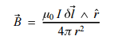 ……………………………(1-1)

1.4.2 Lorentz force law:
When a magnetic field is created, a magnetic force acts on any object that lies inside that magnetic field. The magnitude of this magnetic force is given by Lorentz force law, which takes into account both the magnetic and electric force around an object. This is given by the equation … (1-2)
This equation is particularly useful when analyzing the phenomena occurring in outer space and also helps in the development of cyclotron (particle accelerators), electric motors, maglev trains, etc.( )

1.4.3 Faraday’s law:
This is perhaps the most important of all the laws. Without this law, we wouldn’t have electric batteries, motors, transformers and other such devices. This law predicts how a magnetic field will interact with an electric circuit to produce an electromotive force (EMF)—a phenomenon called electromagnetic induction. Faraday proposed two laws – 1st law in simple words states that whenever a conductor cuts magnetic lines of forces, an EMF is generated across its two ends. The 2nd law states that the EMF induced is equal to the rate of change of flux in the coil i.e. how many times the magnetic field associated around a conductor changes with time does.
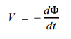 ………………………. (1-3)

1.4.4 Ampere’s law:
Ampere’s Law states that for any closed loop path, the sum of the length elements times the magnetic field in the direction of the length element is equal to the permeability times the electric current enclosed in the loop ( ). This can be interpreted as another form of Biot-Savart’s law and is used for the same applications as the latter.
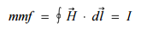 ………………. (1-4)
The aforementioned four laws are only a few of all the laws of electromagnetism but are the most fundamental ones due to the fact that these laws formed the basis for whatever is achieved so far in this field. Considering from the exam point of view, especially JEE, electromagnetism is one topic which forms a major chunk of the questions and primarily most of the questions are formed to test you on your conceptual knowledge these four laws, so if you are a student wanting to pursue physics or engineering you would want to be thorough in these topics.
1.5 Literature Review and Theoretical Background
For more details on EMW see Fig.( 1-1) ( ) A small and somewhat variable window of frequencies is sensed by the eyes of various organisms; this is what we call the visible spectrum, or light.
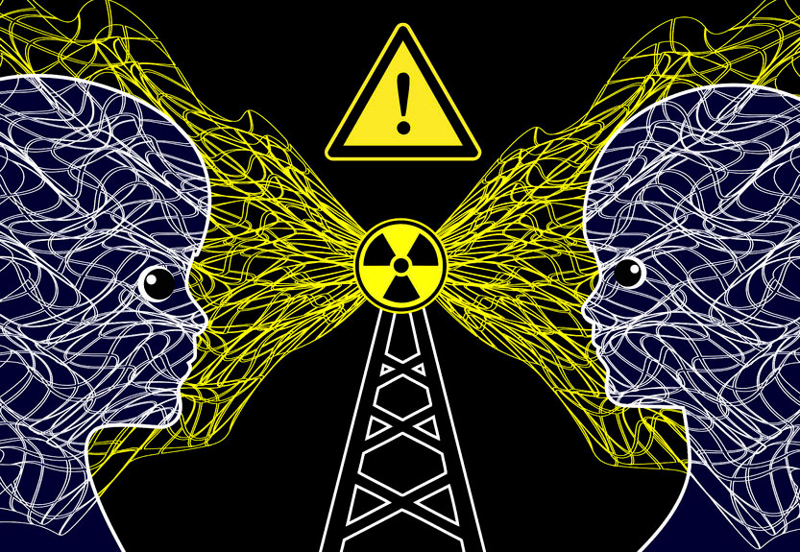
Figure (1-1): General view of electromagnetic radiation
Electromagnetic waves were first postulated by James Clerk Maxwell and subsequently confirmed by Heinrich Hertz. Maxwell derived a wave form of the electric and magnetic equations, revealing the wave-like nature of electric and magnetic fields, and their symmetry. Because the speed of EM waves predicted by the wave equation coincided with the measured speed of light, Maxwell concluded that light itself is an EM wave ( ). According to Maxwell's equations, a spatially-varying electric field generates a time-varying magnetic field and vice versa. Therefore, as an oscillating electric field generates an oscillating magnetic field, the magnetic field in turn generates an oscillating electric field, and so on. These oscillating fields together form an electromagnetic wave. We talk about electromagnetic waves. For more details see Fig.(1-2).

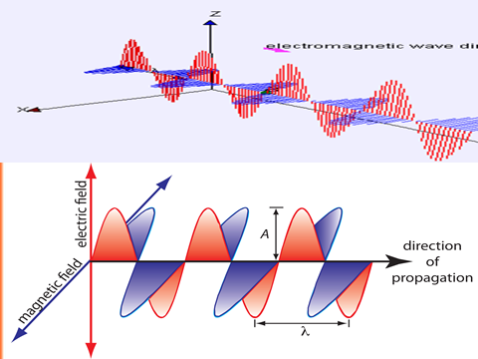
Figure. (1-2): A diagram of the planes an electromagnetic wave travels on
EM radiation carries energy and momentum that may be imparted to matter with which it interacts.
These are harder to get a handle on, for a number of reasons. First, the things that are oscillating are electric and magnetic fields, which are much harder to see (which is an ironic statement, considering that we see with light, which is an electromagnetic wave). Second, the fields can have components in various directions, and there can be relative phases between these components (this will be important when we discuss polarization). And third, unlike all the other waves we've dealt with, electromagnetic waves don't need a medium to propagate in. In the late 1800's, it was generally assumed that electromagnetic waves required a medium, and this hypothesized medium was called the \ether." However, no one was ever able to observe the ether. And for good reason, because it doesn't exist. The EM spectrum is the range of all possible frequencies of electromagnetic waves. At one end of the spectrum are the waves with the lowest frequencies. At the other end are the highest frequency waves. The spectrum is broken up into regions that define each of the different wave types. At the lowest frequencies, we have radio waves. Then, as we increase frequency ( ), we encounter the microwaves, infrared radiation, and visible light waves. Moving further up the spectrum, we have ultraviolet radiation, X-rays, and gamma rays. Gamma rays have the highest frequencies of all the EM waves.³
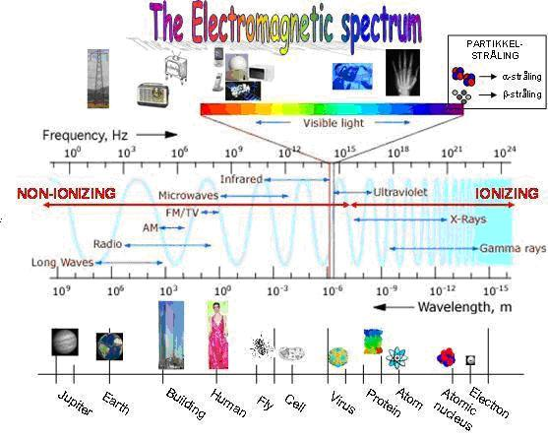
A)
B) 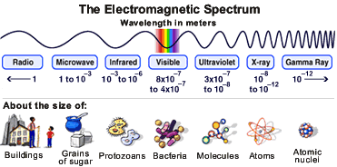
Figure (1-3): A and B sketches represent the whole EMS (6).
A quantum theory of the interaction between electromagnetic radiation and matter such as electrons is described by the theory of quantum electrodynamics

1.5.1 Properties
The physics of electromagnetic radiation is electrodynamics, a subfield of electromagnetism. Electric and magnetic fields obey the properties of superposition so that a field due to any particular particle or time-varying electric or magnetic field will contribute to the fields present in the same space due to other causes: as they are vector fields, all magnetic and electric field vectors add together according to vector addition. For instance, a travelling EM wave incident on an atomic structure induces oscillation in the atoms of that structure, thereby causing them to emit their own EM waves, emissions which alter the impinging wave through interference. These properties cause various phenomena including refraction and diffraction. Waves of the electromagnetic spectrum vary in size, from very long radio waves the size of buildings to very short gamma rays smaller than atom nuclei. Frequency is inversely proportional to wavelength, according to the equation: , where v is the speed of the wave (c in a vacuum, or less in other media), f is the frequency and λ is the wavelength. As waves cross boundaries between different media, their speeds change but their frequencies remain constant. Electromagnetic radiation has particle-like properties as discrete packets of energy, or quanta, called photons. ( ). The frequency of the wave is proportional to the particle's energy. Because photons are emitted and absorbed by charged particles, they act as transporters of energy. The energy per photon can be calculated from the Planck–Einstein equation , where E is the energy, h is Planck's constant, and f is frequency. This photon-energy expression is a particular case of the energy levels of the more general electromagnetic oscillator whose average energy, which is used to obtain.

1.5.2 The different type of EMW

1.5.3 Light (visible region)
EM radiation with a wavelength between approximately 400 nm and 700 nm is detected by the human eye and perceived as visible light. Other wavelengths, especially nearby infrared (longer than 700 nm) and ultraviolet (shorter than 400 nm) are also sometimes referred to as light, especially when visibility to humans is not relevant.

1.5.4 Radio waves
Radio waves can be made to carry information by varying a combination of the amplitude, frequency and phase of the wave within a frequency band. When EM radiation impinges upon a conductor, it couples to the conductor, travels along it, and induces an electric current on the surface of that conductor by exciting the electrons of the conducting material. This effect (the skin effect) is used in antennas. EM radiation may also cause certain molecules to absorb energy and thus to heat up; this is exploited in microwave ovens. This chapter will focus on the electromagnetic (EM) radiation. Electromagnetic radiation is a self-propagating wave in space with electric and magnetic components. These components oscillate at right angles to each other and to the direction of propagation, and are in phase with each other. Electromagnetic radiation is classified into types according to the frequency of the wave: these types include, in order of increasing frequency, radio waves, microwaves, infrared radiation, visible light, ultraviolet radiation, X-rays and gamma rays( ). Light and all other types of electromagnetic radiation seems like a continuous wave at first, but when one performs experiments on the light, one can notice that the light can have both wave and particle like properties.
1.5.5 Ultraviolet (UV) radiation and the skin
UVA and UVB are different ranges of frequencies for ultraviolet (UV) light. UVA and UVB can damage collagen fibers which results in the speeding up skin aging. In general, UVA is the least harmful, but it can contribute to the aging of skin, DNA damage and possibly skin cancer. It penetrates deeply and does not cause sunburn. Because it does not cause reddening of the skin (erythema) it cannot be measured in the SPF testing. There is no good clinical measurement of the blocking of UVA radiation, but it is important that sunscreen block both UVA and UVB.
UVB light can cause skin cancer. The radiation excites DNA molecules in skin cells, resulting in possible mutations, which can cause cancer. This cancer connection is one reason for concern about ozone depletion and the ozone hole. As a defense against UV radiation, the body tans when exposed to moderate (depending on skin type) levels of radiation by releasing the brown pigment melanin. This helps to block UV penetration and prevent damage to the vulnerable skin tissues deeper down. Suntan lotion, often referred to as sunblock or sunscreen, partly blocks UV and is widely available. Most of these products contain an SPF rating that describes the amount of protection given. This protection, however, applies only to UVB rays responsible for sun burn. UPF rating that describes the protection given against both UVA and UVB.
1.5.6 X-rays
While x-rays are used significantly in medicine, prolonged exposure to X-rays can lead to cell damage and cancer. For example, a mammogram is an x-ray of the human breast to detect breast cancer, but if a woman starts having regular mammograms when she is too young, her chances of getting breast cancer increases ( ).
1.5.7 Gamma rays
Due to the high energy of gamma-rays, they are able to cause serious damage when absorbed by living cells. Gamma-rays are not stopped by the skin and can induce DNA alteration by interfering with the genetic material of the cell. DNA double-strand breaks are generally accepted to be the most biologically significant lesion by which ionizing radiation causes cancer and hereditary disease. A study done on Russian nuclear workers exposed to external whole-body gamma-radiation at high cumulative doses shows a link between radiation exposure and death from leukemia, lung, liver, skeletal and other solid cancers. Extension {Cellphones and electromagnetic radiation}.Cellphone radiation and health concerns have been raised, especially following the enormous increase in the use of wireless mobile telephony throughout the world. This is because mobile phones use electromagnetic waves in the microwave range. These concerns have induced a large body of research. Concerns about effects on health have also been raised regarding other digital wireless systems, such as data communication networks.
The World Health Organization (WHO) has officially( ), ruled out adverse health effects from cellular base stations and wireless data networks, and expects to make recommendations about mobile phones in 2007-08. When light encounters or passes through a material, the photons of the light interact with the atoms or molecules of the material. Depending on the strength of the interactions and how often they happen, the light will pass through the material or be scattered in some other direction. Each wavelength of light relates to a particular energy, and the closer that energy is to the energy difference between two of the levels of the atom, the likelier the photon is to interact with the atom. The sun emits light in many different wavelengths, including all of the visible wavelengths. Light which is made up of all the visible wavelengths appears white. So what causes the sky to look blue? The air is not just full of nitrogen and oxygen gases. It is also full of tiny dust grains. The light from the sun scatters off these many dust grains. The chance that the light will scatter off one of these dust grains is bigger for shorter wavelengths.( ). The short wavelength blue light is therefore scattered much more than the other colors. At noon, when the light from the sun is coming straight down, the scattered blue light reaches your eyes from all directions and so the sky appears blue. The other wavelengths do not get scattered much and therefore miss your line of sight. At sunrise or sunset, the direction of the light coming from the sun is now straight towards your eyes (see picture below). Therefore the scattered blue light can't be seen because it is scattered out of your line of sight. The redder colors (oranges and reds) can now be seen because they are not scattered as much and still fall in your line of sight. Around the turn of the twentieth century, it was observed by a number of physicists (including Hertz, Thomson and Von Lenard) that when light was shone on a metal, electrons were emitted by the metal. This is called the photoelectric effect for light and for the electron. Electromagnetic waves are used to transmit long/short/FM wavelength radio waves, and TV/telephone/wireless signals or energies. They are also responsible for transmitting energy in the form of microwaves, infrared radiation (IR), visible light (VIS), ultraviolet light (UV), X-rays, and gamma rays. Electromagnetic waves differ from mechanical waves in that they do not require a medium to propagate. This means that electromagnetic waves can travel not only through air and solid materials, but also through the vacuum of space. The main importance is that EM fields allow energy to be stored within them through the process of induction and then propagated over vast distances using the dielectric and magnetic properties of materials (free space being one). This allows both power and data to be generated, transmitted and distributed via EM waves to benefit society either as end use power or information.( ).
EM waves have natural importance as a fundament pillar for all live form on this planet and perhaps elsewhere. This natural phenomenon is also used as ground pillar for all radio equipment in modern history and is used as transmission and modulation media for information signaling in all telecom communication. There was this older guy named Marconi, he figured out that a spark between two little metal balls attached to wires, gave off an invisible energy pulse that could be detected by one or two long wires at some distance. It turns out that Mr. Marconi had invented the first primitive Wi-Fi device. So, we all now know what Wi-Fi is, and we still use it daily, right? It appears that Mr. Marconi’s first use of electromagnetic waves turned into the magic we all depend upon in today’s wireless world. Now, so we do understand that something like a microwave oven does not send messages between ships at sea, or from country to country across an ocean, however, this wonderful Marconi wireless invention way back into the early 1900’s. Electromagnetic waves are used to transmit long/short/FM wavelength radio waves, and TV/telephone/wireless signals or energies. They are also responsible for transmitting energy in the form of microwaves, infrared radiation (IR), visible light (VIS), ultraviolet light (UV), X-rays, and gamma rays ( ).

1.8 Speed of Electromagnetic Wave

Speed of propagation or speed of light for any electric charge which accelerates, or any changing magnetic field, produces electromagnetic radiation. Electromagnetic information about the charge travels at the speed of light. Accurate treatment thus incorporates a concept known as retarded time which adds to the expressions for the electro dynamic electric field and magnetic field. These extra terms are responsible for electromagnetic radiation. When any wire (or other conducting object such as an antenna) conducts alternating current, electromagnetic radiation is propagated at the same frequency as the electric current. At the quantum level, electromagnetic radiation is produced when the wave packet of a charged particle oscillates or otherwise accelerates. Charged particles in a stationary state do not move, but a superposition of such states may result in oscillation, which is responsible for the phenomenon of irradiative transition between quantum states of a charged particle. Depending on the circumstances, electromagnetic radiation may behave as a wave or as particles. As a wave, it is characterized by a velocity (the speed of light), wavelength, and frequency. When considered as particles, they are known as photons, and each has an energy related to the frequency of the wave given by Planck's relation E = hν, where E is the energy of the photon, h = 6.626 × 10⁻³⁴ J·s is Planck's constant, and ν is the frequency of the wave. In a medium (other than vacuum), velocity factor or refractive index are considered, depending on frequency and application. Both of these are ratios of the speed in a medium to speed in a vacuum. Any electromagnetic radiation can heat a material when it is absorbed. The electromagnetic radiation in an opaque cavity at thermal equilibrium is effectively a form of thermal energy, having maximum radiation entropy. The thermodynamic potentials of electromagnetic radiation can be well-defined as for matter .Thermal radiation in a cavity has energy density, ( ) see Planck's Law.
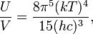 ……………(2-1)
Differentiating the above with respect to temperature, we may say that the electromagnetic radiation field has an effective volumetric heat capacity given by
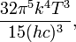 …………………. (2-2)
Generally, EM radiation (the designation 'radiation' excludes static electric and magnetic and near fields) is classified by wavelength into radio, microwave, infrared, the visible region we perceive as light, ultraviolet, X-rays and gamma rays. Arbitrary electromagnetic waves can always be expressed by Fourier analysis in terms of sinusoidal monochromatic waves which can be classified into these regions of the spectrum. The speed c of electromagnetic wave in vacuum is related to μ and ε (the free space permeability and permittivity constants) as follows:
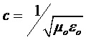 ………………………(2-3)
Electromagnetic waves other than light also have the same velocity c in free space. The speed of light, or of electromagnetic waves in a material medium is given by
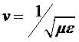 ………………………… (2-4)
Where μ is the permeability of the medium and ε its permittivity.

1.9 Electromagnetic Spectrums
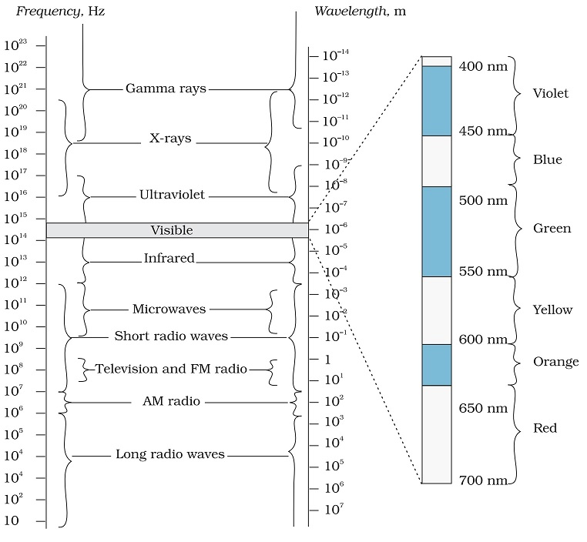

Figure (2-2): Represent the whole EM spectrum (14)

1.10 Source of energy of electromagnetic waves?
Electromagnetic waves are generated by an accelerating charge. When the wave is generated, the charge loses energy. Work is done by the charged object to generate the wave. This is the source of the energy. This is also why transmitting antennae consume electrical power - the consumed power is converted to wave energy. Once the wave is in motion, its energy remains constant unless it is consumed by absorption. Electromagnetic waves see Fig.(2-3), are the combination of electric and magnetic field waves produced by moving charges. Electromagnetic waves consist of both electric and magnetic field waves. These waves oscillate in perpendicular planes with respect to each other, and are in phase. The creation of all electromagnetic waves begins with an oscillation charged particle, which creates oscillating electric and magnetic fields.
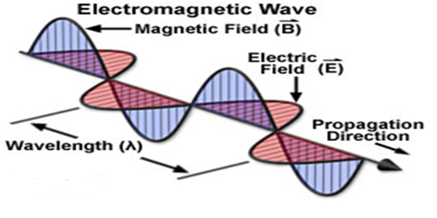
Fig.( 2-3): Shows the main part of electric and magnetic fields of a charge particle
Once in motion, the electric and magnetic fields that a charged particle creates are self-perpetuating: time-dependent changes in one field (electric or magnetic) produce the other. Electromagnetic radiation, is a form of energy emitted by moving charged particles. As it travels through space it behaves like a wave, and has an oscillating electric field component and an oscillating magnetic field. These waves oscillate perpendicularly to and in phase with one another. The creation of all electromagnetic waves begins with a charged particle. This charged particle creates an electric field (which can exert a force on other nearby charged particles). When it accelerates as part of an oscillatory motion, the charged particle creates ripples, or oscillations, in its electric field, and also produces a magnetic field (as predicted by Maxwell's equations). Electromagnetic waves are ubiquitous in nature (i.e., light) and used in modern technology—AM and FM radio, cordless and cellular phones, garage door openers, wireless networks, radar, microwave ovens, etc. These and many more such devices use electromagnetic waves to transmit data and signals. All the above sources of electromagnetic waves use the simple principle of moving charge. Many of the EM waves present in Earth’s environment come from the Sun. The Sun’s high temperature allows it to give off countless EM waves. Other stars give off as many EM waves as the Sun, but because these bodies are so far away, fewer of their EM waves reach Earth. In addition to the Sun, technology is a source of EM waves that humans use for a wide variety of purposes. EM waves from the Sun provide most of the energy for the environment on Earth. Some of the energy goes into Earth’s surface, which then gives off EM waves of different wavelengths. The sun's energy is the primary source of energy for all surface phenomena and life on Earth. Combined with the material of the Earth (including the molecules held close by the Earth's gravitational force called the atmosphere), this energy provides for the immense diversity of life forms that are found on the Earth ( ).

1.11 Natural sources of electromagnetic fields
Electromagnetic fields are present everywhere in our environment but are invisible to the human eye. Electric fields are produced by the local build-up of electric charges in the atmosphere associated with thunderstorms. The earth's magnetic field causes a compass needle to orient in a North-South direction and is used by birds and fish for navigation.

1.12 Human-made sources of electromagnetic fields
Besides natural sources the electromagnetic spectrum also includes fields generated by human-made sources: X-rays are employed to diagnose a broken limb after a sport accident. The electricity that comes out of every power socket has associated low frequency electromagnetic fields. And various kinds of higher frequency radio waves are used to transmit information – whether via TV antennas, radio stations or mobile phone base stations.

Chapter Two

Material and Methods / Theory

2.1 Properties of electromagnetic
The main characteristics of EMW can be summarized as follow:
1- The electric E and magnetic B fields are perpendicular to each other and to the direction of motion of the wave.
3- Electric E and magnetic B fields are in phase to each other and
3-Vibrates at the same frequency, the frequency of the EMW.
4 All EMW travel at the same speed in vacuum, 2.998 x 10 8 m s-1
5- EMW travel in straight lines.
6- Electromagnetic waves are transverse wave only and they are capable of being polarized

2.2 Uses of Electromagnetic Waves
1-Radio Waves (communications)
- TV and FM radio (short wavelength)
- Direct line of sight with transmitter (do not diffract)
- Medium wavelength – travel further because they reflect from layers in the atmosphere
2.3 Satellite signals (Microwaves)
- Frequency of microwaves pass easily through atmosphere and clouds
2.4 Cooking (Microwaves)
- Microwaves are absorbed by water molecules.
- These water molecules become heated > heat food
- Dangers: microwaves are absorbed by living tissue Internal heating will damage or kill cells
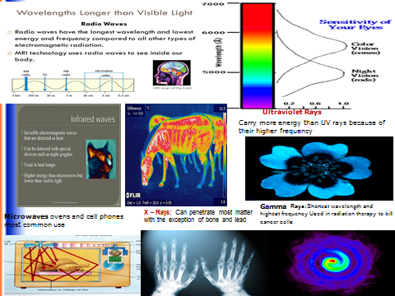
Figure (2-1) : A general view of most part of EMW uses and applications¹⁴.
2.5 Infrared Radiation (remote controls, toasters)
- Any object that radiates heat radiates Infrared Radiation
- Infrared Radiation is absorbed by all materials and causes heating
- It is used for night vision and security cameras as Infrared Radiation is visible in daytime or night-time
- Police use it to catch criminals, army use it to detect enemy
- Dangers: damage to cells (burns)
2.6 Ultraviolet
Dangers:

Over-exposure to UVA and B damages surface cells and eyes and can cause cancer.

There is a problem with current sunscreens which protect against skin burning from high UVB but give inadequate protection against free radical damage caused by UVA.

Dark skins are not necessarily safer from harm. Sun exposure for the skin is best restricted to before 11am and after 3pm in the UK in summer months.

2.7 X-rays

X-rays detect bone breaks. X-rays pass through flesh but not dense material like bones

Dangers: X-rays damage cells and cause cancers. Radiographer precautions include wearing lead aprons and standing behind a lead screen to minimize exposure.

2.8 Gamma Rays

Gamma Rays cause and treat cancers. In high doses, gamma can kill normal cells and cause cancers. Gamma can be used to kill mutated cells though too.

2-9 The Risk of EMW on Human Being
What happens when you are exposed to electromagnetic fields? Exposure to electromagnetic fields is not a new phenomenon. However, during the 20th century, environmental exposure to man-made electromagnetic fields has been steadily increasing as growing electricity demand, ever-advancing technologies and changes in social behavior have created more and more artificial sources)¹⁴. Everyone is exposed to a complex mix of weak electric and magnetic fields see Fig.(2-4) , both at home and at work, from the generation and transmission of electricity, domestic appliances and industrial equipment, to telecommunications and broadcasting. Tiny electrical currents exist in the human body due to the chemical reactions that occur as part of the normal bodily functions, even in the absence of external electric fields. For example, nerves relay signals by transmitting electric impulses. Most biochemical reactions from digestion to brain activities go along with the rearrangement of charged particles. Her are part of the most risk and hazardous on human being and can be summarized as follow:
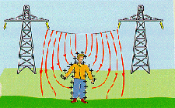
Figure (2-4 ) : Represents the effect of radiation on human being ¹⁶.
1-Low-frequency electric fields influence the human body just as they influence any other material made up of charged particles. When electric fields act on conductive materials, they influence the distribution of electric charges at their surface. They cause current to flow through the body to the ground. Low-frequency magnetic fields induce circulating currents within the human body. The strength of these currents depends on the intensity of the outside magnetic field. If sufficiently large, these currents could cause stimulation of nerves and muscles or affect other biological processes.

2-Biological effects or health effects? What is a health hazard?
Biological effects are measurable responses to a stimulus or to a change in the environment. These changes are not necessarily harmful to your health. For example, listening to music, reading a book, eating an apple or playing tennis will produce a range of biological effects¹⁷. Nevertheless, none of these activities is expected to cause health effects. The body has sophisticated mechanisms to adjust to the many and varied influences we encounter in our environment. Ongoing change forms a normal part of our lives. But, of course, the body does not possess adequate compensation mechanisms for all biological effects. Changes that are irreversible and stress the system for long periods of time may constitute a health hazard.
3-Effects on pregnancy outcome
Many different sources and exposures to electromagnetic fields in the living and working environment, including computer screens, water beds and electric blankets, radiofrequency welding machines, diathermy equipment and radar, have been evaluated by the WHO and other organizations ( ). The overall weight of evidence shows that exposure to fields at typical environmental levels does not increase the risk of any adverse outcome such as spontaneous abortions, malformations, low birth weight, and congenital diseases. There have been occasional reports of associations between health problems and presumed exposure to electromagnetic fields, such as reports of prematurity and low birth weight in children of workers in the electronics industry, but these have not been regarded by the scientific community as being necessarily caused by the field exposures (as opposed to factors such as exposure to solvents).

2.10 Effects on general health
Some members of the public have attributed a diffuse collection of symptoms to low levels of exposure to electromagnetic fields at home. Reported symptoms include headaches, anxiety, suicide and depression, nausea, fatigue and loss of libido¹⁶. To date, scientific evidence does not support a link between these symptoms and exposure to electromagnetic fields. At least some of these health problems may be caused by noise or other factors in the environment, or by anxiety related to the presence of new technologies.
2.10.1 Electromagnetic fields and cancer
Despite many studies, the evidence for any effect remains highly controversial. However, it is clear that if electromagnetic fields do have an effect on cancer, then any increase in risk will be extremely small( ) .The results to date contain many inconsistencies, but no large increases in risk have been found for any cancer in children or adults. A number of epidemiological studies suggest small increases in risk of childhood leukemia with exposure to low frequency magnetic fields in the home. However, scientists have not generally concluded that these results indicate a cause-effect relation between exposure to the fields and disease (as opposed to artifacts in the study or effects unrelated to field exposure). In part, this conclusion has been reached because animal and laboratory studies fail to demonstrate any reproducible effects that are consistent with the hypothesis that fields cause or promote cancer ( ). Large-scale studies are currently underway in several countries and may help resolve these issues.
2.10.2 Electromagnetic hypersensitivity and depression
Some individuals report "hypersensitivity" to electric or magnetic fields. They ask whether aches and pains, headaches, depression, lethargy, sleeping disorders, and even convulsions and epileptic seizures could be associated with electromagnetic field exposure.

2.10.3 Progress in research
If electromagnetic fields constitute a health hazard, there will be consequences in all industrialized countries. The public demands concrete answers to the ever more pressing question, whether everyday electromagnetic fields cause adverse health effects. The large number of studies which suggest that electromagnetic fields are harmless receive little if any coverage. Science cannot provide a guarantee of absolute safety yet but the development of research is reassuring overall. Researchers try to establish if there is a statistical association between exposure to electromagnetic fields and the incidence of a specific disease or adverse health effect. A mix of studies in different research areas is essential for the evaluation of a potential adverse health effect of electromagnetic fields. Different types of studies investigate distinct aspects of the problem. Laboratory studies on cells aim to elucidate the fundamental underlying mechanisms that link electromagnetic field exposure to biological effects ( ). They try to identify mechanisms based on molecular or cellular changes that are brought about by the electromagnetic field.¹⁷

2.10.4 Protection against high frequency of electromagnetic pollution
1-Less time should be spend on the cell phone.
2-Cell phones with a lower specific absorption rate (SAR) should be used.
3-Children's use of cell phones should be limited.
4-It should be avoided to make calls with a low signal and low battery as the cell phone will generate more radiation in an effort to compensate for it.
A wide frequency range of radio wave (3 kHz – 300 GHz) and microwave scattering in our living environment affect our daily life. Most of these EMW are man-made byproducts of broadcasting ( ), radar communications, satellite communications, medical and industrial manufacturing. More specifically, EMW sources form household microwave oven, cellular phone (including base station), radio broadcasting, computer terminal equipment, medical rehabilitation devices, plastic cutting and molding high frequency industrial machinery, etc. EMW is ubiquitous to our daily life. As the result, the effect of EMW to human health has becoming a concern to the public. For non-ionizing radiation, the frequency starts from extreme low frequency (0 Hz) to nanometer wave (300 Hz) are all in the category of EMW. There are controllable and uncontrollable EMW surrounding ( ). Example of controllable EMW surrounding includes laboratory where strength of EMW can be measured and adjust by professionals for protection. Standard Exposure Limits.

Chapter Three

Conclusions and Discussions
People study waves because the ideas learned from a vibrating string are the same as those found within atoms and molecules, electronic apparatus and antennas, so learning the vibrating string help people know the inner operation of these other fields of study. So, we may conclude by stating that,
1-Because actual waves are observed as present in a great variety of physical phenomena and circumstances, the mathematics of waves (formulating how they are formed and how they actually move away from their source) forms a most important part of the study of mathematics and science.
2- Many Conclusions from scientific research in the area of biological effects and medical applications of non-ionizing radiation approximately 30,000 articles have been published over the past 30 years.
3- Based on a recent in-depth review of the scientific literature, the WHO concluded that current evidence does not confirm the existence of any health consequences from exposure to low level electromagnetic fields. However, some gaps in knowledge about biological effects exist and need further research²².
4-The potential health effects of the very low frequency of electromagnetic fields surrounding power lines and electrical devices are the subject of ongoing research and a significant amount of public debate.
5- According to the World Health Organization (WHO), electromagnetic fields of all frequencies represent one of the most common and fastest growing environmental influences, about which anxiety and speculation are spreading. While For the future futuristic view, we can say as follow:
1-Today's advances in technology may be associated with increasing risk to the human user. While no certain conclusions can be drawn from the evidence, a growing number of studies indicate a decrease in male fertility associated with cellular phone usage.
.
2- Changes on the macro-scale (morphology, motility, and count) as well as the micro-scale can be observed. The exact mechanisms of how this RF-EMW may affect the spermatozoa have not yet been verified.
3-Although many feasible models have been proposed. Cellular phones are a vital part of everyday life, and additional studies are needed to evaluate the consequences of increasing usage of new-age "Smartphones." Based on the results of future studies, government may decide on new regulations to reduce the risks.
4-The various equipment’s generating electromagnetic radiations such as wireless phones, various electrical equipment etc. have now become a very important part of life. Life cannot be imagined without these equipment.
5- In spite of all uses the electromagnetic fields imposes great danger to the human body. Electromagnetic pollution (or EMF pollution) is a term given to all the man -made electromagnetic fields (EMFs) of various frequencies, which fills homes, workplaces and public spaces. And lastly: Practically every new invention adds to the pollution. The rate of increase is rising exponentially. This paper provides an overview of electromagnetic fields and its adverse effect on the human body. And lastly according to the US National Institutes of Health, today, cell phone Wi-fi connection is on at almost all times and cell phones are carried in every person's pocket. Can this frequent exposure to electromagnetic fields cause cancer, nervous disorders, birth defects or any other health hazards? Many studies have been carried out, and no direct links have been found between non-Ionizing EMFs and cancer in adults. However, under certain circumstances, ionizing EMFs can lead to cellular and DNA damage with prolonged exposure.
Finally we have to know that the technology plays a major role in most people’s lives. While you can certainly try live without your mobile devices, it might be difficult. So what is a person to do? Avoiding the effects of Electromagnetic Radiation isn’t exactly easy, as mobile devices that emit it are everywhere and practically inescapable and your best bet is to educate yourself and find ways to protect yourself.

References

1- P.A. Tipler (1999). Physics for Scientists and Engineers (4th ed.). Macmillan,. p. 511. ISBN 9781572594913.

2-Paul M. S. Monk (2004). Physical Chemistry. John Wiley and Sons. p. 435. ISBN 9780471491804.

3-Vu-Quoc, L., Configuration integral (statistical mechanics), 2008.

4-Hecht, Eugene (2001). Optics (4th ed.).

5- Pearson Education. ISBN 0-8053-8566-5. ineers (6th ed.). Brooks/Cole. ISBN 0-534-40842-7.

6-Tipler, Paul (2004). Physics for Scientists and Engineers: Electricity, Magnetism, Light, and Elementary Modern Physics (5th ed.). W. H. Freeman. ISBN 0-7167-0810-8.

7-Reitz, John; Milford, Frederick; Christy, Robert (1992). Foundations of Electromagnetic Theory (4th ed.). Addison Wesley. ISBN 0-201-52624-.

8-Jackson, John David (1999). Classical Electrodynamics (3rd ed.). John Wiley & Sons. ISBN 0-471-30932-X.

9-Allen Taflove and Susan C. Hagness (2005). Computational Electrodynamics: The Finite-Difference Time-Domain Method, 3rd ed. Artech House Publishers. ISBN 1-58053-832-
10- Digital Wireless Basics: Frequencies V Cellular, PCS, GSM, and Japanese Digital Cellular Frequencies. 2007; Available www.privateline.com/PCS/Frequencies.htm
11- Artur Wdowiak et al. 2017 Effect of electromagnetic waves on human reproduction, Ann Agric Environ Med.

12- Carson MK (2007) Alexander Graham Bell: Giving voice to the world. Sterling Publishing Company Inc., New York, USA.

13- Collins L, Ellis SR (2015) Mobile Devices: Tools and Technologies. CRC Press, USA.

14-Boyce JD Jr. (2015) Ionizing Radiation and Breast Cancer Risk Fact Sheet #52. International Epidemiology Institute, Rockville, MD 20850.

15-Kibona L (2013) Assessment of the Impact of Electromagnetic Radiations From Mobile Phone Towers On Male Sperm Infertility. Int J Tech Enhance Emer Eng Res 1:80-85.
16-Blank, M., and Goodman, R. 2004. A biological guide for electromagnetic safety: The stress response. Bio electromagnetics, 25(8): 642-646

17- Blank M, Goodman R (2009) Electromagnetic Fields Stress Living Cells. Pathophysiology, published on line, 2009. 10.01.006

18- Bioi nitiative Report. 2012 http://www.biomitiative.org/

19- EMF Portal, http://www.emf-portal.de/

20- WI - Fi? : Is Wireless Communication Hazardous to Your Health? http://www;sccma-mcms.org/portals/19/assets/docs/

21- World Health Organization. 2006 WHO Research Agenda for Radio Frequency Fields, [homepage on the Internet]. 2006 [cited 2011 Feb15]. Available at: World Health Organization, Web site: http://www.who.int/peh-emf/research/rf_research_agenda_2006.pdf .

22- Janni Illegems Student number: 01202331(2016-2017) , THE INTERNET OF THINGS IN HEALTH CARE

Master’s Dissertation submitte, to obtain the degree of Master of Science in Business Engineering

