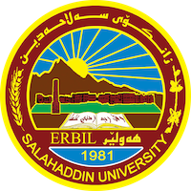
Academic Curriculum Vitae

Personal Information:
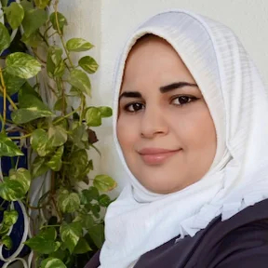
Full Name: Israa Mahmood Mohammed
Academic Title: lecturer
Email: (university email) israa.mohammed@su.edu.krd
Mobile: 07518703205

Education:
- Bachelor in biology, master in biology, zoology. PhD student now.

Employment:
- 2012(Asst. biologist) in biology dept., College of Education, Salahaddin University.
- 2017 Asst. lecturer in the same place.
- 2020 lecturer in the same place of work.

Qualifications
- Teaching qualifications: master degree in biology
- IT qualifications: ICDL
- Language qualifications IELTS 6, Toefl 503, language Centre courses ( intermediate level).
- Any professional qualification: teaching methods, First aids.

Teaching experience:
- State all teaching courses you delivered, stating undergraduate or post graduate
- Teaching methods, first aids, ICDL, language Centre courses.
- Research and publications
Publishing Research Papers:
1-The Protective Role of Omega-3 and Melatonin Against AlCl₃ Induced some Biochemical Changes in Albino Rats.

2-In vivo, Antibacterial Effect of Green and Black Tea Extracts on Infected Liver and Kidney of Rats.

3-The effect of schiff base [n-n(ethane-1,2-diyl) bis (1-phenyl
methanimine)] on pathogenic bacteria induced histological changes in rats liver and kidney.

4- Comparison of the Antimicrobial Efficacy of Green and Black Tea Extracts Against E.Coli: In Vitro and In Vivo Study.

5-The Ameliorative Effects of Omega-3, Melatonin and their
Combination Against Aluminum Chloride Induced Oxidative
Stress in Albino Rat Brain.

6- Publishing book:

- اسراء محمود محمد , رسائل بالمجان للعيش بأمان , 2020. اربيل

7-Physiological and Histopathological Studies on Bisphenol - A Induced Oxidative Stress in Albino Rats: Amelioration by Green and White Tea Extracts.
8- Effects of Aqueous Extract of Cumin Seed (Cuminum cyminum) on the Structure and Function of Albino Rat Kidneys Treated with Dibutyl Phthalate
9-Parastitic Fauna of some Fresh Water Fishes from Greater Zab river, Kurdistan region, Iraq. Israa M. Mohammad, Sarah F.Dhahir and Sami j. Bilal
Conferences and courses attended
- ICOBAS7 , I had presented a research in 2016 at CIHAN university, as well as I have attended many conferences and workshops.

Funding and academic awards
- no

Professional memberships
Professional Social Network Accounts:

- List your profile links of ReserchGate, LinkedIn, etc.

https://www.linkedin.com/in/israa-mohammed-1ab102161/?originalSubdomain=iq

https://www.researchgate.net/profile/Israa-Mohammed-4

https://scholar.google.com/citations?user=i3BzhscAAAAJ&hl=en

