Question 1.
Draw the energy band diagram for a p-type semiconductor.
Answer:
The energy level diagram is shown below.
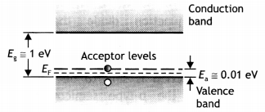
Question 2.
Draw the voltage-current characteristic of a p-n junction diode in forwarding bias and reverse bias.
Answer:
The characteristics are as shown.
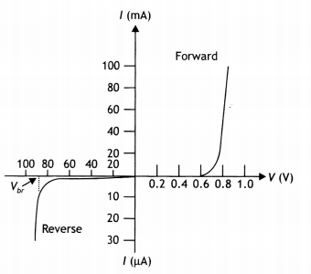

Question 4.
Draw the energy band diagram for n-type semiconductor.
Answer:
The diagram is as shown.
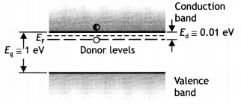
Question 6.
Give the ratio of the number of holes and the number of conduction electrons in an intrinsic semiconductor.
Answer:
The ratio is one.
Question 8.
Name an impurity which when added to pure silicon makes it a
(i) p-type semiconductor
Answer:
Boron, aluminum, etc.
(ii) n-type semiconductor.
Answer:
Phosphorous, antimony, etc.
Question 17.
Why is the conductivity of n-type semiconductors greater than that of p-type semiconductors even when both of these have the same level of doping?
Answer:
It is because in n-type the majority carriers are electrons, whereas in p-type they are holes. Electrons have greater mobility than holes.
Question 18.
How does the conductance of a semiconducting material change with rising in temperature?
Answer:
Increases with an increase in temperature.
Question 19.
How is a sample of an n-type semiconductor electrically neutral though it has an excess of negative charge carriers?
Answer:
It is because it contains an equal number of electrons and protons and is made by doping with a neutral impurity.

Question 4.
Draw the energy band diagrams of (i) n-type and (ii) p-type semiconductor at temperature T > 0 K.
In the case of n-type Si semiconductors, the donor energy level is slightly below the bottom of the conduction band, whereas in p-type semiconductors, the acceptor energy level is slightly above the top of the valence band. Explain what role do these energy levels play in conduction and valence bands. (CBSE AI 2015 C)
Answer:
For energy bands
(i) The energy level diagram is shown below.
(ii) The diagram is shown as
In the energy band diagram of n-type Si semiconductor, the donor energy level E_{A} is slightly below the bottom Ec of the conduction band and electrons from this level move into the conduction band with a very small supply of energy. At room temperature, most of the donor atoms get ionized but very few (-10-12) atoms of Si get ionized. So the conduction band will have most electrons coming from the donor impurities.
Similarly, for p-type semiconductors, the acceptor energy level E_{A} is slightly above the top E_{v} of the valence band. With the very small supply of energy, an electron from the valence band can jump to the level E_{A} and ionize the acceptor negatively. Alternately, we can also say that with a very small supply of energy, the hole from level EA sinks down into the valence band. Electrons rise up and holes fall down when they gain external energy.
Questio
Question 5.
Give reasons for the following:
(i) High reverse voltage does not appear across an LED.
Answer:
It is because the reverse breakdown voltage of LED is very low, i.e. nearly 5 V.
(ii) Sunlight is not always required for the working of a solar cell.
Answer:
Because solar cells can work with any light whose photon energy is more than the bandgap energy.
(iii) The electric field, of the junction of a Zener diode, is very high even for a small reverse bias voltage of about 5 V. (CBSE Delhi 2016C)
Answer:
The heavy doping of p and n sides of the p-n junction makes the depletion region very thin, hence for a small reverse bias voltage, the electric field is very high.

