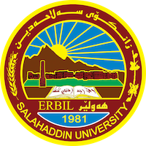
Academic Curriculum Vitae
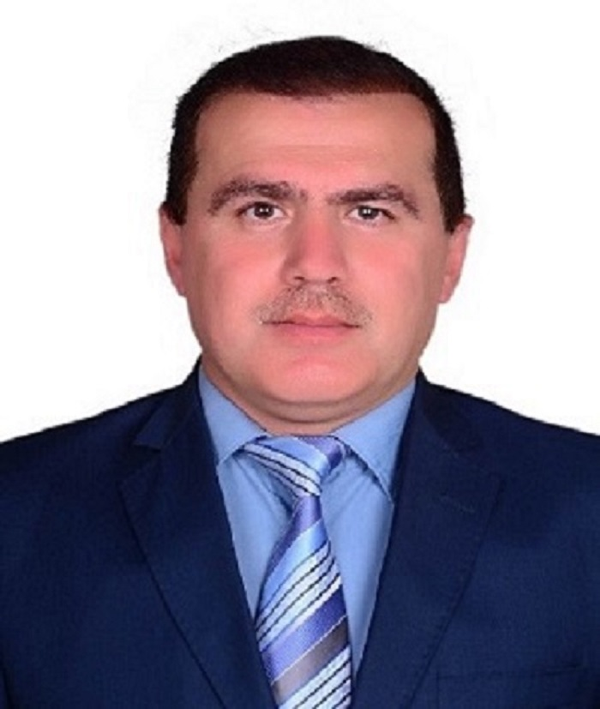
Personal Information:
Full Name: Dr. Jamal Anwer Yaba
Academic Title: Lecturer
Email: (University E-mail) jamal.yaba@su.edu.krd
Mobile: (+964)750 448 9748

Education:
No. | certificates | Graduated year | university | Granted country
1 | Bachelor of accounting | 1995 | Salahadin-Erbil | Iraq
2 | Master degree of accounting | 2006 | Salahadin-Erbil | Iraq
3 | PhD | 2020 | Salahadin-Erbil | Iraq

Employment:

1) Started as assistance lecturer at April.10, 2006 in Salahadin university college of Administration & Economic - Accounting Dep.
2) 2020-2024: Lecturer in Accounting department, College of Administration and Economic, University of Salahaddin – Erbil.

Qualifications
Teaching many subjects in accounting as Financial Accounting, Auditing, Governmental Accounting, Specialized Accounting/2, Unified Accounting System and other subjects.
- Using many skills of computer and Electronic Accounting system.
- Speak Kurdish, Arabic and English.
- Work as accounting adviser for many companies in Erbil for more than 11 years

Teaching experience:
- Teaching many accounting subjects and other topics Bachelor’s and postgraduate studies in the universities of the Kurdistan Region (Salah al-Din and Polytechnic) and the Higher Institute of Certified Public Accountants in Erbil.
- He supervised two postgraduate research studies for the Master’s degree and Chartered Accounting.
- Participation in many workshops and courses on international accounting standards and rules of professional conduct.

Research and publications:

No. | The name of the research | Magazine published
1 | Evaluating and Developing Governmental Accounting System in Iraqi Kurdistan Region | Master degree thesis  2005
2 | The gap in expectations between the external auditor’s report and the financial community in revealing creative accounting practices | Poly technique Journal  Vol 6/no. 2/2016
3 | The possibility of applying enhanced indicators to the  revised International Auditing Standard (ISA) 570 for  enterprise continuity audit | CPA Research  2019
4 | The impact of strategic audit dimensions in reducing cases of financial fraud | Zanko Journal of Human Sciences/vol 24/no. 2/2020
5 | The impact of strategic audit in mitigating the risk of corporate failure | PhD dissertation 2020
6 | The Effects of Computerized Accounting System on Auditing Process: a Case Study from Northern Iraq | Solid State Technology  Vol 63/issue 5/2021
7 | The importance of applying the requirements of INTOSAI reporting standards in developing audit reports for supreme audit bodies | Iraqi University Journal  Vol 50/issue 3/2021
8 | The role of the accounting disclosure of intellectual capital in maximizing the value of the company in the Iraqi business environment | Iraqi University Journal  558/53P1
9 | The Role of Voluntary Disclosure Content in Changing the  Behavior of Stakeholders Towards Commercial Banks | Qalai Zanist Scientific Journal
10 | The impact of adopting (IAS 8) accounting policies, changes in accounting estimates and errors on the financial performance | Tikrit Journal of Administrative and Economic Sciences

