1st Lecture Phycology 1
Assistant professor Janan Jabbar Toma 2nd class 2024
Definition of the Algae:
The term algae are derived from (Latin word-sea= weeds). The algae comprise of a large heterogeneous assemblage of micro and macro flowerless plants which are diverse in habitat. It is an important group of Thallophyta (Gr. Thalls (a sprout) and phyton (a green plant). The science of algal study is called Phycology (Gr. Seaweeds or phyco=green plant, logos= science
The Differences between Higher Plants and Algae:
- Sexual reproduction never occurs without water.
- In unicellular algae, the organisms themselves may act as gametes.
- In multicellular algae the gametes may produce in special containers called gametangia as in Oedogonium, or in unicellular and multicellular gametangia called plurilocular or unilocular sporangia as in Fucus or male and female conceptales as in Ectocarpus.
- Some of them are free-living prokaryotes or prokaryota organisms that have no nucleolus or nucleus sheath or cellular organization.
- Some algae produce flagellated spores (motile spores) or a flagellated one (non-motile spores).
- The algal body is thallus (gametophyte) which is not differentiated into roots, stems, leaves and is without vascular tissues. The Photosynthetic portion of the algae is a thallus, while the attached portion to the substrate comprises hair-like rhizoids. Therefore, old classification put algal flora into a grouping known as the Thallophyta.
- For most algae, sperm and eggs (male and female gametes) fusion in the water and the zygote develops into a new plant without any protection organ. While in higher plants, the zygote develops into an embryo remaining within the parent female plant. For these reason old classification systems, term all other plant groups Embryophytes.

1st Lecture Phycology 2
Assistant professor Janan Jabbar Toma 2nd class 2024

General Characteristics:
- Gametophyte or thallus (1n=1chromosome) is the dominant phase of the life cycle which is without roots, stems, and leaves.
- The plants are mostly aquatic. Therefore, sexual reproduction (fertilization and zygote formation) never occurs without water.
- A Zygote is sporophyte (2n=2 chromosomes) subdominant.
- A Zygote is without jackets (sterile organs or protects organs).
- Most algae are photosynthetic organisms possessing chlorophyll-a, -b, -c and -d, with alpha & beta carotene, leutin, violaxanthin, zeanithin and other accessory pigments.
- The algal cell wall is commonly in three layers made of cellulose, pectin, and chitin.
- Mainly reserve food material is of starch type.
- Zoospores or antherozoids and gametes are motile and flagellated.
- Male and female organs called antheridia (plural) antheridium (singular) and Oogonia (plural) and Oogonium (singular).
- All types of sexual reproduction occur among algae (isogamous, anisogeous, and Oogomous).
- Asexual reproduction occurs by vegetative parts, spore's formation as zoospore, aplanospore, endospore, exospores, auxospore, carpospores, androspore and other spores in addition to cysts, heterosystis, and akinetes.

Algal Habitats
Algae are abundant and ancient organisms that can be found in virtually every ecosystem in the biosphere. It is the main component of aquatic ecosystems like springs, streams, rivers, ponds, and lakes because they reflect the health of their environment through their abundance, distribution, and productivity.
The habitats of algae may be as follows: Planktonic: for (phytoplankton) or tychoplanktonic, the later is named as:

1st Lecture Phycology 3
Assistant professor Janan Jabbar Toma 2nd class 2024

Benthose (in the U.S.A.), Periphyton (in the UK), Auffwuches (in German language) all referred to as living underwater on the substrates as benthic that are divided into epilithic that attached to the rocks, epipelic attached to the muds or moist soil and epiphytic attached to the dead or/and living plant organs.
Algae are living in aquatic and terrestrial, sublittoral, intertidal habitats. Some of them are found living on moist soils and rocks in the water of streams like some species of Nostoc muscarm and N microspica found from Ahmad Iwa in Sulaimaniyah, Gally Zanta in Ikri district in Duhok and around Bekhal and Jundian spring in Erbil province.
Edaphic: living on the soil surface as terrestrial e.g. N. muscarum found near the main road between Bekhal spring and Ruwandiz town, Erbil province.

*The habitats may be as follows:
Endedaphic: living inside soil like Chroococcum
Epidaphic: living in moist soil like Chroococcus
Epilithic: living on rock surface like diatoms
Endolithic: living on rock penetration like diatoms
Hydrolithic: living in the lower surface of rocks like Hydrarus foetidus found near Joman-Azadi Bridge, Haji Omaran, and Erbil province
Chasmolithic: living in rock fissures as diatoms
Endophytic: living within another plant e.g. Nostoc in Anthoceros and Anabaena in Azola moss plant.
Epizoic attached to the animals as Chlorella living on Hydra.

* According to the lakes, the algal habitats divided into:-
Autotrophic algae: Living in water rich in nutrients
Oligotrophic algae: Living in a water medium in nutrients
Distrophic algae: Living in water poor in nutrients

1st Lecture Phycology 4
Assistant professor Janan Jabbar Toma 2nd class 2024

*According to water types algae are divided into:
- Freshwater algae 2. Brackish water algae 3. Salty water algae such as Ulva and Enteromorpha 4. Some algae living in sulfur springs as Formedium sp. Gleocapsa sp.

Algal Classification:
More recently algal flora has been classified on the basis of chlorophylls content. While, algae have traditionally been classified (Bold and Wynne, 1985) on the basis:
Pigments color
Chlorophyll types
Flagella apparatuses
Cell wall compositions
Storage foods
Cell organizations
Habitats
Plastids
Evolution and phylogeny
Therefore, algae with other green plants or with other organisms beastly classified in 1883 (Van den Hoek, et.al. 1997).
However, the position of algae and with respect to evolution represented as follows:
Sub Kingdome monera (prokaryota)
Bacteria (Shizomycophyta)
Cyanophyta (Cyanobacteria)
Sub Kingdome protesta or eukryota
Protozoa
Algae (Thallophyta)
Myxomycetes
1st Lecture Phycology 5
Assistant professor Janan Jabbar Toma 2nd class 2024

Subkingdom Plantae:
Bryophyte
Pteridophyta
Trachyeophyta
Phanerogamy
Gymnosperm
Angeosperm
Monocotyledonous
Dicotyledonous
Sub Kingdome (Animalia)

The classical classification of algae divided into 6-7 categories for example:
Division or (phylum): Thallophyte
Classes (Class): Chlorophyceae
(Order) : Volvocales
(Family): Chlamydomonaceae
Genus Chlamyomonas
Species Chlamydomonas sp
Variety and forms

Algal occurrence and classification:
Algae can be aquatic or subaerial when they are exposed to the atmosphere rather than being submerged in water. Aquatic algae are found almost anywhere from freshwater spring to salty lakes.

1st Lecture Phycology 6
Assistant professor Janan Jabbar Toma 2nd class 2024

Algal Forms (Bold and Wynne, 1985):

Unicellular Algae:
Unicellular forms of algae are also called cellular algae. They function or act as complete organisms. Unicellular forms are common groups of algae except for Rhodoohyceae, Phaeophyceae and Charophyceae. The unicells may be motile or non-motile. The motile unicells are either rhizopodial or flagellated.
The rhizopodial forms lack rigid cells and have cytoplasmic projections that help in amoeboid movement e.g. Chrysomoeba from (Chrysophyceae) and Rhizochloris from Xanthphyceae.
The flagellated unicells resemble the gametes and zoospores. The flagella are the organ of locomotion varying in number, type, length, and position. The flagellated cells are found in many groups of algae, e.g., Carteria and Chlamydomonas of Chlorophyceae and Euglena of Euglenophyceae… etc.
1. Unicellular motile algae: Chlamydomonas and Euglena (Figure 1).
2. Unicellular non-motile algae: Tetraedron, Protococcas. Chlorella,
Chroococcum (Figure 2).
The non-motile cells may be filament or colonial as found in Cyanophyceae. The coccoid unicellular algae are the simplest forms of algae found in Cyanophyceae and in Chlorophyceae, e.g. Gleocapsa and Oocystis. (Figure 3)
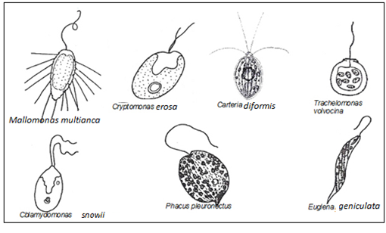
Figure 1: Unicellular motile algal forms

1st Lecture Phycology 7
Assistant professor Janan Jabbar Toma 2nd class 2024
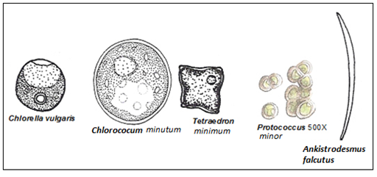
Figure 2: Nonmotile unicellular algae
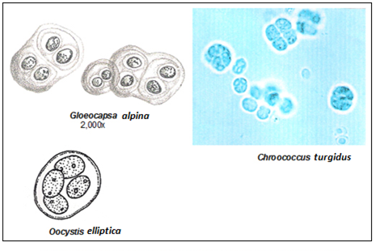
Figure 3: Non-motile colonial algal forms

