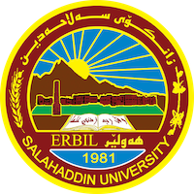
Academic Curriculum Vitae

Personal Information: 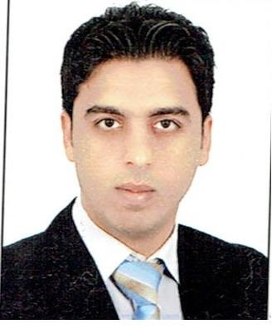

Full Name: Jange Zrar Khudhur
Academic Title: Assistant Lecturer
Email: (university email): jange.khudhur@su.edu.krd
Mobile: 07504771059

Education:
- Masters: Islamic Archaeology
- Undergraduate: Archaeology

Employment:
- University of Salahadin/ College of Arts/ Archaeology Department

Qualifications
- Masters: Archaeology
- Undergraduate: Archaeology

Teaching experience:
- Islamic art
Civilization of the Islamic East

Research and publications

1ـ قشڵەی قوشتەپە.
2- مسجد الصحابة ودوره في التنمية السياحية الاثرية في مدينة عقرة.

Conferences and courses attended

Funding and academic awards

Professional memberships

Professional Social Network Accounts:

- Research Gate: https://www.researchgate.net/signup.SignUpPublications.html
- Google Schooler: https://scholar.google.com/citations?user=eShLUbUAAAAJ&hl=en
- Facebook: https://www.facebook.com/jange.kurda
- LinkedIn: https://www.linkedin.com/onboarding/start/people-you-may-know/new/

