Academic Curriculum Vitae
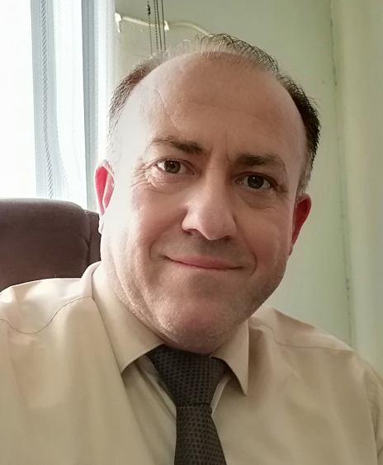
Personal Information:
Full Name: Jehad Shareef Kader
Academic Title: Lecturer
Email: (university email): jehad.kader@su.edu.krd
Mobile: 09647504051070

Education:
Degrees | Department | University | Country | Date of Completion
B.Sc. | Horticulture | Mosul | Mosul / Iraq | 1993 – 1994
Diploma | - | - | - | -
M.Sc. | Horticulture | Sulaimani | Kurdistan Region/ Iraq | 2008
Ph.D. | Horticulture | Mosul | Mosul / Iraq | 2016

Employment:
- From 2001 to 2005 I worked in (Grdarasha Field) affiliated to the college of agriculture/ University of Salahaddin – Erbil, Iraq.
- From 2005 to 2008 I was M.Sc. student at Horticulture Dept. / College of Agriculture / University of Sulaimany – Sulaimanyia, Iraq.
- Since 2008 as a Lecturer till 2011 at Horticulture Dept., College of Agriculture, University of Salahaddin – Erbil, Iraq.
- From 2011 till 2016, I awarded to study Ph.D. in college of agriculture/Mosul University, Mosul, Iraq.
- From 2017 until now I'm Head of Horticulture Department, college of agriculture/ University of Salahaddin – Erbil, Iraq.
- Currently I work full time as the head of the horticulture department at the college of agricultural engineering sciences/Salahaddin university – Erbil, Iraq.

Qualifications:
- Language qualifications
- I speak Kurdish and Arabic (excellent).
- I can speak English at an average level.

- Professional qualifications:
- Training course on Computer Learning / College of Agriculture, Salahaddin University- Erbil- Iraq /. 23th May - 2010.
- بةشداركردن لة ووركشوبي (بةربةستةكاني بةردةم ثيَشظةضووني كةرتي كشتوكالَ لة كوردستان) / زانكؤي ثؤليتةكنيكي هةوليَر وذووري بازرطاني وثيشةسازي هةوليَر ئةنجامدرا لة ريَكةوتي 19/2/2018.
- Learning Management System- Moodle/ research center, Salahaddin University- Erbil, Iraq. 22th to 23st April 2018.
- Teaching Method training/ Presidency of Salahaddin University 2010.
- Training course on: Monitoring and Implementing Drought Mitigation in Iraq on 27 – 29- March 2022.

Teaching experience:
Department | Stage | Course Teaching | No.
Horticulture | Undergraduate / First stage | Principle of Horticulture
Food Technology | Undergraduate / Fourth stage | Fruit and Vegetable Production
Horticulture | Undergraduate / Third stage | Deciduous Fruit Production-1
Horticulture | Undergraduate / Third stage | Deciduous Fruit Production-2
Horticulture | Undergraduate / Fourth stage | Evergreen Fruit Production
Horticulture | Undergraduate / Third stage | Organic Agriculture
Horticulture | Undergraduate / Fourth stage | Horticulture Seed Production
Horticulture | Undergraduate / Third stage | Pome and Stone Fruit Production
Horticulture | Undergraduate / Third stage | Nut and Miscellaneous Fruit Production
Horticulture Dep. /College of Agriculture Engineering Sciences/University of Salahaddin | Postgraduate/ M.Sc. | Organic Farming
Horticulture Dep. /College of Agriculture Engineering Sciences/University of Salahaddin | Postgraduate/ Higher Diploma | Deciduous Fruit
Horticulture/Technic college/Duhok University | Postgraduate/ M.Sc. | Adv. Nut Fruit Production
Horticulture/Technic college/Duhok University | Postgraduate/ Higher Diploma | Adv. Nut Fruit Production

Research and publications:
No | Research Title
 | Effect of some liquid organic fertilizers on growth and fruiting of apricot fruit trees "Prunus armeniaca L." cv. Royal
 | Effect of foliar application of Citric and Gibberellic acid (GA₃) on growth and fruiting of apricot fruit trees "Prunus armeniaca L." cv. Royal
 | Effect of Leaf Spray with Salicylic acid and Humic acid on some Growth and yield parameter of Apricot, (Prunus armeniaca L.) Royal CV.
 | Response of Pomegranate Trees cv. Sawa to Foliar Application with NPK Fertilizer and Licorice Root Extract
 | Study the Effect of Foliar Application of Gibberellic acid (GA₃) and Liquid Calcium on Growth and Fruit Quality on Pomegranate fruit trees (Punica granatum L.) var. Sawa

Conferences and courses attended:
2nd International Conference of Agricultural Sciences/ College of Agricultural Sciences/ University of Sulaimani – April 4th – 5th , 2018
The 2nd Scientific Agricultural Conference Duhok University
First International Conference of Agri Science 2019 , Salahddin University- Erbil Collage Of Agriculture Engineering Sciences 6th – 7th Nov. 2019
First International Conference of Agri Science 2019 , Salahddin University- Erbil Collage Of Agriculture Engineering Sciences 6th – 7th Nov. 2019

Professional Social Network Accounts:
Profile link | Social Account | No.
https://scholar.google.com/citations?hl=en&user=avVnTDoAAAAJ | Google Scholar
https://www.researchgate.net/profile/Jehad-Kader | ReserchGate
https://www.linkedin.com/in/d-jihad-sharef-709ba9b4?trk=public-profile-join-page | LinkedIn
https://orcid.org/0009-0008-1002-5718 | Orcid

Cover letter

Dear Professor
I am writing to apply for the position of assist. Professor at Salahaddin University- Erbil. Teaching has been my lifelong career, and I am excited to reach new heights in the field of education. As a dedicated researcher with a passion for knowledge and learning.
I have been lecturer in Horticulture Department/Agricultural Engineering Sciences College / Salahaddin University – Erbil since the past 7 years now, and I feel like I’m not going to grow in my career if I stay on the same post. I want to achieve more in my career and be more specialized in it the subject that I teach is “(Deciduous fruit production 1+2, Evergreen fruit production, Principles of Horticulture, Organic Farming, Horticulture Seed Production and Adv. Nut Fruit Production)” and moreover I carry a specialization in my subject (Pomology) as well. The only way I think is best for me to reach my goals is only if I get promoted to as assist. Professor.
That way I’ll be able to teach post Graduate students and grow much more in my field of specialization. Both as an educator and learner, my attention to detail has always been one of my strong points. As a professional, I feel it is my duty to ensure everything I do is done correctly and to the highest degree of excellence, reviewing lesson plans or collaborating with my peers to establish academic goals for the department. Naturally, this professionalism extends to the classroom where I endeavor to teach my students in engaging manner focused on ensuring that they understand the material for more than just passing a test.
Thank you for your time and consideration of my application. I hope that you will be kind enough to approve my promotion request and help me more in my future. Education is a constant factor of life, and I endeavor to partake in it both as a learner and educator and hope to continue applying my skills as a part of your university.
Yours Truly,

April / 7 / 2023
Lecturer Dr. Jehad Shareef Kader
Horticulture Department
University of Salahaddin
Mobile: 07504051070
Jehad.kader@su.edu.krd

