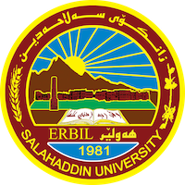
Academic Curriculum Vitae
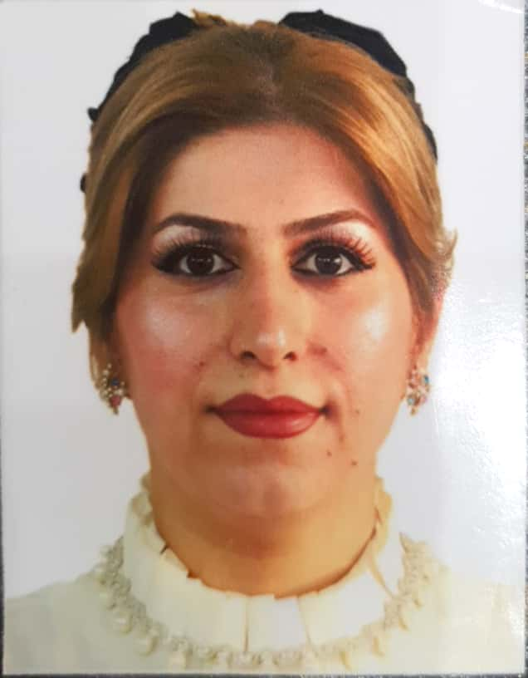
Personal Information:
Full Name: Jeyran Sabah Abdulla
Academic Title: Assistant lecture
Email: jeyran.abdulla@su.edu.krd
Mobile: 07504479815

Education:
- Bachelor in Education and Psychology (Sallahaddin University 2011-2012)
- Master's degree in Educational Psychology (Sallahaddin University 2017 )
- Ph.D. student until now ( Salahaddin University)

Employment:
- 2000- 2008 Editor in Kurdistan tv.
- 2008-2012 An employee in the Ministry of Finance.
- 2017-2018 An employee of an organization AESH (American Empowerment and human services.
- 2012-2020 Teaching Assistant
- 2023-2020 Assistant Lecturer, College of Education.

Qualifications
- 2000 Computer Course (Dos, Windows, Word) in Jihan Center.
- 2000 Computer Course (Photoshop, Premier, PowerPoint, Action, 3D Max, After Effect( in Kurdistan TV.
- 2006 Latin Language Course in Kurdistan TV.
- 2008 Leadership Course at a Cultural Center.
- 2011 English course at the (ITTC) center.
- 2011 Access course at the (ITTC) center.
- 2013 English course at the Language Center of Salahaddin University.
- 2017 teaching methods and research methodology at Salahaddin University.
- 2018 tips and techniques to maximize your IELTS score.
- 2020 Moodle platform workshop- EDU College of Education.

Teaching experience:
- in undergraduate students; Physiology Stage 1 - Educational Psychology Stage 2 - General Psychology Stage 1 - Developmental Psychology Stage 2 - School Counseling Stage 4 - Communication Psychology Stage 2 - Educational Foundations Stage 1 - Counseling Theories Stage 4 -
- Educational Research for Undergraduates.

Research and publications

Jeyran Sabah Abdulla , Prof. Omar Yasin Ibrahim, The level of psychological resilience of women with breast cancer in the center of Erbil Governorate, Journal of Raparin University, Vol. 11 No. 4 (29/8/2024)

Conferences and courses attended
- 2021; The Second International Scientific Conference held by the Faculty of Fine Arts, University of Qadisiyah.
- 29/11/2022; workshop (student project and research challenge (SPARC) Sallahaddin University - Erbil – Iraq
- 2022 ; The first joint Academic Scientific Symposium between the Department of Psychological and Educational Guidance in the College of Education, Sallahaddin University - Erbil – Iraq And University of Tikrit – Iraq .
- 4/12/2022 Impact Engineering Course, Egypt/ Via Zoom
- 25/12/2022; A training workshop entitled (success obstacles) In the Invest Your Time platform
- 17/12/2022; Training Session (Change Management) In the Invest Your Time platform
- 11/12/2022; Training Workshop (Risk and crisis management) In the Invest Your Time platform
- 16/12/2022; Training Session (The association of people with disabilities with healthy people)In the Invest Your Time platform
- 3/12/2022; Intellectual Workshop(The duality of the major powers in the war on terrorism)
- 9/12/2022; Training Workshop(Modern teaching strategies) Anbar – Iraq
- 20/12/2022; Workshop (Secrets of changing lives) In the Invest Your Time platform
- 23/12/2022; Training Workshop (Education and self-learning) In the Invest Your Time platform
- 11/12/2022 training meeting ) Family harmony(
- 13/12/2022 Training Workshop ) Emotional intelligence is the secret of satisfaction and understanding happiness(
- 23/12/2022 Workshop ) Causality in atomic vision and the thesis of the levels of the universe(
- 16/12/2022 Workshop ) Social order and social systems(
- 2/12/2022 Third Workshop (Social Construction is a Social Necessity)
- 11/12/2022 Training Course ) Successful Scholar Program(
- 8/12/2022 Training Workshop ) Artificial Intelligence Design in the Educational Environment(
- 10/12/2022 Workshop ) Practical application to brainstorming strategy(
- 6/12/2022 Training Workshop ) Effective Communication/Active Listening (
- 7/12/2022 Training Workshop ) Effective Communication/How to talk to my child (
- 8/12/2022 Training Workshop ) Building the child's brain in the first five years(
- 5/12/2022 Training Evening ) I'm close.(
- 15/12/2022 Training Workshop ) The art of dealing with children(
- 15/12/2022 training meeting)The art of dealing with characters(
- 22/12/2022 Workshop ) The art of dealing(
- 6/12/2022 Workshop ) How to start in the field of graphic design(
- 14/12/2022 Course (Data Journey in the World of Artificial Intelligence)
- 15/12/2022 Conference ) The future of brain research and education models(
- 3/12/2022 Workshop ) Scientific Research Reading Skills(
- 27/2/2022 Course ) Research plan writing skills for the purpose of acceptance(
- 19/12/2022 Course ) Advanced skills in building electronic questionnaires(
- 19/12/2022 Workshop ) Successful women who do not know failure(

Funding and academic awards

Professional memberships
- American Human Development and Services Organization
- Kurdistan Women's Union– Erbil- Iraq
- The Organization of Psychologists in Kurdistan– Erbil- Iraq
- World Youth Federation

Professional Social Network Accounts:
https://academics.su.edu.krd/jeyran.abdulla
https://www.researchgate.net/profile/Jeyran-Abdulla
https://scholar.google.com/citations?hl=en&user=0tgZh-AAAAAJ

