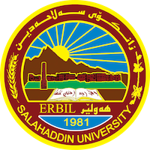
Academic Curriculum Vitae

Personal Information: 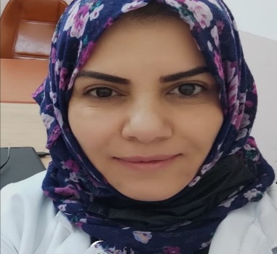

Full Name: Jian Lateif Hussein

Academic Title: Assist Professor

Email: (university email) jian.hussen@su.edu.krd
Mobile:0000000

Education:
- M.Sc. degree in medical chemistry, 2003, University of Tikrit, Iraq. (M.Sc. thesis / Sialic acid profile in diabetic Patients).
- Diploma in Laboratory Clinical Investigation,1999, University of Tikrit, Iraq .

- B.Sc. degree in chemistry/ 1994, University of Tikrit ,Iraq.
- M.Sc. degree in medical chemistry, 2003, University of Tikrit, Iraq. (M.Sc. thesis / Sialic acid profile in diabetic Patients).
- Diploma in Laboratory Clinical Investigation,1999, University of Tikrit, Iraq .

.

Employment:
- 2005-to present  - 2021-2023 | Lecturer at college of Science, Chemistry department, Salaheddin University  Lecturer at college of Science, MLS department, Knowledge University, Kurdistan-Region, Iraq
- 2003-2005  - 1994- 2003 | Assistant Lecturer at college of Medicine, Tikrit University, Tikrit, Iraq  Chemist at college of Medicine, Tikrit University, Tikrit, Iraq

Qualifications
- Teaching qualifications
- IT qualifications
- Language qualifications such as TOEFL, IELTS or any equivalent
- Any professional qualification
- You could put any professional courses you have attended

Teaching experience:
- 2005-2011  - 2011-2017  - 2018- 2023  - 2021-2023 | Stage 3 chemistry/biochemistry lab  Stage 2 biology/biochemistry lab, theory clinical chemistry stage 4 chemistry, Hormones stage 4 chemistry  Stage 3 chemistry/ theory biochemistry, clinical chemistry lab stage 4 chemistry  Clinical chemistry lab stage 4, MLS department, Knowledge University

Research and publications
- https://scholar.google.com/scholar?oi=bibs&cluster=14365312325026659444&btnI=1&hl=en
- https://scholar.google.com/citations?view_op=view_citation&hl=en&user=88xqUz8AAAAJ&citation_for_view=88xqUz8AAAAJ:9yKSN-GCB0IC
- https://scholar.google.com/citations?view_op=view_citation&hl=en&user=88xqUz8AAAAJ&citation_for_view=88xqUz8AAAAJ:d1gkVwhDpl0C
- https://scholar.google.com/citations?view_op=view_citation&hl=en&user=88xqUz8AAAAJ&citation_for_view=88xqUz8AAAAJ:UeHWp8X0CEIC
- https://scholar.google.com/citations?view_op=view_citation&hl=en&user=88xqUz8AAAAJ&citation_for_view=88xqUz8AAAAJ:IjCSPb-OGe4C
6.https://scholar.google.com/citations?view_op=view_citation&hl=en&user=88xqUz8AAAAJ&citation_for_view=88xqUz8AAAAJ:qjMakFHDy7sC
7. http://dx.doi.org/10.21271/ZJPAS.34.5.19
8. https://doi.org/10.21123/bsj.2022.7166
9. https://doi.org/10.32947/ajps.v23i3.1048

Conferences and courses attended
1.https://academics.su.edu.krd/public/profiles/jian.hussen/conference/conference-24-8933-1648755940-1.jpg
2. https://academics.su.edu.krd/public/profiles/jian.hussen/conference/conference-24-8926-1648475797-1.jpg
3. https://academics.su.edu.krd/public/profiles/jian.hussen/conference/conference-24-8927-1648476427-1.jpg

Funding and academic awards
- List any bursaries, scholarships, travel grants or other sources of funding that you were awarded for research projects or to attend meetings or conferences.

Professional memberships
- Member of Kurdistan Teachers union
- Member of chemistry Syndicate, Kurdistan -Region, Iraq
- Member of many committees for evaluation PhD student and MSc student’s theses.
- Head of examination committee of chemistry department for 7 years
- Member of many committees in chemistry department
- Member of health and safety committees in chemistry department for 3 years
- Organizer in workshops at the college of science, Salaheddin University

Professional Social Network Accounts:

Google Scholar
https://scholar.google.com/citations?hl=en&user=88xqUz8AAAAJ&view_op=list_works&gmla=AJsN-F6Tr0T1LiSt8pqKs-QxmPdJD0zrnxLbNgtcEOq5fFn6AtmC5yGrX1pXAZqthTyVAjWW4qU-GYl7ja009fVYg3Lnf0mvDg

3- Research gate link
https://www.researchgate.net/profile/Jian_Zangana

4-Linkedin
https://www.linkedin.com/in/jian-latief-b60331122
5.Orcid
https://orcid.org/0000-0001-6132-0719

