Course book of Biochemistry ( Practical)
For biology students, 2nd stage And 3 ^{rd} Chemistry students
2 hours in the week, 2023-2024
MSc. Jian Lateif Hussein
1. Course name | Theory Biochemistry
2. Lecturer in charge | Jian Lateif Hussein
3. Department/ College | Chemistry department / Science College
4. Contact | e-mail: jian.hussen@su.edu.krd
5. Time (in hours) per week | Practical biochemistry 2*14
6. Office hours | Mo 8.30:30-3:30 biochemistry Lab Biology  TH.8:30 – 5:00 Practical Biochemistry Lab /chemistry
8. Teacher's academic profile | High School:1989  BSc at 1994  Master degree at 2003
9. Keywords | Practical Biochemistry, Enzyme, Immobilization, Clinical
10. Course overview:
▪ The general aim of this course is to equip students with knowledge and skills to develop and understand principle of biochemistry and the methods which use in practical biochemistry.
- It is important to learn what is the practical biochemistry and its relation to their live.
-they will understanding the principle of carbohydrate, lipids , proteins, enzymes, Vitamins and many other techniques in practical biochemistry like electrophoresis, separation methods of protein, denaturation of protein and they will take Sufficient knowledge and understanding working in bio lab or clinical biochemistry lab in future in hospital or private biochemical lab.
11. Course objective:
After this course and Upon completing this course, students should understand the basic concepts and practices of contemporary experimental biochemistry. A successful student will learn how to keep a laboratory notebook and prepare laboratory reports in the style of a biochemical journal, and have practical experience in the fundamental biochemical techniques that would be expected of a student applying to quantities and qualitative experiments in carbohydrates, lipid, protein and enzymes. And some techniques form the foundation for many of the experiments of a contemporary biochemical research laboratory.
12. Student's obligation
- Lack of attendance and tardiness to class are unacceptable practices for laboratory courses. Obviously unforeseen events can lead to absenteeism and/or tardiness, but those instances are expected to be rare. So, please report to class on time! Due to limitations in support personnel and materials/supplies, opportunities to make up missed laboratory experiments will not be feasible. If a student is absent for any reason, he/she should email Dr. Peek and the teaching assistant as soon as possible. Late assignments will only be accepted at the discretion of the instructor. Typically prompt written documentation will be required to justify the acceptance of late assignments as a result of absenteeism.
- Weekly report:- The purpose of the laboratory report is to communicate experimental work in writing. The educational goal is to help students learn and practice expressing their ideas and describing their work in a professional manner.
- Homework assignments will be given to students.
-PROJECT PRESENTATION some time will done
- LABORATORY NOTEBOOK MAINTENANCE
All experimental data, except instrument output, should be recorded in indelible ink in a bound laboratory notebook with pre-printed sequential page numbers. θ Students should sign the notebook on the last page of that day’s experiment. θ Do not leave blank pages in a laboratory notebook. θ A lab notebook should include protocols, identification of samples, observations, and data. θ Record data and observations as you obtain or make them. Do not write on scraps of paper with the intention of transferring information to the lab notebook later. θ Do not worry if your notebook is a little messy. θ The recording and organization of a permanent record of laboratory observations is as important a technique to master as any of the experimental methods you learn. The research notebook is a day-by-day record of the progress of experimental work. It should reflect the integrity and honesty of the experimenter as well as the clarity of his or her thought.
-Examination:- there will be two exam in two course and at end it will be final exam
13. Forms of teaching
We use data show and white board
14. Assessment scheme
The overall grading is 15% and distribute as in this scheme for this course is as follows:
10 % 1st exam and
15% 2nd Examinations‌
40 Final exam
15. Student learning outcome:
Upon completing this course, students should understand the basic concepts and practices of contemporary experimental biochemistry. A successful student will learn how to keep a laboratory notebook and prepare laboratory reports in the style of a biochemical journal, and have practical experience in the fundamental biochemical techniques. Also they will learn how to do clinical test because it is important to their future work in hospital and bio lab.
16. Course Reading List and References‌:
▪ Key references: References
Biochemistry
Lubert Stryer
The foundation of Biochemistry
Lehninger
Text book of Biochemistry
Thomas M. Devlin
Illustrated Biochemistry
Harpers
Biochemisrty
Lippincotts

 |  | Lecturer's name
Jian Lateif Hussein
ex: (3hrs)

ئه‌م کۆرسبووکه‌ ده‌بێت له‌لایه‌ن هاوه‌ڵێکی ئه‌کادیمیه‌وه‌ سه‌یر بکرێت و ناوه‌ڕۆکی بابه‌ته‌کانی کۆرسه‌که‌ په‌سه‌ند بکات و جه‌ند ووشه‌یه‌ک بنووسێت له‌سه‌ر شیاوی ناوه‌ڕۆکی کۆرسه‌که و واژووی له‌سه‌ر بکات.
هاوه‌ڵ ئه‌و که‌سه‌یه‌ که‌ زانیاری هه‌بێت له‌سه‌ر کۆرسه‌که‌ و ده‌بیت پله‌ی زانستی له‌ مامۆستا که‌متر نه‌بێت.‌‌

Course Book
1. Course name | Practical Biochemistry
2. Lecturer in charge | Jian Lateif Hussein
3. Department/ College | Chemistry department / Science College
4. Contact | e-mail.jian.hussen@su.edu.krd  Tel: 00964-750-4553147
5. Time (in hours) per week | Practical: 2
6. Office hours | Su 9:00-1:00 Office hours  Mo 8.30-10.30 biochemistry theory . 11.30-1.30 biochemistry theory  Tu 9:30-10:30 biochemistry theory 12:30-1:30 biochemistry theory  We 2.30-5.30 Practical Biochemistry  Th. 8:30 – 5:00 Practical Biochemistry Lab
7. Course code
8. Teacher's academic profile | High School:1989  BSc at 1994  Master degree at 2003
9. Keywords | Practical Biochemistry, Enzyme, Immobilization, Clinical
10. Course overview:
▪ The general aim of this course is to equip students with knowledge and skills to develop and understand principle of biochemistry and the methods which use in practical biochemistry.
- It is important to learn what is the practical biochemistry and its relation to their live.
-they will understanding the principle of carbohydrate, lipids , proteins, enzymes, Vitamins and many other techniques in practical biochemistry like electrophoresis, separation methods of protein, denaturation of protein and they will take Sufficient knowledge and understanding working in bio lab or clinical biochemistry lab in future in hospital or private biochemical lab.
11. Course objective:
After this course and Upon completing this course, students should understand the basic concepts and practices of contemporary experimental biochemistry. A successful student will learn how to keep a laboratory notebook and prepare laboratory reports in the style of a biochemical journal, and have practical experience in the fundamental biochemical techniques that would be expected of a student applying to quantities and qualitative experiments in carbohydrates, lipid, protein and enzymes. And some techniques form the foundation for many of the experiments of a contemporary biochemical research laboratory.
12. Student's obligation
- Lack of attendance and tardiness to class are unacceptable practices for laboratory courses. Obviously unforeseen events can lead to absenteeism and/or tardiness, but those instances are expected to be rare. So, please report to class on time! Due to limitations in support personnel and materials/supplies, opportunities to make up missed laboratory experiments will not be feasible. If a student is absent for any reason, he/she should email Dr. Peek and the teaching assistant as soon as possible. Late assignments will only be accepted at the discretion of the instructor. Typically prompt written documentation will be required to justify the acceptance of late assignments as a result of absenteeism.
- Weekly report:- The purpose of the laboratory report is to communicate experimental work in writing. The educational goal is to help students learn and practice expressing their ideas and describing their work in a professional manner.
- Homework assignments will be given to students.
-PROJECT PRESENTATION some time will done
- LABORATORY NOTEBOOK MAINTENANCE
All experimental data, except instrument output, should be recorded in indelible ink in a bound laboratory notebook with pre-printed sequential page numbers. θ Students should sign the notebook on the last page of that day’s experiment. θ Do not leave blank pages in a laboratory notebook. θ A lab notebook should include protocols, identification of samples, observations, and data. θ Record data and observations as you obtain or make them. Do not write on scraps of paper with the intention of transferring information to the lab notebook later. θ Do not worry if your notebook is a little messy. θ The recording and organization of a permanent record of laboratory observations is as important a technique to master as any of the experimental methods you learn. The research notebook is a day-by-day record of the progress of experimental work. It should reflect the integrity and honesty of the experimenter as well as the clarity of his or her thought.
-Examination:- there will be two exam in two course and at end it will be final exam
13. Forms of teaching
We use data show and white board
14. Assessment scheme
The overall grading is 15% and distribute as in this scheme for this course is as follows:
1% Laboratory Reports
3% Laboratory Performance and Notebook Maintenance
1% Homework and quiz
5% tow Mid exam and
15% Final Examinations‌
15. Student learning outcome:
Upon completing this course, students should understand the basic concepts and practices of contemporary experimental biochemistry. A successful student will learn how to keep a laboratory notebook and prepare laboratory reports in the style of a biochemical journal, and have practical experience in the fundamental biochemical techniques. Also they will learn how to do clinical test because it is important to their future work in hospital and bio lab.
16. Course Reading List and References‌:
▪ Key references: Practical biochemistry, analytical biochemistry, enzymes. Clinical biochemistry
▪ Useful references: Analysis of Lipids practic detail
: analyticaltechniquesinbiochemistbyrajankatoch
▪ Magazines and review (internet): highwire press web site
The journal of biological chemistry
Enzyme journals

17. The Topics: |  | Lecturer's name
They are divided to the blocks  { B 1 } : Carbohydrates  1- Laboratory roles and safety………………………………..…..…………..1st week  2- Molisch,s test………………………………….………………………….…. 2nd week  3- Reactions of reducing sugars including………………………….....3rd week.  4- Test for individual carbohydrates including................................................................................... 4th week  5-The hydrolysis of polysaccharides…………………………………….. 5th week  6- identification of an unknown carbohydrate…………………..… 6th week  It is examination about the carbohydrates by using the scheme  { B2 } Chemical And physical properties of amino acids and proteins  Qualitative tests  1- The solubility of amino acids………………………………………….….7th week  2- Ninhydrin reaction  3- Xanthoproteic reaction………………………………………..………….. 8th week  4-The Biuret test for peptide bonds  5- Denaturation and Precipitation of portions including  5:1- by heat and Heavy metal ……………………………………………...9th week  5:2- by Precipitation of protein by ammonium sulfate ……….10th week  5:3- Denaturation of protein by organic solvents……………….. 11th week  ---------------------------------------------------------------------------------------- -{B 3 } : LIPIDS AND MEMBRANES  Qualitative tests for Lipids……………………………………..….……...12th week  1-The solubility of lipids  2-Grease test  3-Tests for unsaturated fatty acids  4-Tests for triacyl glycerol……………………………….…………………..13th week  5- Tests for cholesterol  1.Lieberman test  2. Salkowaski test  Quantitative Analysis of Lipids  1- The determination of the peroxide value of a fat …..……….14th week  1. Determine the rancidity in the fat  2. Determine the peroxide value in fat  2- The determination of the acid value of a fat……………………..15th week  Exam in the B1,B2,B3………..………………………………….…………...16th week  ----------------------------------------------------------------------------------------------  -{ B4 } : ENZYMES  1- Enzymes classification ……………………………..………………….….17th week  1. Catalase by using H2O2 which is act as substrate …..18th week  2. Peroxidase by using 4 amino antipyrine reagent ……..19th week  3. Polyphenol oxidase by using catechole ………………….20th week  2- factors affecting the rate of the enzyme activity  1:Temperature ……………………………...………………………………. 21th week  2: pH ………………………………………………………………………………..22th week  2: Substrate concentration…………………………….…………………23th week  3- Determination of ascorbic acid …...............................……..24th week  4- Dialysis and separation of large molecule ……………………. 25th week  5- electrophoresis ……………………………………………………………..26th week  -----------------------------------------------------------------------------------------  Clinical Chemistry Assay  -{ B5 }1. Blood chemistry sampling …………………………………... 27th week  2-urinary analysis ……………………………………………………. 28th week  Determination the element in the urine by the physical, chemical and microscopic analysis.  2. Determination of the blood sugar….....................……………29th week.  -{B6 }: liver function test including…….....................................30th week  1.T.protein  2. Bilirubin test  Lipid profile test .................................................................... 31th week  Total Cholesterol  Practical examination in general tests…………………………….…..32th week |  | Jian Lateif Hussein  ex: (3h)
18. Practical Topics (If there is any)
In this section The lecturer shall write titles of all practical topics he/she is going to give during the term. This also includes a brief description of the objectives of each topic, date and time of the lecture |  | Lecturer's name  ex: (3-4 hrs)  ex: 14/10/2015
19. Examinations:
1. Compositional: In this type of exam the questions usually starts with Explain how, What are the reasons for…?, Why…?, How….?
Q1) - Explain the following: (2 marks)
- Explain dialysis and its benefits.
A)- In biochemistry, dialysis is the process of separating molecules in solution by the difference in their rates of diffusion through a semipermeable membrane, such as dialysis tubing..
The benefits are to separation large molecules like protein or polysaccharides for purification.. Or desalting in protein purification steps. And Dialysis may be used for those with an acute disturbance in kidney function.
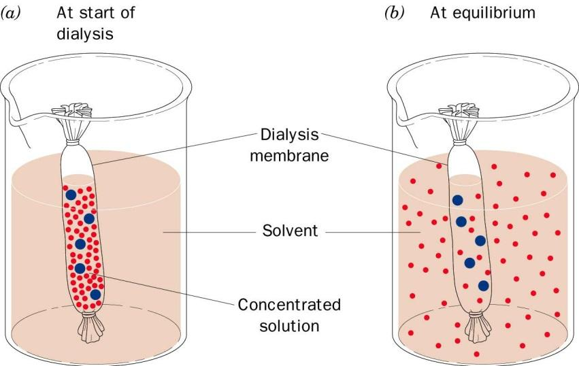
2. True or false type of exams:
In this type of exam a short sentence about a specific subject will be provided, and then students will comment on the trueness or falseness of this particular sentence. Examples should be provided
Q-) Place (+ve or –ve) for following chemical tests:
Name | Barfoed | Benedict | Seliwanoff’s | Bial
Galactose | + | + | - | -
Sucrose | - | - | + | -
Lactose | - | + | - | -
Fructose | + | + | + | -
Ribose | + | + | - | +

3- Complet following reactions:
Gly+Asp = Gly-asp
Protein + Pb⁺² = ppt. of protein
4- Compare between the following
Q- Slating in and salting out
A- 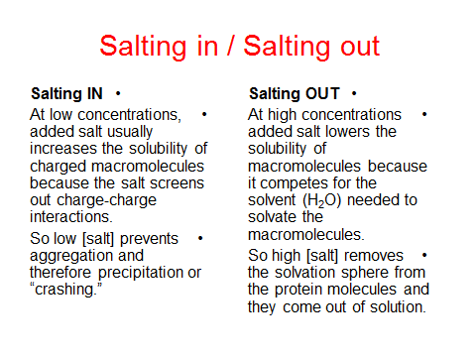

20. Extra notes:
The Academic Honor System of Iraqi is based on the premise that each student has the responsibility (1) to uphold the highest standards of academic integrity in the student's own work, (2) to refuse to tolerate violations of academic integrity in the University community, and (3) to foster a high sense of integrity and social responsibility on the part of the University community. This means that you will not give or receive information during an examination, nor will you consult unauthorized sources of information during an examination. Students should review the Academic Honor System outlined in the (الوقائع العراقية) Student Handbook. Violations of the Honor Code will not be tolerated and will result in zero points being awarded for the course work in question.

21. Peer review پێداچوونه‌وه‌ی هاوه‌ڵ
This course book has to be reviewed and signed by a peer. The peer approves the contents of your course book by writing few sentences in this section.
(A peer is person who has enough knowledge about the subject you are teaching, he/she has to be a professor, assistant professor, a lecturer or an expert in the field of your subject).
ئه‌م کۆرسبووکه‌ ده‌بێت له‌لایه‌ن هاوه‌ڵێکی ئه‌کادیمیه‌وه‌ سه‌یر بکرێت و ناوه‌ڕۆکی بابه‌ته‌کانی کۆرسه‌که‌ په‌سه‌ند بکات و جه‌ند ووشه‌یه‌ک بنووسێت له‌سه‌ر شیاوی ناوه‌ڕۆکی کۆرسه‌که و واژووی له‌سه‌ر بکات.
هاوه‌ڵ ئه‌و که‌سه‌یه‌ که‌ زانیاری هه‌بێت له‌سه‌ر کۆرسه‌که‌ و ده‌بیت پله‌ی زانستی له‌ مامۆستا که‌متر نه‌بێت.‌‌

