Monthly exam of poultry management /practice
College of veterinary medicine
First stage(2023)
Q1-Write name and function organs of the following(only 3 answer)3M
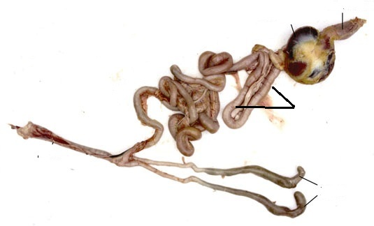

Q2-Enumerate avian respiratory system air sacs(3Marks)
Q3-Define incubation period and write types of incubation(3Marks)
Q4-Tempreture of the incubator should be 99.5-100 F˚ so low temperature than optimum degree for few hours make a big problem in hatching and lead to(3Marks)
A………………………………..
B…………………………………
C………………………………….
Q5-Talk about types of poultry farms.(3Marks)
Good luck
Assistant prof.
Dr. Jinan Najdat Abdulrahman

Monthly exam of poultry management /practice
College of veterinary medicine
First stage(2023)

Q1/Fill the blanks with suitable answer:(5 marks)
1-The embryo start to develop from------------------- .
2-What egg structure holds the yolk in the center by anchoring and supporting it ,is name--------------------- .
3-The egg white is actually called ------------------ .
4-Measure color of the shell by ----------------- method.
5-The normal thickness of the egg is ----------- mm.
Q2/Explain your answer on the following:(only 5 answer) (10 marks)
A-What is a local chicken ?
B-What are the components of a chicken egg?
C-What are the best breeds for egg purpose?
D-What are the five parts of the oviduct in poultry?
E-Description of meat –type chickens?
F-Enumerate the shape of comb and write one breed of each?

Good luck
Assistant lecturer
Dr.Ekhlas Salih Salim

