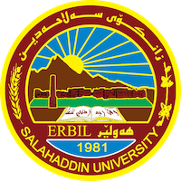

**Academic Curriculum Vitae**

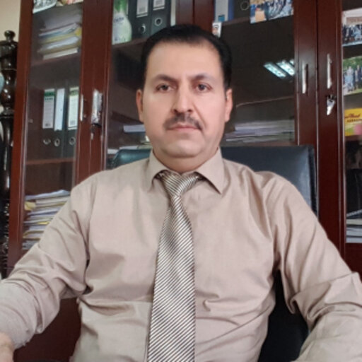

**Personal Information:**

Full Name: **Joshan Majeed Ahmed**

Academic Title: Assistant professor

Email: (university email): joshan.ahmed@su.edu.krd

Mobile: 00964 07504673272

**Education:**

|  |  |  |  |
| --- | --- | --- | --- |
| **Degree obtained** | **Name of institution** | **Year** | **Area of specialization** |
| Doctor of Philosophy | Salahaddin University-Erbil, Kurdistan Region, Iraq | 2020 | Dairy cattle |
| Master Degree | Salahaddin University-Erbil, Kurdistan Region, Iraq | 2008 | Dairy cattle |
| Bachelor Degree | University of Mosul, Iraq | 1989 | Animal Resources |

**Employment:**

|  |  |  |  |  |
| --- | --- | --- | --- | --- |
| ***Employer*** | ***Designation*** | ***Department*** | ***Start Date*** | ***Date Ended*** |
| Salahaddin University-Erbil, Kurdistan Region, Iraq | Assist Lecturer | Department of Animal Recourses , Collage of Agriculture | 2009 | 2014 |
| Salahaddin University-Erbil, Kurdistan Region, Iraq | Lecturer | Department of Animal Recourses , Collage of Agriculture | 2014 | 2022 |
| Salahaddin University-Erbil, Kurdistan Region, Iraq | Assist Prof. | Department of Animal Recourses , Collage of Agriculture | 2022 | Present |

**Qualifications**

* Teaching qualifications
* Language qualifications such as IELTS.
* Any professional qualification
* You could put any professional courses you have attended

**Teaching experience:**

|  |  |
| --- | --- |
| *Course title* | *Student’s program* |
| Dairy cattle | Bachelor of Agriculture (Animal Recourses) |
| Beef cattle production | Bachelor of Agriculture (Animal Recourses) |
| Academic skills | Bachelor of Agriculture (Animal Recourses) |

**Research and publications**

|  |  |  |  |  |  |  |
| --- | --- | --- | --- | --- | --- | --- |
| *No.* | *Name of author(s)* | *Year* | *Title of article* | *Title of journal* | *Vol. No.* | *Page No.* |
| 1 | Joshan Majeed Ahmed Hadad and Nawzad Mohammed Aziz | 2021 | Effect of Broccoli Stem and Leaves on Milk Production and it is Compositions in Cross Bread Frisian Dairy Cattle | Annals of R.S.C.B. | 25 | 1819 - 1825 |
| 2 | Joshan Majeed Ahmed Hadad | 2021 | An Economic Study of the Cost of Dairy Milk Production  In Erbil Governorate | Annals of R.S.C.B. | *25* | 10764-10768 |
| 3 | H. N. Hermiz and Joshan Majeed Ahmed Hadad | 2020 | FACTORS AFFECTING REPRODUCTIVE TRAITS IN SEVERAL BREEDS  OF DAIRY CATTLE IN IRAQ | Iraqi Journal of Agricultural Sciences | 51 | 1348-1354 |
| 4 | H. N. Hermiz and Joshan Majeed Ahmed Hadad | 2020 | Factors affecting and estimates of repeatability for milk production and  composition traits in several breeds of dairy cattle | Indian Journal of Animal Sciences | 90 | 129–133 |

**Professional Social Network Accounts:**

1. <https://www.researchgate.net/profile/Asistant-Prof-Drjoshan-Ahmed>
2. <https://scholar.google.com/citations?user=QhNGl6QAAAAJ&hl=en>
3. <https://orcid.org/0009-0002-8755-9087?lang=en>