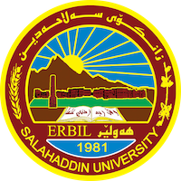
Academic Curriculum Vitae

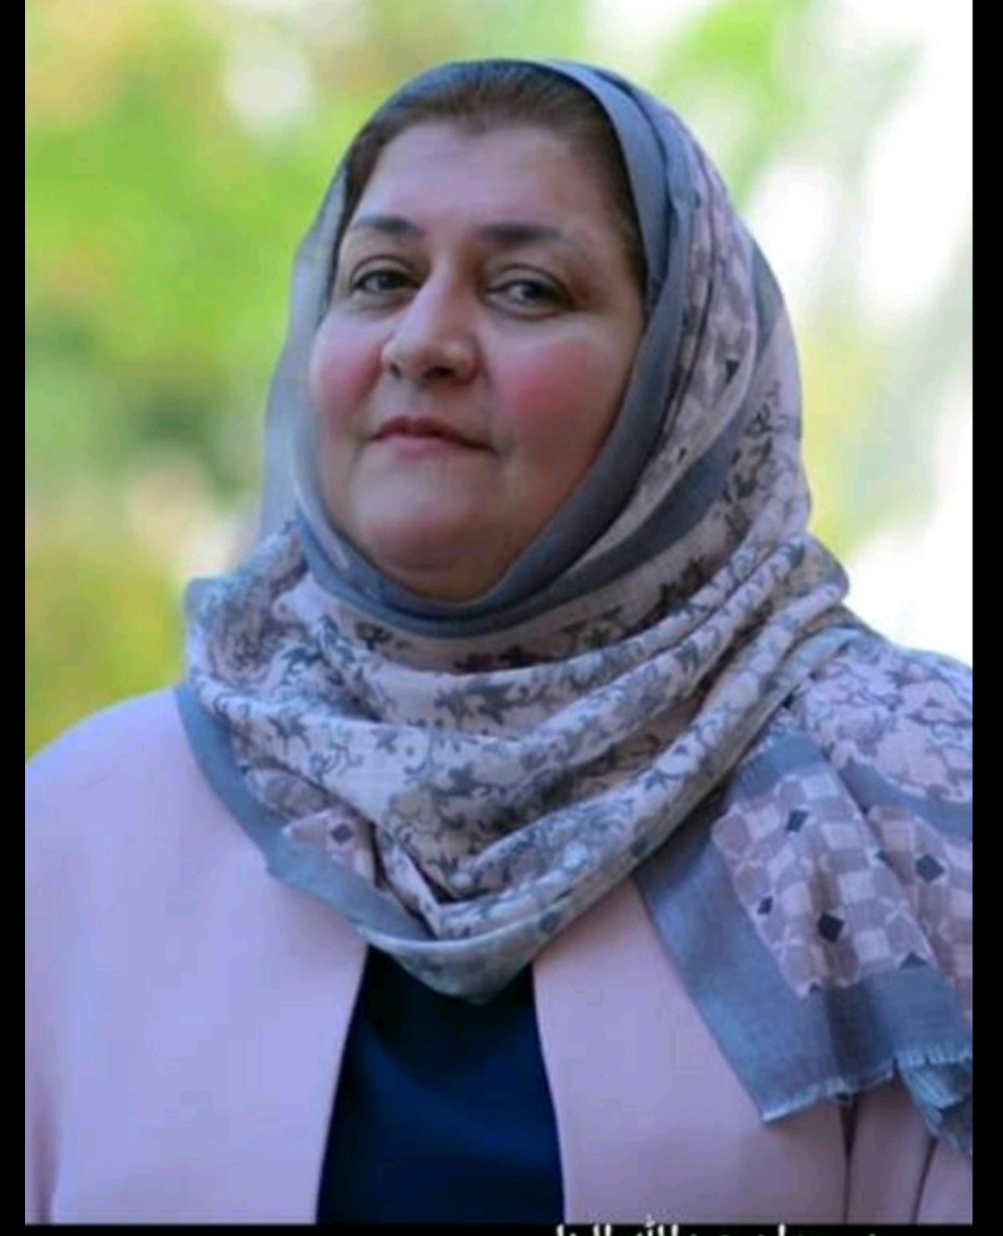
Personal Information:

Full Name: Juan Abdullah Ibrahim Al-Banna
Academic Title: Professor
Email: juan.ibrahim@su.edu.krd
Mobile: 07504753677

Education:
Bachelor Degree / Salahaddin University/ English Language and literature 1989-07-03
Master of Arts/ Baghdad University/ English Literature/ 1994-07-03
Doctor of Philosophy/ Koya University/ English Literature/2008-07-03
Employment:

Appointed as An Assistant Researcher in 1989 as a first of the college graduate of 86% average.
1989/ graduated from University of Salahaddin/ College of Arts/ English Department /Erbil
1994/ I have completed my MA degree in stylistics from Baghdad University/ college of Arts/E department/ Baghdad.
2007/ I have completed my PH. D in English Literature/ Modern Novel from Koya University/ College of Education/ English Department / Koya.
1994/ got the scientific title/ Assistant Instructor after my MA graduation from Baghdad University.
2002/ promoted to ( Instructor) by writing Two research papers entitled as:
1- Some linguistic Elements manipulated by Daniel Defoe in The Adventures of Robinson Crusoe.
2- The use of Personal Pronouns in Graham Green's The Heart of the Matter.
2012/ promoted to ( Assistant Professor) after presenting the following research papers:

1- PH. D dissertation entitled as: Twentieth Century Women's Autobiographical novels : a study of Virginia Woolf's To the lighthouse and Sylvia Plath's The Bell Jar. As an original research. Published in Koya University/ college of Education /English department.
2- Horror signs in Stephen King's The Shining. Published in Arts magazine in Baghdad university/ college of Arts.
3-Life and Death in Philip Larkin's Poetry. Published in Al-Ustath magazine in Baghdad University/ College of education / Ibn Rushd.
In 2001 I have taken a post as a manager of Academic relations in the presidency of Salahaddin University .
I have written two more researches one is entitled as Conflicted Female Modernism in Rose Macaulay's Non- Combatants and Others. It is published in Al- Mansura University/ College of Arts/ in Egypt. The other research is published in Al-Adab journal.It is entitled as Experimentalism in Hilda Doolittle's HERmione.

During these year I have published Four (4) more papers one abroad in Zielona Gora, 28-1-2015 entitled as Cultural and political impact on modern Kurdish poetry in Erbil. The other 3 papers are published in Baghdad university journals. The following file is a detailed description of my Academic Achievement of this year.
Last year I was responsible for Higher Studies Department in our College ( College of Languages) I have presented 10 research papers for Professorship in my specialization, 20th century British and American women’s autobiographical writings of Virginia Woolf and Sylvia Plath.
This year I have received an acceptance for publishing a research paper in Polytechnic university about Critical Thinking.

I have supervised two MA Students and now I am a supervisor of Two PHD students.
Now I am editor in Zanko Journal for humanities in our Salahaddin university.

Appointed as Assistant Researcher at college of Arts/ Salahaddin University/ English Dept/ 10/10/1989
Worked as a manager of Academic relations, in the presidency of Salahaddin Universiy/2001
Worked as a manager of Higher Studies Dept. At the College of Languages/ Deanery Dept.2015.
Now I am a member of Editorial Dept. of Zanco Journal for Humanities from 2018 and continuing.

Qualifications
- Promoted to Assistant Lecturer at College of Arts/ English Dept. 1994-01-01
- Promoted to Lecturer at College of Arts/ English Dept.2002-01-01
- Promoted to Assistant Professor at College of Arts/ English Dept. 2012-01-01
- Promoted to professor at College of Languages/ English Dept. 2022-29-5
- Got an IT certificate from college of Languages/ IT Dept.
- Turkish Language qualification.

Teaching experience:
I taught Bachelor degree students from 1989 till last year. In 1989, I taught first year Arabic Dept. a course in English Language for non-Departmental part. At the same time started to each for 27 hours weekly on various topics but basically I am specialized in Novel. So I taught second year students of English Dept., a course in 18th century novel, and Victorian Novel for third Year students, and Modern Novel for Fourth Year Novel. I also taught third year Students a course in Victorian Poetry.
I taught Drama for second year students in the college of Education English Dept.

I taught MA students the following courses, Studies in Modern Novel, The rise of the Novel, Modern British Novel, Modern American Novel.
I taught PhD Students courses in Literary criticism, Modern British Novel, Modern American Novel, Studies in Gender, Gender of Modernism.
Research and publications
1-2021
173
Vol.25, No.3, 2021
Mental Health in John Green’s Turtles All the Way Down
ID No.3852
(PP 173 - 182)
https://doi.org/10.21271/zjhs.25.3.11
Juan Abdullah Ibrahim Khadeeja Saeed Ismail
2-The Construction of Identity in Zadie Smith’s White Teeth
ID No.2976
(PP 330 - 342)
https://doi.org/10.21271/zjhs.23.5.18
Banaz Wirya Ali Juan Abdulla Ibrahim

3- Al-Adab Journal – Issue no (2) Vol. (143) (December) 2022 / 1444
Reading Trauma in Antonia White’s Confessional Autobiographical
Novels
Asst. Prof. Juan Abdullah Ibrahim (Phd.)
Salahaddin University-Erbil, College of Languages,
English Department, Iraq / Erbil
juan.ibrahim@su.edu.krd
DOI: https://doi.org/10.31973/aj.v2i143.3749
4- Loss and Nostalgia in Willa Cather's trilogy: O Pioneers! ,The Song of the lark and My Antonia.
Asst. Prof Dr. Juan Abdullah Ibrahim Al-Banna
Dept. of English. College of Languages
Salahaddin University/Erbil
banaali_juan@yahoo.com
published in Babel Journal.
5-Journal of Positive School Psychology
http://journalppw.com
2022, Vol. 6, No. 4, 9171 – 9178
Restless Female Ambition in Selected Autobiographical novels
of Rebecca West
1JUAN ABDULLAH IBRAHIM
1College of Languages, Department of English, Salahaddin University, Iraq/Erbil, juan.ibrahim@su.edu.krd
(https://www.journalppw.com/index.php/jpsp/article/view/5635/3708)
6-3029
307
Vol. 23 , No. 3, 2019
Neither Black nor White: A New Approach to the Modern Racial Plight in
Jean Toomer’s Cane
ID No. 2534
(PP 307 - 316)
https://doi.org/10.21271/zjhs.23.3.18
Juan Abdullah Ibrahim
Khadeeja Saeed Ismail
English Department- College of Languages. Salahaddin University.
7- Koya University Journal of Humanities and Social Sciences (KUJHSS)
Original Article |DOI: https://doi.org/10.14500/kujhss.v3n1y2020.pp94-101
Modernity, Mass Culture, and Self-Delusion in
Nabokov’s Lolita and Martin Amis’ Money
8- International Journal of Psychosocial Rehabilitation, Vol. 24, Issue 06, 2020
ISSN: 1475-7192
William Faulkner as an Experimental, modern
novelist in as I lay Dying (1930)
1Dr Juan Abdulla Ibrahim

9- Modernism in Antonia White’s Confessional Autobiographical Narratives: A study of Woman’s Life in Twentieth Century

Juan Abdullah Ibrahim
College of Languages-Department of English/ Salahaddin University-Erbil
Juan.ibrahim@su.edu.krd

10- Experimentalism In Hilda Doolittle's HERmione
Dr. Juan Abdullah Ibrahim Al-Banna
Asst. Professor
Dept. of English. College of Languages
Salahaddin University/Erbil
banaali_juan@yahoo.com

11-
Silence and Suffering in Jean Rhys Wide Sargasso Sea (1966) and Good Morning , Midnight (1967)

Asst. Prof Dr. Juan Abdullah Ibrahim Al-Banna
Dept. of English. College of Languages
Salahaddin University/Erbil
banaali_juan@yahoo.com

12- International Journal of Psychosocial Rehabilitation, Vol. 24, Issue 06, 2020
ISSN: 1475-7192
Received: 22 Feb 2020 | Revised: 13 Mar 2020 | Accepted: 05 Apr 2020
7376
POSTMODERNISM IN ANGELA
CARTER’S NOVELS: THE BLOODY
CHAMBER (1979) AND NIGHTS AT THE
CIRCUS (1984)
1Dr. Juan Abdullah Ibrahim

13- An unconventional narrative approach in Gertrude Stein's Avant Garde works Three Lives, Tender Buttons and The Making of Americans.

Conferences and courses attended
A joint conference between Salahaddin University & CinCinnatti American University in Erbil. 2012

A conference in Malatya/Turkey/ Inonu University with a research paper. 2015
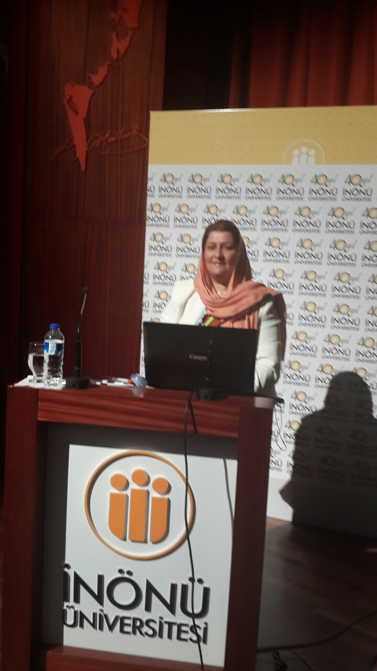

A conference of Poly technic university/ Erbil with a research paper. 17-18/ May /2017
A conference with Ishik University / Erbil 2017
With many certificates from the above mentioned universities
A book and a certificate of thanks from the head of the Quality Assurance for getting higher marks concerning scientific issues, students feedbacks and continuous scientific issues .

Many book of thanks from the President of the university of Salahaddin , as a responsible for higher studies in the college of languages 2016/2017.And as an editor in Zanco journal for humanities. And participated in many scientific committees in the presidency of Salahaddin University and the college of languagesas well.

I have attended a conference in Turkey , Malatya, Inonu University and presented a research paper.

I have also attended a joint conference between our university by video conference and
- Give details of any conferences you have attended, and those at which you have presented delivered poster presentations.

Funding and academic awards
- List any bursaries, scholarships, travel grants or other sources of funding that you were awarded for research projects or to attend meetings or conferences.

Professional memberships
- List any membership you hold of any professional body or learned society relevant to your research or other life activities.

Professional Social Network Accounts:

- List your profile links of ReserchGate, LinkedIn, etc.

It is also recommended to create an academic cover letter for your CV, for further information about the cover letter, please visit below link:
https://career-advice.jobs.ac.uk/cv-and-cover-letter-advice/academic-cover-letter/

