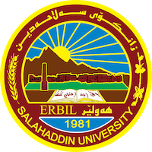
Academic Curriculum Vitae

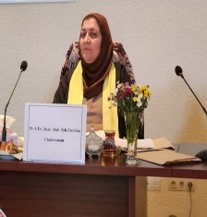

Personal Information:

Full Name: Juan Abdullah Ibrahim Al-Banna
Academic Title: Professor
Email: juan.ibrahim@su.edu.krd
Mobile: 07504753677

Education:
Bachelor Degree / Salahaddin University/ English Language and literature 1989-07-03
Master of Arts/ Baghdad University/ English Literature/ 1994-07-03
Doctor of Philosophy/ Koya University/ English Literature/2008-07-03
Employment:

Appointed as An Assistant Researcher in 1989 as a first of the college graduate of 86% average.
1989/ graduated from University of Salahaddin/ College of Arts/ English Department /Erbil
1994/ I have completed my MA degree in stylistics from Baghdad University/ college of Arts/E department/ Baghdad.
2007/ I have completed my PH. D in English Literature/ Modern Novel from Koya University/ College of Education/ English Department / Koya.
1994/ got the scientific title/ Assistant Instructor after my MA graduation from Baghdad University.
2002/ promoted to ( Instructor) by writing Two research papers entitled as:
1- Some linguistic Elements manipulated by Daniel Defoe in The Adventures of Robinson Crusoe.
2- The use of Personal Pronouns in Graham Green's The Heart of the Matter.
2012/ promoted to ( Assistant Professor) after presenting the following research papers:

1- PH. D dissertation entitled as: Twentieth Century Women's Autobiographical novels : a study of Virginia Woolf's To the lighthouse and Sylvia Plath's The Bell Jar. As an original research. Published in Koya University/ college of Education /English department.
2- Horror signs in Stephen King's The Shining. Published in Arts magazine in Baghdad university/ college of Arts.
3-Life and Death in Philip Larkin's Poetry. Published in Al-Ustath magazine in Baghdad University/ College of education / Ibn Rushd.
In 2001 I have taken a post as a manager of Academic relations in the presidency of Salahaddin University .
I have written two more researches one is entitled as Conflicted Female Modernism in Rose Macaulay's Non- Combatants and Others. It is published in Al- Mansura University/ College of Arts/ in Egypt. The other research is published in Al-Adab journal.It is entitled as Experimentalism in Hilda Doolittle's HERmione.

During these year I have published Four (4) more papers one abroad in Zielona Gora, 28-1-2015 entitled as Cultural and political impact on modern Kurdish poetry in Erbil. The other 3 papers are published in Baghdad university journals. The following file is a detailed description of my Academic Achievement of this year.
Last year I was responsible for Higher Studies Department in our College ( College of Languages) I have presented 10 research papers for Professorship in my specialization, 20th century British and American women’s autobiographical writings of Virginia Woolf and Sylvia Plath.
This year I have received an acceptance for publishing a research paper in Polytechnic university about Critical Thinking.

I have supervised two MA Students and now I am a supervisor of Two PHD students.
Now I am editor in Zanko Journal for humanities in our Salahaddin university.

Appointed as Assistant Researcher at college of Arts/ Salahaddin University/ English Dept/ 10/10/1989
Worked as a manager of Academic relations, in the presidency of Salahaddin Universiy/2001
Worked as a manager of Higher Studies Dept. At the College of Languages/ Deanery Dept.2015.
Now I am a member of Editorial Dept. of Zanco Journal for Humanities from 2018 and continuing.

Qualifications
- Promoted to Assistant Lecturer at College of Arts/ English Dept. 1994-01-01
- Promoted to Lecturer at College of Arts/ English Dept.2002-01-01
- Promoted to Assistant Professor at College of Arts/ English Dept. 2012-01-01
- Promoted to professor at College of Languages/ English Dept. 2022-29-5
- Got an IT certificate from college of Languages/ IT Dept.
- Turkish Language qualification.

Teaching experience:
I taught Bachelor degree students from 1989 till last year. In 1989, I taught first year Arabic Dept. a course in English Language for non-Departmental part. At the same time started to each for 27 hours weekly on various topics but basically I am specialized in Novel. So I taught second year students of English Dept., a course in 18th century novel, and Victorian Novel for third Year students, and Modern Novel for Fourth Year Novel. I also taught third year Students a course in Victorian Poetry.
I taught Drama for second year students in the college of Education English Dept.

I taught MA students the following courses, Studies in Modern Novel, The rise of the Novel, Modern British Novel, Modern American Novel.
I taught PhD Students courses in Literary criticism, Modern British Novel, Modern American Novel, Studies in Gender, Gender of Modernism.
Research and publications
1-2021
173
Vol.25, No.3, 2021
Mental Health in John Green’s Turtles All the Way Down
ID No.3852
(PP 173 - 182)
https://doi.org/10.21271/zjhs.25.3.11
Juan Abdullah Ibrahim Khadeeja Saeed Ismail
2-The Construction of Identity in Zadie Smith’s White Teeth
ID No.2976
(PP 330 - 342)
https://doi.org/10.21271/zjhs.23.5.18
Banaz Wirya Ali Juan Abdulla Ibrahim

3- Al-Adab Journal – Issue no (2) Vol. (143) (December) 2022 / 1444
Reading Trauma in Antonia White’s Confessional Autobiographical
Novels
Asst. Prof. Juan Abdullah Ibrahim (Phd.)
Salahaddin University-Erbil, College of Languages,
English Department, Iraq / Erbil
juan.ibrahim@su.edu.krd
DOI: https://doi.org/10.31973/aj.v2i143.3749
4- Loss and Nostalgia in Willa Cather's trilogy: O Pioneers! ,The Song of the lark and My Antonia.
Asst. Prof Dr. Juan Abdullah Ibrahim Al-Banna
Dept. of English. College of Languages
Salahaddin University/Erbil
banaali_juan@yahoo.com
published in Babel Journal.
5-Journal of Positive School Psychology
http://journalppw.com
2022, Vol. 6, No. 4, 9171 – 9178
Restless Female Ambition in Selected Autobiographical novels
of Rebecca West
1JUAN ABDULLAH IBRAHIM
1College of Languages, Department of English, Salahaddin University, Iraq/Erbil, juan.ibrahim@su.edu.krd
(https://www.journalppw.com/index.php/jpsp/article/view/5635/3708)
6-3029
307
Vol. 23 , No. 3, 2019
Neither Black nor White: A New Approach to the Modern Racial Plight in
Jean Toomer’s Cane
ID No. 2534
(PP 307 - 316)
https://doi.org/10.21271/zjhs.23.3.18
Juan Abdullah Ibrahim
Khadeeja Saeed Ismail
English Department- College of Languages. Salahaddin University.
7- Koya University Journal of Humanities and Social Sciences (KUJHSS)
Original Article |DOI: https://doi.org/10.14500/kujhss.v3n1y2020.pp94-101
Modernity, Mass Culture, and Self-Delusion in
Nabokov’s Lolita and Martin Amis’ Money
8- International Journal of Psychosocial Rehabilitation, Vol. 24, Issue 06, 2020
ISSN: 1475-7192
William Faulkner as an Experimental, modern
novelist in as I lay Dying (1930)
1Dr Juan Abdulla Ibrahim

9- Modernism in Antonia White’s Confessional Autobiographical Narratives: A study of Woman’s Life in Twentieth Century

Juan Abdullah Ibrahim
College of Languages-Department of English/ Salahaddin University-Erbil
Juan.ibrahim@su.edu.krd

10- Experimentalism In Hilda Doolittle's HERmione
Dr. Juan Abdullah Ibrahim Al-Banna
Asst. Professor
Dept. of English. College of Languages
Salahaddin University/Erbil
banaali_juan@yahoo.com

11-
Silence and Suffering in Jean Rhys Wide Sargasso Sea (1966) and Good Morning , Midnight (1967)

Asst. Prof Dr. Juan Abdullah Ibrahim Al-Banna
Dept. of English. College of Languages
Salahaddin University/Erbil
banaali_juan@yahoo.com

12- International Journal of Psychosocial Rehabilitation, Vol. 24, Issue 06, 2020
ISSN: 1475-7192
Received: 22 Feb 2020 | Revised: 13 Mar 2020 | Accepted: 05 Apr 2020
7376
POSTMODERNISM IN ANGELA
CARTER’S NOVELS: THE BLOODY
CHAMBER (1979) AND NIGHTS AT THE
CIRCUS (1984)
1Dr. Juan Abdullah Ibrahim

13- An unconventional narrative approach in Gertrude Stein's Avant Garde works Three Lives, Tender Buttons and The Making of Americans.

Conferences and courses attended
A joint conference between Salahaddin University & CinCinnatti American University in Erbil. 2012

A conference in Malatya/Turkey/ Inonu University with a research paper. 2015
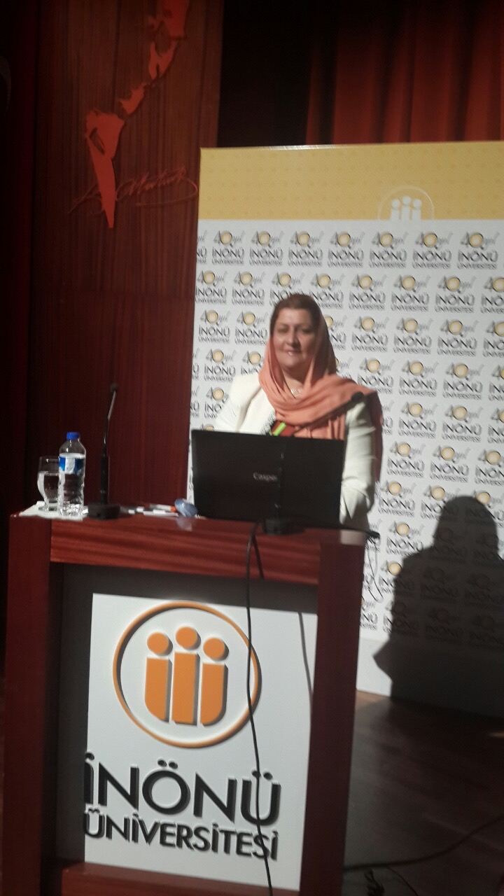

A conference of Poly technic university/ Erbil with a research paper. 17-18/ May /2017
A conference with Ishik University / Erbil 2017
With many certificates from the above mentioned universities
A book and a certificate of thanks from the head of the Quality Assurance for getting higher marks concerning scientific issues, students feedbacks and continuous scientific issues .

Many book of thanks from the President of the university of Salahaddin , as a responsible for higher studies in the college of languages 2016/2017.And as an editor in Zanco journal for humanities. And participated in many scientific committees in the presidency of Salahaddin University and the college of languagesas well.

I have attended a conference in Turkey , Malatya, Inonu University and presented a research paper.

I have also attended a joint conference between our university by video conference and
- Give details of any conferences you have attended, and those at which you have presented delivered poster presentations.

Funding and academic awards
- List any bursaries, scholarships, travel grants or other sources of funding that you were awarded for research projects or to attend meetings or conferences.

Professional memberships
- List any membership you hold of any professional body or learned society relevant to your research or other life activities.

Professional Social Network Accounts:
https://www.researchgate.net/profile/Juan-Ibrahim-2/unconfirmed
https://orcid.org/0000-0002-9623-0868
https://scholar.google.com/citations?user=b-wF8ggAAAAJ&hl=en

