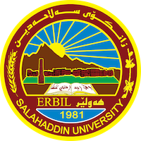
Academic Curriculum Vitae
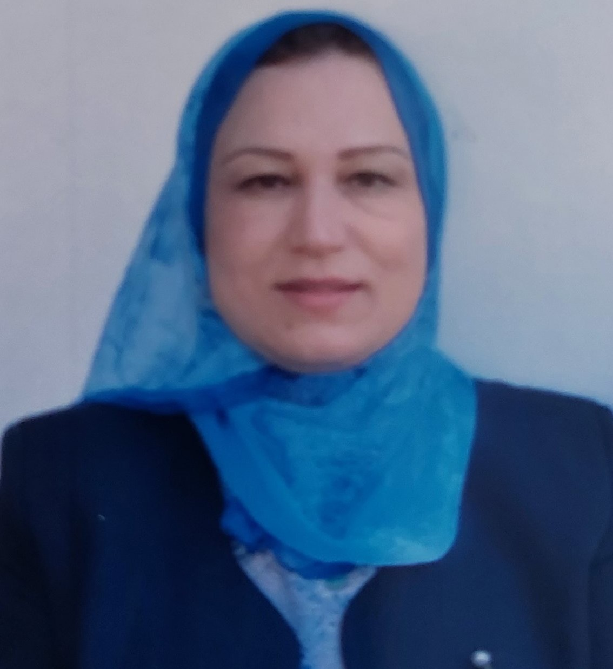
Personal Information:
Full Name:jwan zrar fathulall
Academic Title: leactrer
Email: jwan.fathulall@su.edu.krd
Mobile: 07504811699

Education:
In 1992-1993, Bachelor's degree in physical Education from Salahaddin University.
- In 2000, received Master's degree in physical Education from Salahaddin University.
-In 2010, received (ph.d. ) degree in physical education from Salahaddin University.

Employment:
Department of physical education and sport sciences of education collgge in salahaddin university in 1993
Qualifications
- Teaching qualifications:doctor of philosophy/history and philosophy of physical education
- IT qualifications : Electronic programs required by my college work
- Language qualifications such as TOEFL, IELTS or any equivalent: nothing
- Any professional qualification:
- You could put any professional courses you have attended

Teaching experience:
- State all teaching courses you delivered, stating undergraduate or post graduate
Courses, trainings, lab supervision, e

Research and publications

State all researches, publication you made.
- فلسفة وتاريخ التربية الكشفية ودورها في التنمية الشاملة للنشئ والمجتمع
- مقارنة الاتجاهات الفلسفية السائدة لدى بعض مدرسي الالعاب الفردية والجماعية في كليات وسكول التربية التربية البدنية وعلوم الرياضة في اقليم كوردستان- العراق

Conferences and courses attended
- Give details of any conferences you have attended, and those at which you have presented delivered poster presentations.
- I have attended research conferences in Antalya, Turkey
- making the olympic champion and caing for the gifted......a future vision in duhok-iraq
-لبحث العلمي والتحديات المعاصر
Funding and academic awards
- List any bursaries, scholarships, travel grants or other sources of funding that you were awarded for research projects or to attend meetings or conferences.

Professional memberships
- List any membership you hold of any professional body or learned society relevant to your research or other life activities

Professional Social Network Accounts:

- List your profile links of ReserchGate, LinkedIn, etc.
- https://www.linkedin.com/in/jwan-fathulall-0a41a7106/
- https://scholar.google.com/citations?view_op=list_works&hl=ar&user=9bWERSkAAAAJ
- https://orcid.org/0009-0005-2090-874X
- https://www.researchgate.net/profile/Jwan-Fathulall

It is also recommended to create an academic cover letter for your CV, for further information about the cover letter, please visit below link:
https://career-advice.jobs.ac.uk/cv-and-cover-letter-advice/academic-cover-letter/

