Q¹:- Define economy.
A:- The word economy originally comes from a Greek word for “one who manages a household”
Q²:- Define scarcity.
A:- means that society has limited resources and therefore cannot produce all the goods and services people wish to have.
Q³:- What is economics? (Definition)
A:- Economics is a social science concerned with the production, distribution and consumption of goods and services.
Q⁴:- Define Microeconomics.
A:- the study of households, firms, and governments make decisions in a world of scarcity and how they interact in markets.
Q⁵:- Define Macroeconomics.
A:- the study of economy-wide phenomena including inflation, unemployment, and economic growth.
Q⁶:- Count four economic System,
A:-
1- Market economy
2- Traditional economy
3- Centrally planned (command) economy
4- Mixed economy
Q⁷:- Define opportunity cost.
A:- measures cost by what is given up in exchange.
Q⁸:- Define opportunity set.
A:- all possible combinations of consumption that someone can afford given the prices of goods and the individuals income.
Q⁹:- What is law of diminishing marginal utility?
A:- means that as a person receives more of a good the additional (or marginal) utility from each additional unit of the good declines.
In other words the first slice of pizza brings more satisfaction than the sixth.
Q¹⁰:- Define sunk cost.
A:- is cost that are made in the past and cannot be recovered.
Q¹²:- What is the lesson of sunk cost?
A:- the lesson of sunk cost is to forget about the money and time that is irretrievably gone and instead to focus on the marginal costs and benefits of current and future options.
Q¹²:- Define production possibilities frontier (PPF).
A:- shows the productively efficient combinations of two products that an economy can produce given the resources it has available.
Q¹³:- What is the difference between a budget constraint and PPF?
A:- 1- The first is the fact that the budget constraint is a straight line. This is because its slope is given by the relative prices of two goods. In contrast the PPF has a curved shape because of the law of the diminishing returns.
2- The second is absence of specific numbers on the axes of the PPF. There are no specific numbers because we do not know the exact amount of resources this imaginary economy has, nor do we know how many resources it takes to produce healthcare and how many it takes to produce education..
Q¹⁴:- Define productive efficiency.
A:- productive efficiency refers the maximum amount of output that an economy can produce at a certain point in time.
Q¹⁵:- Define allocative efficiency.
A:-means that the particular mix of goods being produced the specific choice along the production possibilities frontier, represents the allocation that society most desires.
Q¹⁶:- What is assumptions of the ricardian model?
A:- 1- Only two nations and two goods
2- Free trade
3- Perfect mobility of labor within each nation but immobility between the two nations
4- Constant costs of production
5- No transportation costs
6- No technical change
Q¹⁷:- Answer the following multiple choice questions.
1- Points out of production possibilities frontier are
a- Inefficient
b- Normative
c- Unattainable
d- Efficient
2- Economic growth is depicted by
a- A shift in the PPF outward
b- A movement from inside the curve toward the curve
c- A shift in the production possibilities frontier inward
d- A movement along a production possibilities frontier toward capital goods
3- Wants are ---------- when there are several ways of satisfying a particular want.
a- Complementary
b- Alternative
c- Competitive
d- Non of the above
4- The budget constraint clearly shows the trade of that -------------
a- Consumer should choose between variety goods
b- Choose some combination that includes both bus tickets and burgers
c- A combination of burgers and bus tickets that ahmad can afford
d- b&c
5- Rational people act only when ----------- of the action exceeds the marginal cost.
a- Utility
b- The marginal benefit
c- Profit
d- total cost
6- Economies determine
a- How resources are distributed among members of a society
b- The value of goods or services
c- What sorts of things can be traded or bartered for those services and goods.
d- All the above answer
7- ------------------ is the study of households, firms, and governments makes decisions in a world of scarcity.
a- Macroeconomics and microeconomic
b- Microeconomics
c- Macroeconomics
d- None of the above answers
8- In the command economy ----------- about the production and the consumption of goods and services
a- Government makes all decisions
b- Government decides HOW goods and services will be produced
c- The government decides WHO receives the products that are produced
d- All of the above
9- Wants are competitive when an increase in the price of on results -------- in demand for the other and vice versa
a- An increases
b- A decrease
c- A rise up
d- A stable
10- Consumption of the first few units of any good tends to bring to a person --------- that consumption of later units
a- Higher level of utility
b- Lower level of utility
c- a&b
d- Non of the above
11- If the economy goes into a recession and income fall, what happens in the markets for inferior goods?
a- Prices and quantities both rise
b- Prices and quantities both fall
c- Prices rise, quantities fall
d- Prices fall, quantities rise
12- Wants are -------------- when an increase in the price leads to an increase in the demand for the other.
a- Complementary
b- Alternative
c- Competitive
d- None of the above
13- Goods with no substitutes are more ---------
a- Elastic demand
b- Inelastic
c- Perfectly elastic
d- Highly elastic
`
26- -----------------------------------means that as a person receives more of a good, the additional utility from each additional unit of the good declines.
- Consumption
- The law of diminishing marginal utility
- Distribution
- All of the above answers
27- An inefficient organization operates with
- long delays
- high costs
- lack of waste
- a&b

28- According to ---------, countries should only produce goods that they have an absolute advantage in.
- David Ricardo
- John M. Keynes
- Adam Smith
- None of them
29/ A famous economist named David Ricardo (1772-1823) came up with law of ------------------------------in (principle of Political Economy and taxation, 1817).
- Absolute advantage
- Comparative advantage
- Economic theory
- Marginal utility

30/ According to the Law of ----------------specialize and free trade benefits all trading partners.
- Absolute advantage
- Economic theory
- Marginal utility
- Comparative advantage
Fill in the following blanks:
- Economics borrows from multiple sciences e.g. sociology or law ----------------------------------------------------------------------------------------------------------------------------------------------------------------------------------------------------------------------.
- Tradeoff means --------------------------------------------------------------------------------------------------------------------------------------------------------------------------------------------------------------------------------------------------------------------------------------.
- Market economy is--------------------------------------------------------------------------------------------------------------------------------------------------------------------------------------------------------------------------------------------------------------------------------.
- Economics studies ---------------------------------------------------------------------------------------------------------------------------------------------------------------------------------------------------------------------------------------------.--------------------------------------------------------------------------------------------------------------------------------
- Centrally planned economy is ---------------------------------------------------------------------------------------------------------------------------------------------------------------------------------------------------------------------------------------------------------------------------------------------------------------------------------------------------------------.
Net exports------------------------------------------------------------------------------------------------------------------------------------------------------------------------------------------------------------------------------------------------------------------------------------------------------------------------------------------------------------------------------------------.

Q¹⁸:- Indicate whether the sentences or statement is true or false
- If an economy is operating on its production possibilities frontier, it must produce less of one good if it produces more of other

1- T
2- F
2- Rational people act only when the marginal cost of the action exceeds the marginal benefit
1- T
2- F
3- If golf clubs and golf balls are complements, an increase in the price of golf clubs will decrease the demand for golf balls
1- T
2- F
4- The supply of cars for this week is likely to be more price inelastic than the supply of cars for this year
1- T
2- F
5- When PPF is downward sloping from left to right, the only way society can obtain more education is by giving up some healthcare
1- T
2- F
6-To a student, the opportunity cost of going to a football match would include the price of the ticket and value of the time that could have been spent studying
1- T
2- F
7- If an increase in the price of blue jeans leads to an increase in the demand for tennis shoes, then blue jeans and tennis shoes are complements
1- T
2- F substitutes
8- The price of elasticity of supply tends to be more inelastic as the firms production facility reaches maximum capacity
1- T
2- F
9- The budget constraint has a curved shape. This is because its slope is given by the relative prices of the two goods
1- T
2- F straight line
10- The money you spent on food is not part of the opportunity cost of going on holiday
1- T
2- F
11- If an increase in consumers incomes leads to a decrease in the demand for potato, then potato in an inferior good
1- T
2- F
12- In general, a flatter demand curve is more likely to be price inelastic
1- T
2- F price elastic
12- The utility a person receives from consuming the first unit of a good is typically more than the utility received from consuming the fifth or the tenth unit of that same good.
1- T
2- F
13- The first few bus rides that Ahmed chooses might provide him with much less utility. But later bus rides might provide a great deal of utility, they may only serve to waste time on a rainy day.
1- T
2- F
14- Consumption of the first few units of any good tends to bring a higher level of utility to a person than consumption of later units

Q19/ What is difference between theory and model?
- a theory is a more abstract representation,
- while a model is more applied or empirical representation.
- Models are used to test theories
Q20/ How is economics different from other social sciences?
- Economics borrows from multiple sciences e.g. sociology or law, to explain why and how people act to improve their well-being and wealth.
Q21/ List Characteristics of Human Wants in Economics?
Human Wants are Unlimited
Wants are Complementary
Wants are Competitive
Some Wants are Both Complementary and Competitive
Wants are Alternative
Wants Vary in Urgency and Intensity
Wants Multiply with Civilization
Q22/ Fill in the following blanks with the appropriate words:
- Marginal decisions mean comparing the benefits and costs of choosing a little more or a little less of a good.

Q/ Illustrate a graph showing production possibility frontier (PPF) at the maximum possible output combinations of two goods (health care and education) economy can achieve when all resources are fully and efficiently employed.
A/ healthcare is shown on the vertical axis and education is shown on the horizontal axis. This production possibilities frontier shows a tradeoff between devoting social resources to healthcare and devoting them to education. The society can allocate its resources to produce healthcare or/ and education. At A all resources go to healthcare and at B, most go to healthcare. At D most resources go to education, and at F, all go to education.

A Healthcare vs. Education Production Possibilities Frontier
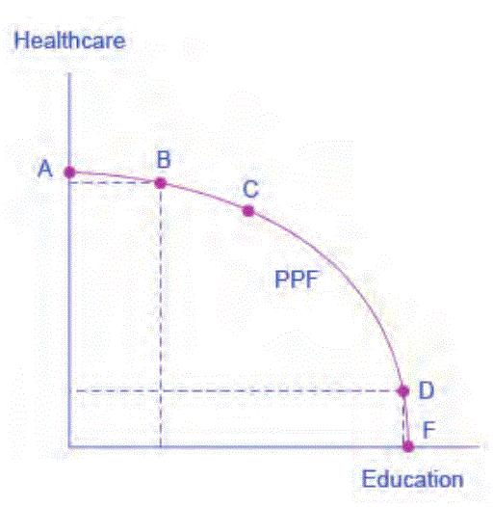

Q/ how does a production possibilities model differ from a budget constraint model?
1- The first is the fact that the budget constraint is a straight line. This is because its slope is given by the relative prices of the two goods. In contrast, the PPF has a curved shape because of the law of the diminishing returns.
2- The second is the absence of specific numbers on the axes of the PPF. There are no specific numbers because we do not know the exact amount of resources this imaginary economy has, nor do we know how many resources it takes to produce healthcare and how many resources it takes to produce education.

Q/ The term productive efficiency refers to what ?

A1/ Productive efficiency occurs when the economy is utilizing all of its resources efficiently, producing most output from least input. Efficiency refers to lack of waste and lower cost.

A2/ Productive efficiency refers to the maximum amount of output that an economy can produce at a certain point in time. When it is impossible to produce more of one good without decreasing the quantity produced of another good . Efficiency refers to lack of waste and lower cost.
Q/ what does the term allocative efficiency mean?
Q/ Explain, giving an example, the gains from trade arising from a country’s absolute advantage in the production of a good.
Or Q/ what does absolute advantage mean in economics? Explain can two countries have absolute advantage?
A/ Absolute Advantage means means when one nation is more efficient than (or has an absolute advantage over) another in the production of one commodity but is less efficient than (or has an absolute disadvantage with respect to) the other nation in producing a second commodity, 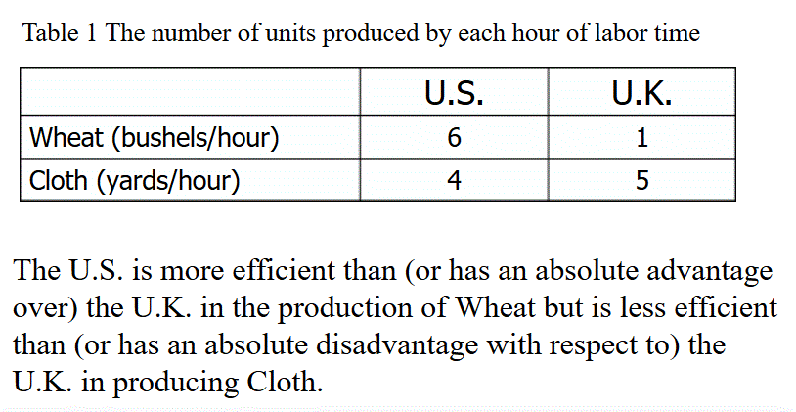
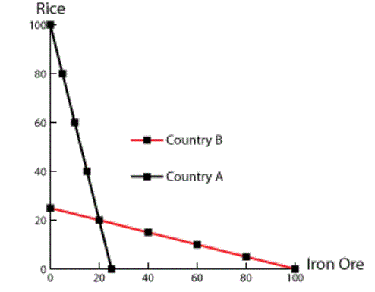

Q/ what does comparative advantage mean in economics? Give an example explaining can two countries have comparative advantage?
Suppose two countries, the US and Brazil, need to decide how much they will produce of two crops: sugar cane and wheat. Due to its climatic conditions, Brazil can produce a lot of sugar cane per acre but not much wheat. Conversely, the U.S. can produce a lot of wheat per acre, but not much sugar cane.
Clearly, Brazil has a lower opportunity cost of producing sugar cane (in terms of wheat) than the U.S. The U.S. has a lower opportunity cost of producing wheat than Brazil. This can be shown by the PPFs of the two countries in below figure

Q/ What is the opportunity cost of seeing a movie?
_ cost of admission?
_ time cost of going to the theater?
_ time cost of attending the show?

A/ Time cost depends on what else you might do with that time. Examples: staying at home and watch TV, working an extra three hours at paid job.

A/ The time cost depends on what else you might do with this time; if it is staying home and watching TV, the time cost may be small, but if it is working three hours to earn money, the time cost will be money you could have earned.

