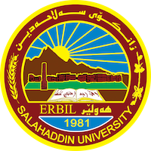
Academic Curriculum Vitae
Personal Information:
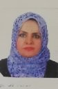
Full Name: Jwan Ahmed Mustafa
Academic Title: Lecturer
Email: jwan.mustafa@su.edu.krd
Mobile:+964750 4791287

Education: MA in English Language and Linguistics

Employment: Teacher at College of Basic Education- Department of English/ Salahaddin University

Qualifications: English Language and Linguistics

Teaching experience: 15 years

Research and publications: 1. Assessment of Strategic Procedures Used in Teaching Communication in English Department - 6th International Visible Conference –Ishik University
2. Function and Position of Noun Phrases in English and Kurdish
-8th International Visible Conference- Ishik University
8TH INTERNATIONAL VISIBLE
CONFERENCE ON
EDUCATIONAL STUDIES
AND
APPLIED LINGUISTICS
April 23-24, 2017
Erbil
KRG-IRAQ
BOOK OF PROCEEDING
http://www.ishik.edu.iq/conf/vesal/
3. Challenges Facing EFL Students of English Department in Some Topics of Grammar
ID No. 3773
(PP 188 - 200)
https://doi.org/10.21271/zjhs.25.2.13

Jwan Ahmed Mustafa
College of Basic Education-Department of English/Salahaddin University-Erbil
Jwan.mustafa@su.edu.krd

Received: 01/10/2020 Accepted: 28/01/2021 Published: 10/03/2021

