Syntax
Fourth Grade Students
Lectures of 1, 2, 3, 4 Weeks
Prepared by:
Assist. Lecturer Jwan Ahmed Mustafa

1. Noun phrase:
A noun phrase is a phrasal constituent whose head is a noun. NPS in English and most other languages can function as subjects, direct and indirect objects, complement of prepositions, subject and object complements, and adverbials.
Quirk et al (1985, 1238-1350) describe the noun phrase and suggest a noun phrase may have different functions in the sentence, being subject and object. The simplest noun phrase consists of an article and a head. The head may be modified in two ways. It can be pre-modified or post -modified.
According to Stageberg (1981:187) a noun phrase is a component which consists of a noun and word groups which belong to the noun, the noun itself is called the head word, or head and other words are modifiers of the noun.
Examples:
The yellow tulips.
The yellow tulips in the garden.
-The yellow tulips in the garden which where gaily blooming.

Quirk et al (1985:238-239) analyzes the structure of an NP from a functional point of view. As consisting of major components, they are namely:
1– The head: It is the main constituent which is preceded and /or followed by other constituents. It usually shows agreement with the other constituent for example:
-The man in the garden is my brother.
-The men in the garden are many brothers.
-The fat man in the garden who has a black coat is my brother.

2. Premodifiers
1– Determiners
In English, many noun phrases begin with article s (a, an, the) or demonstratives are the most common types of determiners. English quantifiers (some, all, few, ect.) also function as determiners though in some other languages determiners and quantifiers belong to distinct categories.
Determiners typically provide information about definiteness, number (singular vs. plural) and in the case of demonstratives distance from the speaker. In some languages they also indicate other grammatical information such as (case) and (gender).
Determiners do not behave like typical adjuncts, because the choice of determiner is often limited by the grammatical and semantic properties of the head noun.
The determinative also includes three types of determiners which are classified as follow:
1-Pre-determiners: they include all the constructions which can take place before any central determiner in an NP, ex. (all, both, zero article)
Both those engineers attend the meeting.
2-Central determiners: they include the articles (the, a/an, and demonstratives, and possessive pronouns) for example:
All the teachers know the rules.
3-Post determiners: they include the determiners which follow the central determiners and precede the pre-modifiers. They are numerals, and quantifiers like (three, many, few)
The few old portraits are presented for sale.
2-Pre-modifiers
A premodifier is a word, phrase or clause which function as an adjective or an adverb to describe a word or make its meaning more specific. They are placed after determiners, but before the head of a noun phrase.
-There are many types of pre-modifiers.
A-Adjectives:
We had a very pleasant journey this time.
We booked a spacious room with really comfortable beds.
Classification of adjectives:
Dixon (1982:34) defines adjectives as parts of speech that can be classified into seven kinds. This division is based on semantic, syntactic and morphological criteria. These types are;
Dimension: The most common adjectives of this type are; small, long, short, fat.
Physical property: This category implies many adjectives such as hard, soft, hot, heavy.
Human propensity: this type contains many adjectives such as jealous, kind, happy.
Color: The adjectives of this category are limited and clear such as black, white, red.
Age: The most common adjectives are old, new, young.
Value: It includes adjectives such as good, bad, fine.
Speed: This type of adjective contains a limited number of adjectives the most common of them are fast, slow and quick.
Order of adjectives in English:
Dixon (1982:212) Discusses the order of adjectives. He notes that there are other pre- modifiers that follow adjectives those of ''origin and composition '' precede those of purpose and beneficiary.
According to British or organization for cultural relations and British council based on the semantic categories of the adjectives, English adjectives follow this order:
1 – General opinion
2 – Specific opinion
3 – Size
4 – Shape
5 – Age
6 – Color
7 – Origin (nationality)
8 – Material (noun)
For adjectives so defined, there is ''a single preferred ''left-to-right '' ordering (1982:24).
(Not important- just for your information)
A speaker can change the order if he feels that the qualities denoted from an unusual combination, for example ''new slow ''means ''new but slow ''
According to Quirk et al (1985: 60), based the account of pre-modifier is based on the results of the survey of English usage.
He set out four positional classes of pre-modifier:
zone 1 (pre central)
zone 2(central),
zone 3 (post central) and
zone 4 (pre-head) .
According to Biber et al (1999:598),pre modifier order is influenced primarily by part of speech, there are three positions in the order ,the following order of pre modifier preferred: Adverb+ color adjective+ participle +noun +head noun

Rosato(2015:16) presents a modification to the previous analysis as shown below :
– Scope –talking (take all adjectives) ex: nice, former, alleged.
– Size: big, fat, tall, short.
– Quality: beautiful, ugly, silly.
– Age: old, new
– Shape: square, round, rectangular.
– Color: white, purple
– Origin: Russian, French, Chinese
– Material: wooden, metal, aluminum
Cinque (1994:90) states that other adjectives which are called ''operators'' behave similarly to adjectives such as ''nice'' These adjectives include ''former'' and ''alleged '' They move more freely within a multiple –adjective NP.
For example:
- the nice big short Indian bus
- the big nice short Indian bus
- the big short nice Indian bus
these phrases are samples of this kind ''nice '' in the first sentence modifies not just the bus, but also all of its other adjectives that come after it.

B-Participles:
The flying clouds looked like the polished strokes of a gifted artist on a surface of shining blue.
C- Nouns:
she wanted to buy an air ticket, but no passenger flight was departing on that day finally, she asked for an online booking.
D-Compounds:
The office has a group of hard–working executives.
3-Post modifiers
A noun that can be modified by other words often (adjectives) placed after the noun head. There are many types of post modifiers:
1– Relative clauses:
The parent wanted to meet the boy who was going out with their daughter.
– Prepositional phrases
A nice young woman in jeans was watching me.
3 – Non-finite clauses equivalent to relative clauses
They wanted to meet the boy going out with their daughter.
More examples on Noun Phrases:
all many old school friends of other days who have passed away.
the apartment downstairs.
the apartment, large and empty.
the apartment, spotlessly clean.
the bend in the river
the woman weeping was escorted to the door
They refused to pay the money demanded

Other forms of post nominal modifiers
Note: 1. A bare adjective modifying a noun often occurs in the pre nominal position, but an adjective in the post nominal position is usually modified by a qualifier.
The mail man, exuberantly happy, whistled merrily.
He had never seen a woman more lovely.
2. When two or more adjectives modify a noun, they can occur after the noun
-The mail man, weary and wet, trudged along in the rain.
-A woman old and gaunt stood at the door.
3. Nouns may be modified by some of the uninflected words that are often adverbial
the people upstairs
the poker game now
the party last night
our vacation next summer
4. An adverb may modify a noun that precedes it.
the blue dress particularly
5. A noun phrase may be post modified by an adjective which is:
1. Romance loans (French) (a) Court Martial
(b) Princess Royal, battle royal
(c) attorney general, postmaster general
(d) notary public
2. Idiosyncratic Adjectives: (a) Syntax proper, president elect
(b) the people (who were) involved
(c) the men (who were) present
3. Postmodified Adjectives MUST themselves be postmodifiers:
(a) Mary is a child (very) SCARED of monsters.
(b) She turned out to be a woman (extremely) FAITHFUL to her
husband.
(c) David is a man very FOND of English literature.
(d) I saw a girl as BEAUTIFUL as Mary / more BEAUTIFUL than
Mary.
6. In the case of indefinite pronouns such as something/one, anything/one, nothing / no-one/none, what’s happened, historically, is that a determiner (some, any, no) and a head noun (thing/one) have coalesced into a single word
some surprising thing → something surprising
any intelligent one → anyone intelligent).
- The fact that such pronouns can only be post-modified (not pre-modified, as in *intelligent anyone) is connected with this historical fact.
- The same analysis might seem appropriate for some of the animals, and those in the cabin especially since the italicized words are sometimes categorized as pronouns:

2-Verb phrases
According to traditional definition of VPS as a group of verbs which together have the same syntactic function like a single verb for example (is reading, may be listening, has written). The structure of VP is analyzed according to the following parameters; complexity, voice, modality and aspect.
According to Stageberg (1981:189) who states that a verb phrase can be defined as a group of words that belong with the verb and cluster around it. The main verb is called the head and complements of the verb ''complements of the verb'' are called modifiers: soon arrives
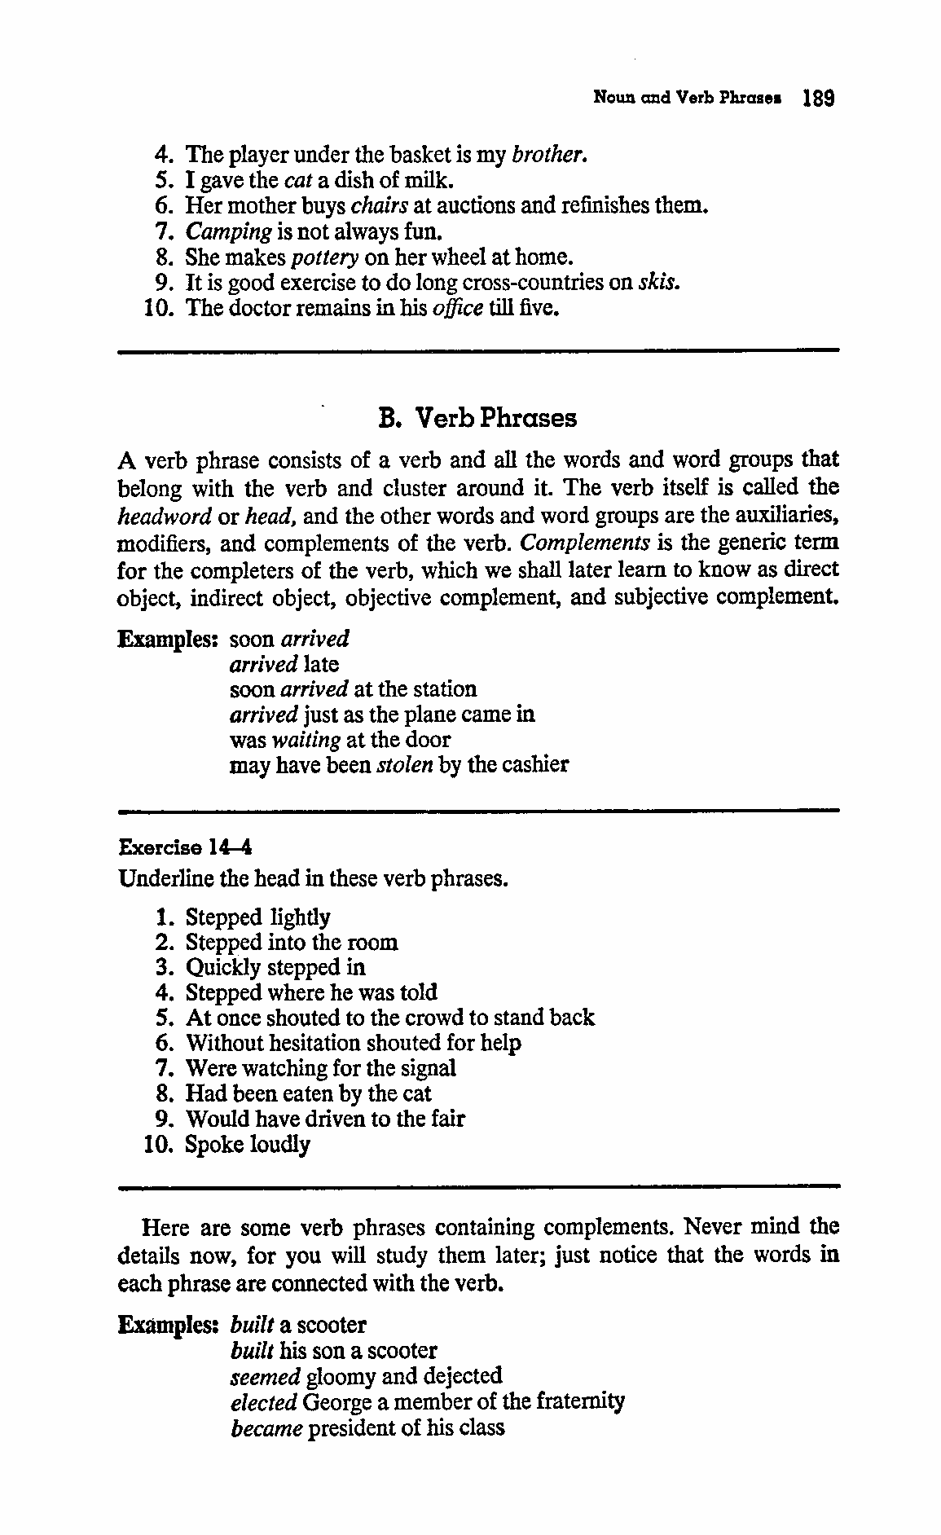
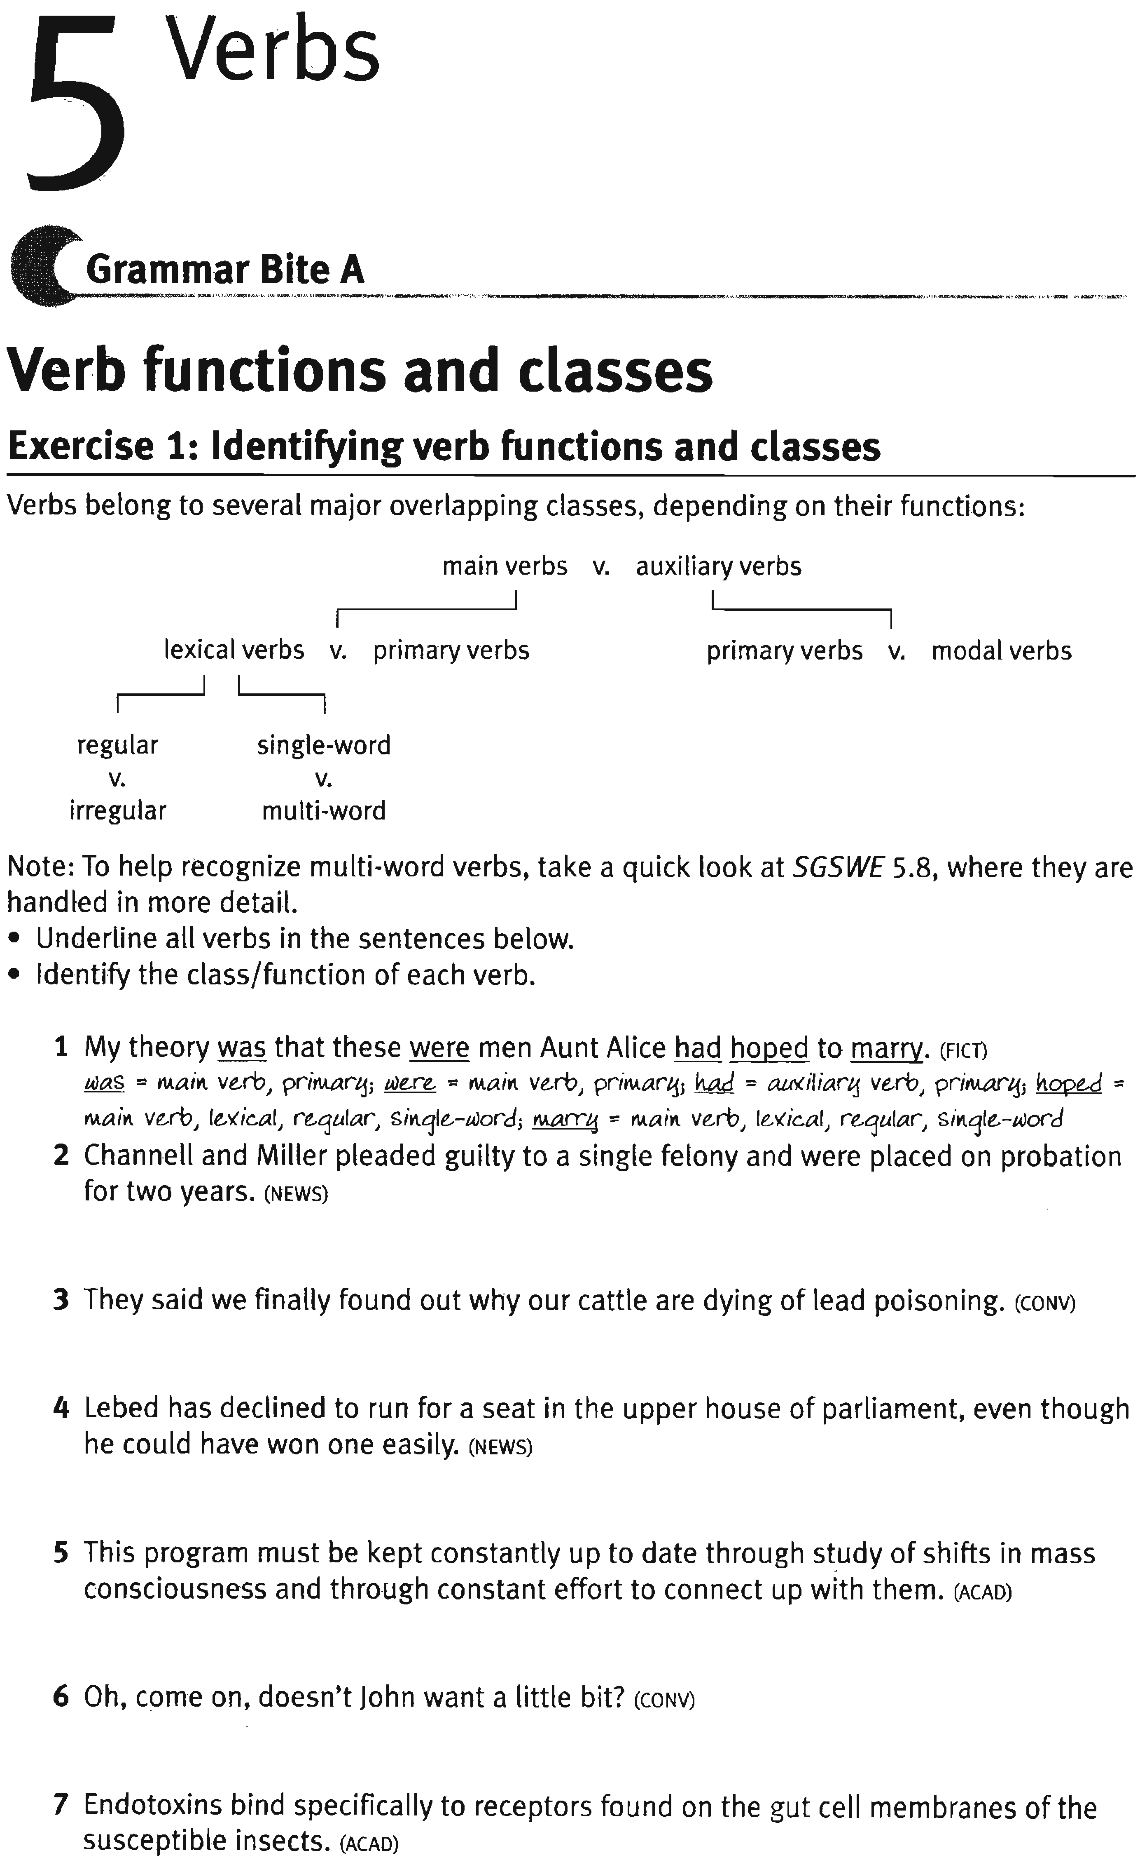
- Burton-Roberts, Noel (2007) (pp- 65-81)
The basic Verb Phrase
The basic sentence consists of a Noun Phrase (functioning as subject) followed by a Verb Phrase (functioning as predicate). You have encountered several examples of VPs, though very little has been said about them. The structure (the immediate constituents) of the VP is half of the basic sentence. Paddle, sunbathed beside a stream, loves fish, hated the chips, dreads affectionate cats, and seemed happy are all VPs.
A first look at verbs:
The one constituent that a Verb Phrase (VP) must contain is a verb (V). VPs are centred on V. There are two kinds of verb in English: lexical and auxiliary. Lexical verbs are the ones that belong to the indefinitely large general vocabulary of the language (e.g. run, eat, seem, explain, recycle, shatter, prepare, depend). Auxiliary verbs, by contrast, are a special and very restricted set of verbs. The clear ones are: be, have, and do (which can also be lexical) and can/could, will/would, shall/should, may/might, must, and need.
A full VP must contain a lexical verb and it may contain auxiliary verbs. In the following, the lexical verbs are in bold and the auxiliary verbs are in italics.
[1a] Diana plays the piano.
[1b] Diana played the piano.
[2] Anders is explaining his generalisation.
[3] Maggie should have recycled those bottles. [4] Wim may have been preparing his lecture.
Lexical verbs are easily identified by their morphological (i.e. their word-form) possibilities. They are words that take some if not all of the verbal inflections -s, -ing, -ed, -en. For example: plays, playing, played and writes, writing, written.
In VPs containing only a lexical verb, that verb will always carry a present or past meaning. In fact, present and past are explicitly marked as above: in; play carries the present tense infelction -s and, it carries the past tense inflection, -ed.
A general point to note in identifying categories – one that applies particularly to verbs – is that words can belong to more than one category. For example, interest is certainly a verb: cf. interests, interesting, interested. or a noun, or an adjective :
Millie’s hair interested him.
Its great architectural interest did not strike him immediately.
John’s interests are rather eccentric.
A very interesting plan was proposed.
He wasn’t very interested in the bean production.
Notice in passing that the adjectives interesting and interested are gradable and so can be modified by very. By contrast, no verb can be modified by very:
*Millie’s hair very interested him.
*Her hair was very interesting him.
Now decide on the category – or categories – of each of the following words. Most of them belong to more than one category. You’ll find it helpful to construct sentences in which they can function.
open, impossible, appeal, up, content, between, export, edit.
Adjunct adverbials (VP) as modifiers in the Verb Phrase. We’ve already encountered PPs functioning as modifiers in VP. Examples are:
- Old Sam sunbathed beside the sea.
- Max sunbathed in summer with his binoculars.
As mentioned, since these PPs are optional and can occur with almost any verb, they can’t be used to sub-categorise the verb. In other words, they are not functioning as complements. They give additional, though not grammatically essential, information. When a constituent functions within a VP as the PPs in [1] and [2] are functioning, it is said to function as an adjunct adverbial (or simply adjunct). [1] and [2], then, are examples of intransitive verbs in sentences with adjunct adverbials.
Taking just the first two examples, note the following pattern of grammaticality:
Max died.
*Max died Bill.
*Max made.
Max made a noise.
Die clearly belongs to the same sub-category as sunbathe, as do sleep and laugh: none of these verbs allows a following NP. But make clearly belongs with dread, inspect, spot, and throw: these demand a following NP. Play, on the other hand, belongs to both sub-categories, with different meanings:
The children played.
Max played the tuba.
Paddle, reflect, break, and relax are further verbs that belong to both sub- categories. You can check this for yourself (for example, Superman relaxed and Superman relaxed his grip).
Categories of lexical verbs:
(1) transitive,
(2) intransitive,
(3) ditransitive,
(4) intensive,
(5) complex transitive,
(6) prepositional.
Transitive verbs
A transitive verb is one which requires a single Noun Phrase to complement it. Of the verbs considered above, then, dread, make, spot, throw, and inspect are transitive verbs.
The NP that complements a transitive verb is said to function (more specifically) as its direct object. So, in Phil dreads affectionate cats, the NP within the VP (affectionate cats) is complementing the transitive verb dread as its direct object.
Notice that, where an NP functioning as the direct object of a verb is a pronoun, it has a special form. This form is called the objective case (more traditionally, ‘accusative case’). Thus the direct object pronouns in the objective case are grammatical in [19], but the corresponding pronouns in the subjective (traditionally, ‘nominative’) case are ungrammatical:
me/. * I
her / * she
Phil dreads him / *he
us / *we
them/ *they
When the form of an NP is determined by its complement relation with another constituent, it is said to be governed by that other constituent (in this case, the verb). Notice that this goes for NPs complementing prepositions in PPs as well. The preposition governs the NP, demanding that it appear in the objective case: for him vs. *for he, against them vs. *against they. You and it are the only pronouns that don’t have a special distinct form in the objective case.
Intransitive verbs
An intransitive verb is one that does not require any further constituent as a sister in the VP. ‘INtransitive’ means ‘has (and needs) no complement’. Sleep, die, laugh and sigh are intransitive verbs. Since an intransitive verb requires no further element to form a complete predicate, an intransitive verb counts as a complete VP in its own right.
Ditransitive verbs
Ditransitive verbs require TWO NPs as complements. The classic example of a ditransitive verb is give. Others are send and buy:
William gave Millie some bleach.
The staff sent the general a message.
Max buys his butler all necessary work-clothes.
Indirect objects are usually the recipients or beneficiaries of the action. The second complement NP (in italics) functions as the direct object – it has the same function as the NP that complements a transitive verb.
Both the NPs are governed by the V gave and would appear in the objective case if they were pronouns. Now decide which of the following verbs are ditransitive. (a) show (b) offer (c) see (d) tell (e) announce. Consider the following sentences:
Max showed Matilda his collection of razors.
Tarzan offered Jane his hairy arm.
Heseltine told his boss the news.
*Max saw Matilda his collection of razors.
*Heseltine announced his boss the news.
The important thing to note about VPs consisting of a ditransitive verb complemented by two NPs is that they are systematically related to VPs in which the indirect object NP corresponds to a Prepositional Phrase (PP) in a position following the direct object.
William gave some bleach to Millie.
The PPs that correspond in this way with indirect objects are always introduced by either to or for.
The staff sent a message to the general.
Max buys all necessary work-clothes for his butler.
The PP corresponding to an indirect object NP has a special status. With transitive verbs, when a PP follows the direct object NP, it’s not part of the complementation of the verb but is an optional modifier. However, in using a ditransitive verb such as send, we need to specify not only (a) a sender (usually subject), and (b) what is sent (usually the direct object), but also (c) to whom it is sent (usually indirect object). As mentioned, indirect objects can take the form of either an NP or a PP containing to or for. So PPs that correspond to indirect objects are part of the complementation of ditransitive verbs and need to be represented as sisters of V within the basic VP.
Intensive verbs (the copula)
Intensive verbs require a single complement, which can take the form of an Adjective Phrase, a Noun Phrase or a Prepositional Phrase. The most obvious and commonly used intensive verb is be. As the classic example of the intensive sub-category of verb, be is called ‘the copula’.
Ed is rather extravagant. (AP)
Sigmund was an auctioneer. (NP)
Oscar and the First Mate were in the engine room. (PP)
The complement of an intensive verb functions (more specifically) as a predicative. (By the way, don’t confuse this term with ‘predicate’.) Other intensive verbs – i.e. other verbs taking a predicative as complement – are: become, seem, appear, turn, remain, look, taste, feel, smell, sound.
When a verb is complemented just by an AP, you can be sure you’re dealing with an intensive verb. This is because [intensive] is the only sub- category of verb that can take just an AP complement. The point is worth noting because, as mentioned, intensive verbs can be complemented by an NP or a PP and, when a verb is complemented by an NP, you’re going to have to decide whether [V + NP] is an example of [transitive V + direct object] or an example of [intensive V + predicative]. Understanding the ‘predicative’ function involves understanding the difference between predicative and direct object. Compare:
Sigmund was an auctioneer.
Sigmund spotted an auctioneer.
In both, we have a verb complemented by an NP. In Sigmund spotted an auctioneer the verb is transitive, so the NP complement functions more specifically as direct object. But, Sigmund was an auctioneer. does not express a relation between two individuals. Instead it expresses the idea that Sigmund has the property of being an auctioneer. Predicatives are used to attribute properties to the things or people referred to by other expressions.
Many of the intensive verbs listed above also belong to the transitive sub- category – but with a different meaning. This difference between transitive (+ direct object) and intensive (+ predicative) can be made quite vivid by contrasting the two meanings of such verbs. For each of the following decide whether the (italicised) complement NP is complementing a transitive verb as direct object or complementing an intensive verb as predicative:
Max turned a subtle shade of green.
Max turned another card.
Tarzan felt a tap on his shoulder.
Tarzan felt a real idiot.
The hat became a very useful wastepaper basket.
The captain sounds an absolute tyrant.
The captain sounded the ship’s horn.
Note: The reflexive pronoun himself in Max shaved himself does refer (to Max), so it’s a direct object.
An [intens] verb, by definition, takes a subject-predicative. A [trans] verb, by definition, takes a direct object. So, by using those features, you are effectively assigning a (more specific) function to the complement of the verb.
Complex transitive verbs:
Complex transitive verbs take two complements: a direct object (NP) and an object-predicative. Again, the predicative can take the form of an AP, an NP or a PP. Here are some examples, with the direct object in italics and the predicative in bold.
Jack finds his own jokes extremely funny. (AdjP)
They made Stella their spokesperson. (NP)
Liza put the liquor under her bed. (PP)
Max found Bill an amusing companion
This example is useful because it very clearly distinguishes between [ditrans] and [complex transitive] VPs. Bear it in mind if you’re ever confused on the matter.
Prepositional verbs
Glance (at NP), reply (to NP), refer (to NP), listen (to NP) and worry (about NP) are examples of prepositional verbs – complemented by a Prepositional Phrase. Take glance, for example (note the asterisks):
*Max glanced. (glance is not intransitive)
*Max glanced the falling acrobat. (glance is not transitive)
Max glanced at the falling acrobat. (glance demands a PP complement) [56] S
The PP that complements a [prepositional] verb is called a prepositional complement. As a reminder, there are three kinds of VP consisting of [V + PP] we’ve looked at so far:
(a) V[intens] + PP.
(b) V[prep] + PP.
(c) V[intrans] + PP.
The PP is a complement (subject predicative);
The PP is a complement (prepositional complement); The PP is an optional modifier.
Prepositional verbs are called ‘prepositional’ because they can only be complemented by a PP. In this, they contrast with [intens] verbs, which can be complemented by NP, AP or PP. The [prep] subcategory of verb is a bit of a ragbag. Notice also that each [prep] verb generally demands that the head of that PP be one particular preposition – for example, we have glance [at NP], not *glance [to NP], and refer [to NP], not *refer [at NP].
The following may help in identifying the sub-categories of verb in sentences:
1. Morgan opened his mouth.
2. Morgan’s open mouth admitted the fly.
3. That was clearly impossible.
4. Mary appealed to John to take the rubbish out.
5. Her repeated appeals were unsuccessful.
6. He booted his drunken colleague up the gangway.
7. They up the rent every other month.
8. Georgette is perfectly content.
9. Jenny criticised the content of the paragraph.
10. He contented himself with a second-hand copy.
11. The recalcitrant mango slipped between Grace’s fingers.
12. Toffee-wrappers are the main export.
13. Boggis and Stone export toffee-wrappers to Mesopotamia.
14. Max has edited a grand total of 253 books.
More examples:
1. The ducks paddled (across the lake) – [intransitive]
2. He paddled the raft (across the lake) – [transitive]
3. Morgan is reflecting (quietly) – [intransitive]

4. The glass reflected Max’s ugly face – [transitive]
5. The samovar broke – [intransitive]
6. Anna broke the samovar – [transitive].
Exercises
- Identify the major functions in the following sentences (subject, direct object, indirect object, subject-predicative, object-predicative, and prepositional comple- ment). Identify the verbs and sub-categorise them. Example:
Otto devoured the couscous
subject V direct object [trans]
  - The girl in the palace dyed her hair a strange colour.
  - Hot air rises.
  - Richard promised me his spaghetti machine.
  - The sedan-chair proved very useful.
  - Someone stole my contact-lenses.
  - It sounds like a really good film.
  - The candidate’s antics amused the board of examiners.
  - The committee nominated her Acrobat of the Year.
  - Oscar feeds his cat smoked salmon.
  - I like my curries as hot as you can make them.
  - This calls for a celebration.
  - The main witness for the prosecution disappeared.
  - He applied for a gun licence.

- Decide whether the PP in the following sentences is part of the complementation of a DITRANSITIVE verb or not.
  - Holden wrote ten letters to Africa.
  - Holden wrote ten letters to the White House.
  - Max took the hyena to the station.
  - Max lent his hyena to the Dramatics Society.
  - William baked a cake for everyone.
  - William baked a cake for Christmas.
  - Laura saved the money for a piano.
  - Laura saved a place for Martha.
Discussion of exercises
1. [The girl in the palace] [dyed] [her hair] [a strange colour]. S V dO oP
2. [Hot air] [rises]. SV [intrans]
3. [Richard] [promised] [me] [his spaghetti machine]. S V iO dO [ditrans]
- [The sedan-chair] [proved] [very useful]. S V sP [intens]
- [Someone] [stole] [my contact lenses]. S V dO [trans]
- [It] [sounds] [like a really good film]. SV sP [intens]
- [The candidate’s antics] [amused] [the board of examiners]. S V dO [trans]
- [The committee] [nominated] [her] [Acrobat of the Year]. S V dO oP [complex]
- [Oscar] [feeds] [his cat] [smoked salmon]. S V iO dO [ditrans]
- [I] [like] [my curries] [as hot as you can make them]. SVdO oP [complex]
- [This] [calls] [for a celebration]. S V PC [prep]
- [The main witness for the prosecution] [disappeared]. SV
- [He] [applied] [for a gun licence]. S V PC [prep]
Notice: it is only NPs denoting ANIMATE things (or things that could be interpreted as being animate) that can be indirect objects. For example, if interpret Christmas as a person rather than a festival, William baked Christmas a cake sounds OK. In (2) above, the White House can be an indirect object because, as well as being a building, it’s an organisation of human beings, as is the Dramatics Society. By contrast, there is no single human institution that represents Africa as a whole, so Africa is an inanimate location and cannot function as indirect object.
Revision of NP & VP:
- Petrol got more expensive.
- Alexander’s father left him.
- Alexander’s father left him the theatre.
- Alexander’s father left him in the care of the bishop.
- Several of the men complained.
- He referred to the fact that you had no clothes on.
- All the customers sit their children on the counter.
- Her mother and father approve of Matilda’s behaviour.
- Most of the students do the work you set.
- Moriarty locked Holmes in the library.
- The sergeant and his men climbed up the drain pipes.
- His fish and chips went cold and greasy.
- The obliging manager poured everyone a glass of wine.
- Joan placed her latest trophy in a prominent position.
- Karen peered into the gaping hole.
- The new chef liquidised last week’s uneaten fritters.
- That spot made a perfect picnic place.
- Bill made a brilliant picnic table. (The most likely interpretation, please!)
- This so-called music makes me mad.
- He made the men a decent meal.
- The exhausted team members made for the nearest pub.
Dynamic and Stative Verbs
Stative Verbs: describe states or conditions. Examples are; know, believe, or understand. These verbs can be used in simple and perfect tenses and aspects. However, they cannot be used in the continuous or progressive forms. This limitation makes stative verbs a little more difficult to master, which means practice is necessary.

Verbs: always stative
Mental states
admire, believe, desire, doubt, know, need, realize, recognize, suppose, understand, want
Common Errors | know, need, understand
Correct Usage | - Yes, I know John.  - We need some help.  - Sorry, I don‘t understand what you mean.
Emotional states
adore, amaze, appreciate, astonish, care, dislike, envy, fear, hate, like, loathe, love, mind, please, prefer, surprise
Common Errors | love, like, hate
Correct Usage | - The kids love ice cream.  - She likes you.  - I hate washing dishes.
Possession
belong, owe, own, possess
Common Errors | own
Correct Usage | - Who owns that car?  - It‘s mine. I own it.
Senses
hear
Other
consist of, contain, cost, deserve, equal, exist, involve, lack, matter, perceive, promise, resemble, seem
consider, forget, imagine, remember, think
I think (stative) |  | Refers to an opinion  - What do you think?  - I think you should accept that job offer.
I am thinking (dynamic) |  | Refers to the act of thinking  - What are you thinking about?  - I‘m thinking about what to do next.
I have (stative) |  | Refers to possession or relation  - I have $120 with me right now.  - I have 3 kids.
I am having (dynamic) |  | Refers to an activity  - I am having a party this Friday.  - We‘re having a great time.
feel, taste, smell, see
It tastes… (stative) |  | Refers to a quality or state of being • The cake? It tastes delicious.
She is tasting… (dynamic) |  | Refers to an activity  • She‘s tasting the soup to check if it needs more salt.
Other
appear, be, cost, deny, include, look, sound, weigh
They are…  (stative) | Refers to a general condition or state • They are helpful, no matter what happens.
They are being… (dynamic) | refers to a temporary state  • They are being helpful, under the  circumstances

Mental states
consider, forget, imagine, remember, think
I think (stative) | Refers to an opinion  - What do you think?  - I think you should accept that job offer.
I am thinking (dynamic) | Refers to the act of thinking  - What are you thinking about?  - I‘m thinking about what to do next.
Possession
have
I have (stative) | Refers to possession or relation  - I have $120 with me right now.  - I have 3 kids.
I am having (dynamic) | Refers to an activity  - I am having a party this Friday.  - We‘re having a great time.
Senses
feel, taste, smell, see
It tastes… (stative) | Refers to a quality or state of being • The cake? It tastes delicious.
She is tasting… (dynamic) | Refers to an activity  • She‘s tasting the soup to check if it needs more salt.
Other
appear, be, cost, deny, include, look, sound, weigh
They are…  (stative) | Refers to a general condition or state • They are helpful, no matter what happens.
They are being… (dynamic) | refers to a temporary state  • They are being helpful, under the  circumstances

