-
Adjective Phrase:
An adjective phrase is a phrase with an adjective as head. An adjective phrase is a group of words that modifies a noun or pronoun in a sentence. It can be placed before or after the noun or pronoun it modifies or describes. It normally indicates quality, size, shape, duration, feelings, contents, and more about a noun or pronoun. (Barany, p, 207)
He was so happy
He was happy.

- The Internal Structure of Adjective Phrases

An adjective phrase always has an adjective acting as the head. The adjective phrase may also have dependents before and/or after the head.

The instructions seem fairly straightforward.
The car is economical for its size.
They were well aware that the company was losing money.
Adjective phrases usually have the following structure:
Premodifier Adjective (HEAD) Postmodifier
too much anxious to go
very sorry to say that
so eager -
- fond of reading
- important to know
- wise enough

The premodifier in an adjective phrase is most commonly
- an adverb (intensifier): extremely very fairly quite rather so
- another adjective: ; wonderful surprising angry
Longman Student Grammar of Spoken and Written English Workbook. (p: 48-49)

2.Types of Adjectives: (Barany, p,142)
1. Central adjectives: are those that take inflections for degree, can have both attributive and predicative functions, and are descriptive and gradable. Peripheral adjectives lack one or more of these characteristics.
1. Can occur predicatively as the subject or object complement after a copular verb such as , be, seem, grow, appear etc. For example:
He seemed happy.
They grew defensive.
They made me unhappy.
They called her stupid.

2. Can occur attributively (i.e., directly before or after the noun phrase) They come in between the determiner and the noun.
He is a happy man.
the old woman.
The meeting proper started late.
The people responsible were arrested.

3. Are gradable so can be modified with amplifiers, limiters and downtoners like very, extremely, not quite, marginally
He was very unhappy.
She was extremely frightened.
I was marginally satisfied.
A mostly satisfied customer.
4. Take comparative and superlative forms
the wisest man
the most interesting man
The cleverer man
That wine is the best.

5. Form adverbs with the addition of a suffix (not necessarily but usually -ly).
wise → wisely
happy → happily
2. Peripheral adjectives: These include any which do not match one of the five things that the central adjectives do such as asleep, bottom, alphabetic, proper etc. Examples of how peripheral adjectives cannot perform the five functions above are:

1. Cannot occur predicatively:
*The figure appeared particular.
*The excuse seemed main.
*A teacher was former.
*A stranger was total.
2. Cannot occur attributively:
*The asleep dog.
*The ready man.
*An ill child.
3 Are not gradable with very:
*He was very unconscious.
*The restaurant was very deserted.
*I was very freezing.
4. Do not take comparative and superlative forms.
*The people were more asleep.
*The situation was perfecter.
*The most boiling water.
5. Do not form adverbs.
asleep → *asleeply
devoid → *devoidly
hand made → *hand madely

Syntactic Functions of Adjectives:
Adjectives function syntactically only in adjective phrases, but since it is the adjective that generally determines the function of the adjective phrase, it is often found convenient to use adjectives alone to illustrate the functions of adjective phrases and it has often referred to adjectives as a shorter way of referring to adjective phrases. (Quirk, et.al p, 108)
Attributive Adjectives: The major syntactic functions of adjectives are attributive and predicative. Adjectives are attributive when they:
(a)premodify noun heads ie: appear between the determiner and the head of the noun phrase:
the beautiful painting.
his main argument.
an extremely attractive family
a reasonably early hour.

(b)post modify noun heads:

the syntax proper
the students present
the court martial
attorney general
no one specific
something interesting
someone brave
2. Predicative adjectives:
(a) Subject Complement:
Your daughter is pretty.
Whether he will resign is uncertain.
Driving a bus isn’t easy.
The instructions seem fairly straightforward.
Her new friend is really good-looking.

(b) Object Complement:Adjectives can be object complement to clauses. The adjective functioning as object complement often expresses the result of the process denoted by the verb:

He pulled his belt tight. (As a result, his belt was then tight)
He pushed the window open. (As a result, the window was then open)
He made his wife happy.
They painted their room sky-blue.

Q/ For each adjective phrase, 1) Identify the syntactic function and 2) the internal structure.
That soup is pretty cold.
I am scared of heights.
She was a very proficient skier.
This study sounds very ambitious.

Study pages 108,109,110, 111 from Quirk’s book

Adverb Phrases: (Quirk, et.al, p118- 135)
Adverb phrases are used to modify verbs. The most common characteristics of the adverb is morphological: the majority of adverbs have the derivational suffix -ly.
She slapped him extremely playfully.
Children grow up really quickly.
Adverb phrases are used with be. This is especially typical of adverbs of place.
Have you been here?
They’re right there.
Syntactic Functions of Adverbs: There are two types of syntactic functions that characterize adverbs:
(1) adverbial
(2) modifier of adjective and adverb
(1) Adverbs as adverbial: An adverb may function as adverbial, a constituent distinct from subject, verb, object, and complement. There are three classes of adverbials: adjuncts, disjuncts, conjuncts.
(a)Adjuncts: They are integrated within the structure of the clause to, at least, some extent. Disjuncts and Conjuncts, on the other hand, are not integrated within the clause.
Adjuncts indicate time, place and manner

They are waiting outside.
I can now understand it
He spoke to me about it briefly.

Disjuncts and Conjuncts, on the other hand, are not integrated within the clause. Semantically,

(b) Disjuncts: Semantically, these express an evaluation of what is being said either with respect to the form of the communication or to its content.
Frankly, I am tired
Fortunately, no one complained.
Probably, they are at home.

(c) Conjuncts: Semantically, have a connective function. They indicate the connection between what is being said and what was said before.

We have complained several times about the noise, and yet he does nothing about it.
He seems very intelligent, though.
If they open all the windows, then I’m leaving.
2. Adverb as modifier
1. Modifier of adjective
An adverb may premodify an adjective:
That was very funny.
It is extremely good of you.
*The adverb enough postmodifies adjectives, as in:
This building is high enough.
Most commonly, the modifying adverb is an intensifier The most frequently used intensifier is very. Other intensifiers include so, pretty, rather, unusually, quite, unbelievably. Many are restricted to a small set of lexical items:
deeply (anxious)
highly (intelligent)
strikingly (handsome)
sharply (critical).
Many intensifiers can modify adjectives, adverbs, and verbs alike.
Adverbs as premodifiers of adjectives may also be ‘viewpoint’, as in:
politically expedient (‘expedient from a political point of view’),
technically possible
theoretically sound.

- Modifier of adverb
An adverb may premodify another adverb, and function as intensifier:
They are smoking very heavily.
They didn’t sing that loudly. (informal)
Your engine is running very/ absolutely/fairly smoothly.
They are smoking very heavily.
They did not injure him that severely.
Like adjectives, the only postmodifier of an adverb head is enough, as in:
cleverly enough
.
3. Modifier of prepositional phrase
The few adverbs that premodify particles in phrasal verbs also premodify prepositions or (perhaps rather) prepositional phrases:
The nail went right through the wall.
His parents are dead against the trip

4. Modifier of noun phrase
A few intensifiers may premodify noun phrases: quite, rather (esp BrE),
and the predeterminers such and exclamatory what. The noun phrase is

He told such a funny story.
I have never heard such wickedness.
It was rather a mess
He was quite some player.
what a (big) fool he is!

So and interrogative and exclamatory how also precede the indefmite article, but they require the noun phrase to contain a gradable adjective and the head o f the noun phrase to be a singular countable noun. In this use, they cause the adjective to move in front of the article:
How tall a man is he?
How tall a man he is!

Some adverbs signifying place or time postmodify noun phrases:
PLACE: the way ahead, the neighbour upstairs, the sentence below
TIME: the meeting yesterday, the day before

Prepositions and Prepositional phrases:
A prepositional phrase consists of a preposition followed by a prepositional complement, which is characteristically a noun phrase or a wh-clause or -ing clause:
at the bus-stop
from what he said
by signing a peace treaty

Prepositional Phrase
Preposition | Dependent  Complement | Complement Type
on  from  by  in terms of  in variance with | the table  what he said  signing a peace treaty  money  the official reports | NP  nominal wh-clause  nominal –ing clause  NP  NP
.
Simple and complex prepositions
- Simple: Most of the common English prepositions, such as at, in, and for, are simple, ie consist of one word: at, but, by, down, for, from, in, like, near (to), on, off, of, about, above, during, except, …etc.
- Complex: Prepositions, consisting of more than one word, are called complex. Most of these are in one of the following categories:
[a] adverb + prep: along with, as for, away from, out of, up to
[b] verb/ adjective /conjunction/+ prep : owing to, due to, because of
[c] prep + noun + prep: by means of, in comparison with, in front of,
[d] which is by far the most numerous category, the noun in some complex prepositions is preceded by a definite or indefinite article: in the light of; as a result of

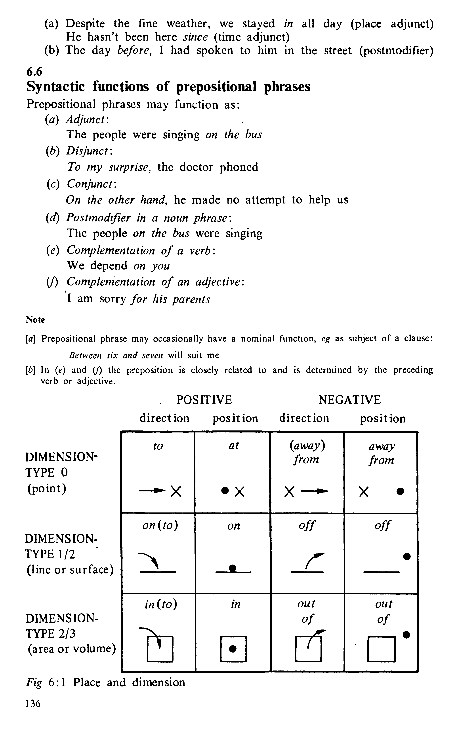
Syntactic functions of prepositional phrases:
1. Adjunct:
The people were singing on the bus.
- Disjunct:
To my surprise, the doctor phoned.
- Conjunct:
On the other hand, he made no attempt to help us.
- Postmodifier in a noun phrase:
The people on the bus were singing.
- Complementation of a verb:
We depend on you.
- Postmodifier of an adjective P:
I am sorry for his parents.
- Prepositional phrase may occasionally have a nominal function, eg as subject of a clause:
Between six and seven will suit me.

To as a preposition and an infinitive marker
To has two different uses. It can be an infinitive marker. Examples are: to swim, to work, to break, to go etc.
- He likes to sing.
- She wants to go.
- You need to work.
To can also be a preposition.When to is a preposition, it can be followed by an –ing form, but not normally by an infinitive. This usually happens after expressions like look forward to, in addition to, object to, be used to and get round to.
In the following examples, the preposition to is followed by either a noun or an (ing) form:
- I look forward to hearing from you. (NOT I look forward to hear from you.)
- We look forward to continuing our business relationship.
- I look forward to your next letter.
- I am used to her silly ways.
- I am used to working with all kinds of people.
- I object to Friday work.
- I object to working on Fridays.

Prepositions and Conjunctions
One distinguishing criterion between the two word classes is that prepositions introduce complements which are nominal or nominalized, whereas the corresponding conjunctions (subordinators) introduce a subordinate clause. In certain cases, the same items can function both as prepositions and conjunctions, eg: after, as, before, since, until:
  - Say goodbye before you go. (Conj.)
  - Larry arrived home before me. (Prep.)
  - She waited until he had finished speaking. (Conj.)
  - The ticket is valid until March. (Prep.)

But can function both as a preposition and a coordinating conjunction:
    - They rushed to the hospital, but they were too late. (Conj.)
    - There’s no one here but me. (Prep.)

Prepositions and Adverbs
Prepositions are items which are often formally identical with and semantically similar to adverbs, e g: up, across, about, under,below, behind ….Compare the following pairs:

She walked slowly up the hill. (Preposition)
John is up in his bedroom. (Adverb)
She walked across the street. (Preposition)
She walked across. (Adverb)

Exercise
Make sentences using the words given below as instructed:
1. after i) as a preposition ii) as a conjunction
2. since i) as a preposition ii) as a conjunction
3. under i) as a preposition ii) as an adverb
4. belowi) as a preposition ii) as an adverb
5. but i) as a preposition ii) as a conjunction
6. behind i) as a preposition ii) as an adve

Exercise on Phrases:
Study the underlined phrases below, then identify:
1. the phrase type (NP, Adv. P, Adj. P), and
2. the syntactic function of each phrase.
3. heads and dependents.
a. Her new purse was pretty expensive.
b. The boy in the blue jeans says he'll do it.
c. I exercise very regularly and I eat quite healthily.
d. Somewhat reluctantly, she returned home a week early.
e. A student smarter than Paula won the spelling bee.
f. Samantha ate a very spicy burrito.
g. Mom baked tasty chocolate cookies.
h. When you became a Minister you appointed me Managing Director.
i. We are hoping to open the factory some time next year.
j. Will you talk with these rude people?

