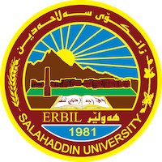
Academic Curriculum Vitae
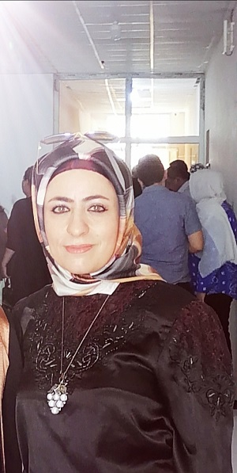
Personal Information:
Full Name: Jwan Khidhr Rahman
Academic Title: Assistant professor
Email: (university email): jwan.rahman@su.edu.krd
Mobile:+9647504855185

Education:
❖ 2016-2020: (PhD. in Environmental Sciences / Phytotoxicity). The title of the thesis is (Phytotoxicity and Phytochemical Studies of Prangos platychlaena Boiss Growing in Halgurd Mountain of Kurdistan Region-Iraq) department of Environmental Sciences and Health / College of Science, Salahaddin University-Erbil, Kurdistan Region, Iraq.
❖ 2008-2011: ( M.Sc. in Biology). The title of the thesis is (Distribution of Asphodelus microcarpus Viv.(Liliaceae) Plant in Erbil Area ). Department of Biology, College of Education, Scientific Departments, Salahaddin University- Erbil, Kurdistan Region, Iraq.
❖ 2002-2006: (B.Sc. in Biology). Department of biology, College of Education, Scientific Departments, Salahaddin University- Erbil, Kurdistan Region, Iraq
Employment:

❖ 2008 to 2011 I was M.Sc. Student at Department of Biology, College of Education, Scientific Departments, Salahaddin University- Erbil, Kurdistan Region, Iraq
- From 2011 to 2012 I have worked as a volunteer at Department of Environmental Sciences and Health / College of Science, Salahaddin University due to the lack of academic staff in this department.
❖ From 2012 to 2015 I worked as Assistant Lecturer at Department of Environmental Sciences and Health / College of Science, Salahaddin University-Erbil, Kurdistan Region, Iraq.

- From 2015 till Now, I have been working as a Lecturer at Salahaddin University-Erbil, Kurdistan Region, Iraq.

❖ From 2016 to 2020 I was PhD. Student at Department of Environmental Sciences and Health / College of Science, Salahaddin University-Erbil, Kurdistan Region and University Technology of Malaysia

Qualifications
❖ Language qualifications
• I speak Kurdish because it is my mother language.
• I can use English and Arabic language to carry out my work

❖ Professional qualifications:

1-Training 101 course, concept, skill and Features / Canada Global Center, 2,3rd October 2013.
2- IBRO course in Neuroscience /11-19th march 2014 /Department of Biology, College of Science, Salahaddin University-Erbil, Kurdistan, Iraq
3- Endnote and Graphpad Prizm 6 Training course, 7-8 March 2018/ department of Biology, Salahaddin University-Erbil, Kurdistan, Iraq
4- Statistics and Statistical Data Analysis with SPSS, Graphpad Prism training course/ 10-14th March 2019 in department of Mathematics, College of Sciences, University of Salahaddin-Erbil,Kurdistan,Iraq
5- Environment course, 5-9th sep 2021, Kurdistan Natural Organization.
6- Making soap, detergents and cleaning product course, 5th June 2022 to 5th November 2022, Powers Plan Organization for Human development

❖ IT qualifications
I have perfect information about using the following information Technology
programs:
▪ Microsoft Word
▪ Microsoft Excel
▪ Microsoft Power Point

Teaching experience:
❖ Teaching the following courses for undergraduate students:
• Environmental Toxicity
• Eco physiology
• Natural product
• Ecology
• Principle of Environmental Sciences
• Environmental Microbiology
❖ Supervised on the research graduation of the 4th class’students.

Research and publications
- Effect of some environmental factors on the distribution of Asphodelus microcarpus Viv. Plant in Erbil area Kurdistan of Iraq.

- Astudy on some micronutrients and phytochemicals in wild plant Asphodelus microcarpus Viv.

- Foliar application of Asphodelus microcarpus Viv. leaf extraction on growth of Pisum sativum L.

- Response of two crop plants to dust deposition

- Phytochemical screening, isolation of coumarins and examining bioactivity of Prangos platychlaena Boiss. Plant in Iraq

- Variation in phytochemical, physiochemical contents and toxicity of Prangos platychlaena Boiss in Halgurd mountain of Iraqi Kurdistan

- Prangos platychlaena Boiss essential oils: A novel study on its toxicity, antibacterial activity and chemical compositions effect on burn rats

- Assessment of phenology and toxicity of Prangos platychlaena Boiss. in Halgurd mountain of Iraqi Kurdistan

- Phytochemical Screening of Different Parts of Prangos Platychlaena Boiss by Liquid-Chromatography Tandem Mass Spectrometry (LC-MS/MS)

- Prangos platychlaena: State of the Art from Ethnopharmacology, Phytochemical, Toxicological and Pharmacological Perspective

- Assessment of toxicity, anti-quorum sensing and anti-biofilm production effects of Hypericum triquetrifolium Turra extract on multi-drug resistant Acinetobacter baumannii

- Down-regulation of abaI, abaR, Bap and OmpA genes in Acinetobacter baumannii by ethanol extract of Glycyrrhiza glabra after toxicity assessment

- Ground Water Quality Assessment Near Municipal Landfill and Characterization of Leachate in Kaniqrzhala Area, Kurdistan Region of Iraq

Conferences and courses attended
1-Training 101 course, concept, skill and Features / Canada Global Center, 2,3rd October 2013.
2- IBRO course in Neuroscience /11-19th march 2014 /Department of Biology, College of Science, Salahaddin University-Erbil, Kurdistan, Iraq
3- 4th Internatational Conference Scientific Conference of Cihan University-Erbil on Biological Sciences (CIC-BIOS 17), 26th April 2017, Erbil, Kurdistan Region-Iraq.
4- 4th International Conference on Applied Sciences, Energy and Environment, 20th May 2017, Faculty of Education, Ishik University, Erbil
5- Endnote and Graphpad Prizm 6 Training course, 7-8 March 2018/ department of Biology, Salahaddin University-Erbil, Kurdistan, Iraq
6- Statistics and Statistical Data Analysis with SPSS, Graphpad Prism training course/ 10-14th March 2019 in department of Mathematics, College of Sciences, University of Salahaddin-Erbil,Kurdistan,Iraq
7- 1st National Tishk Pharmaceutical Conference (NTPC) on Paradigm shift in Drug Discovery and Development,26th June 2021
8- Environment course, 5-9th sep 2021, Kurdistan Natural Organization.
9- Making soap, detergents and cleaning product course, 5th June 2022 to 5th November 2022, Powers Plan Organization for Human development
Funding and academic awards
- List any bursaries, scholarships, travel grants or other sources of funding that you were awarded for research projects or to attend meetings or conferences.

Professional memberships
❖ I am a membership in Kurdistan Biology Syndicate/ Iraq.
❖ Iam a member of the Kurdistan Teachers union
Professional Social Network Accounts:
- https://www.researchgate.net/profile/Jwan-Khidhr
- https://orcid.org/0009-0009-0534-9678

