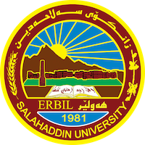
Academic Curriculum Vitae
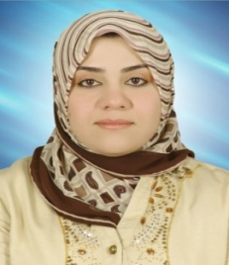
Personal Information:
Full Name:Jwan Ahmed Hamad Saeed
Academic Title:assistant lecture
Email: (jwan.saeed@su.edu.krd)
Mobile:07504685929

Education:
- 2000-2002 Diploma –Teachers Center Institute Erbil –Department of Math and Sciences
- 2008-2004 Bachelor's Degree College of Basic Education of Salahaddin University / Department of Kurdish Language
2014-2012 Master - College of Primary Education - Salahaddin University / Erbil. Methods of teaching

Employment:
- 2002-9-15

Qualifications
- Teaching in Salaheddin University since 2014
- IT
Language, IELTS level, 4.5
Teaching experience:
- Measurement and Educational Evaluation
- General Psychology
- View and Developmental
- Psychology of groth

Research and publications
Structural Equivalence of The Cognitive Representation Scale
Using Exploratory and Confirmatory Factor Analysis

Building a Criterion- Referenced test Achievement Test for Kurdish Grammar
According to the Item Characteristic Curve Theory and Using
the Three-Parametric Birnbum Model

Conferences and courses attended
- Give details of any conferences you have attended, and those at which you have presented delivered poster presentations.

Funding and academic awards
- List any bursaries, scholarships, travel grants or other sources of funding that you were awarded for research projects or to attend meetings or conferences.

Professional memberships
- List any membership you hold of any professional body or learned society relevant to your research or other life activities.

Professional Social Network Accounts:

-google scholar
-LinkedIn
-Research gat
- -Facebook

