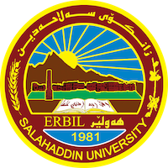
Academic Curriculum Vitae
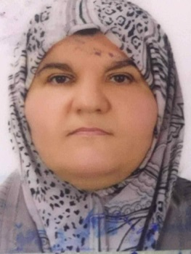
Personal Information:
Full Name: Jwan Dilshad Tawfiq
Academic Title: Lecturer Assistant
Email: Jwan.tawfiq@su.edu.krd
Mobile: +9647504604346

Education:
M. Sc. Degree | Microbiology (Bacteriology), Department of Biology, College of Education, University of Salahaddin – Erbil. Iraq.
Title of thesis | Isolation and Identification of Staphylococcus aureus from  Food and foodhandlers in Hospitals of Erbil City
Date of attainment | April 19, 1993
B.Sc. Degree | General Biology, Department of Biology, College of Education, University of Salahaddin – Erbil. Iraq.

Teaching experience:
1993 – 1998 | Assist. Lecturer in Course on Microbiology Lab (Undergraduate study).
1998 – 2000 | Assist. Lecturer in Course on General zoology lab (Undergraduate study).
2000 – 2020  2020 - 2023 | Assist. Lecturer, Invertebrate lab (Undergraduate study). Assist. Lecturer in Course on General zoology lab  (Undergraduate study).

Research and publications
 | Research Title | Researcher (s) | Year of Publishing | Journal Name
 | Antibacterial activity of lepidium  Sativum and allium porrum  Extracts and juices against some gram positive and gram negative  bacteria | HERO F.S. AKRAYI  JWAN D. TAWFEEQ | 2012 | Medical Journal of Islamic World Academy of Sciences

Professional Social Network Accounts:

ORCID: https://orcid.org/0009-0009-4526-8485

