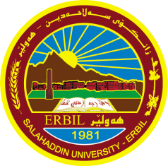
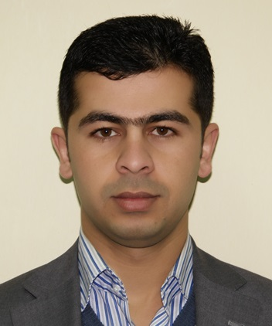
Kadhim Qasim Jabbar
MSc (Materials Science)
Physics Department/ Salahaddin University–Erbil
Iraqi Kurdistan Region
Erbil

Work address: Office address:
Physics Department
Salahaddin University – Erbil
Mobile: 009647504716873
Office:
E-mail: kadhim.jabbar@su.edu.krd
Website: https://sites.google.com/a/su.edu.krd/kadhim-qasim-jabbar/
Birth: 23-01-1985
Academic Qualifications:
- B. Sc. (2003-2007) in Physics - Physics Department, Education College, Salahaddin University Erbil - Iraq.
- Teaching assistance (2007-2009) in Physics - Physics Department, Education College, Salahaddin University Erbil - Iraq.
- M.Sc. (2010-2012) in Nanotechnology of Physics, College of Science, University of RUDN – Moscow- Russia.
- Teaching staff (2012-…) in Physics - Physics Department, Education College, Salahaddin University Erbil - Iraq.

Teaching and advising:
- Mechanics and Properties of matter, (Undergraduate) Physics Department – Shaqlawa - Education College, Salahaddin University Erbil - Iraq.
- MATLAB (Undergraduate) Physics Department – Shaqlawa - Education College, Salahaddin University Erbil - Iraq.
- Biostatics (Undergraduate) Biology Department – Shaqlawa - Education College, Salahaddin University Erbil - Iraq.
- IT (Information Technology) (Undergraduate) Physics Department – Shaqlawa - Education College, Salahaddin University Erbil - Iraq.
- Modern Physics lab. (Undergraduate )Physics Department, Education College, Salahaddin University Erbil - Iraq.
- Electronic lab. (Undergraduate )Physics Department, Education College, Salahaddin University Erbil - Iraq.
- Optics lab. (Undergraduate )Physics Department, Education College, Salahaddin University Erbil - Iraq.
- Electrical lab. (Undergraduate )Physics Department, Education College, Salahaddin University Erbil - Iraq.
- MATLAB lab. (Undergraduate )Physics Department, Education College, Salahaddin University Erbil - Iraq.
- IT (Information Technology) (Undergraduate) Physics Department - Education College, Salahaddin University Erbil - Iraq.
- Advising about 3 Projects of BSc students.

Publications:
Papers:
1. Modelling of Mild Steel Corrosion using COMSOL Multiphysics. Azeez Abdullah Al-Barzinjy, Kadhim Qasim Jabbar and Haidar Jalal Ismael, ICEEE 2015 CONFERENCE, 2nd INTERNATIONAL CONFERENCE on ECOLOGY, ENVIRONMENT, and ENERGY “Green Approaches to Ecology, Environment and Energy” 12-13 APRIL 2015 Jointly Organized by: Ishik and Salahaddin University.
2. Spectrally Solar Selective Coatings in Absorbing Layers: Theoretical Investigation Using MATLAB. Asian Journal of Materials Science.
3. Simulation of Cu Electrodeposition from aqueous solution for solar absorption using COMSOL model. ICNS 2016 CONFERENCE, First International Conference of Natural Science, July 11th − 12th, 2016 Organized by College of Basic Education, Charmo University, Chamchamal, Sulaimani, Kurdistan-Iraq
4. Mathematical Modeling of Charge and Discharge Process in Lithium Ion Batteries Using COMSOL Multiphysics.

