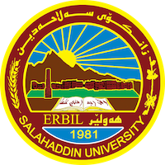
Academic Curriculum Vitae
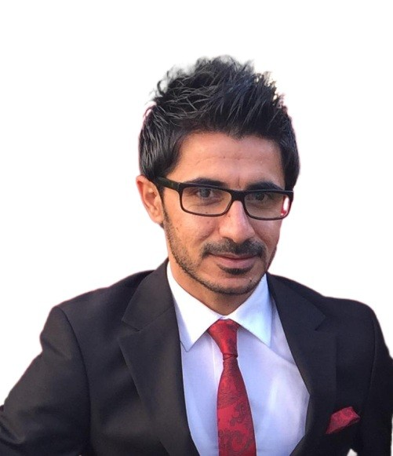
Personal Information:
Full Name: Kaiwan Kareemkhan Fatah
Academic Title: Assistant Lecturer
Email: (kaiwan.fatah@su.edu.krd)
Mobile:00964 750 409 6074

Education:
- BSc. in Geology, College of Science, Salahaddin University-Erbil, Iraq, 2011.
Research title: Petrography (meta-igneous) of Walash volcanic and sub-volcanic rocks in Bardabas Mountain and Rubarook in Iraqi Kurdistan Region.
- MSc. in Applied GIS and Remote Sensing, Southampton University, UK, 2015.
Thesis under title: Investigation of the changes in Lake Dokan (Iraqi Kurdistan Region) and its catchment area in relation to climate change using Remote Sensing data.

- Diploma in Teaching, 2016.

  - Currently PhD student
Employment:
- Assistant geology in Geology department, College of Science- Salahaddin University-Erbil from 2011 to 2018
- Assistant Lecturer at Geology (Earth sciences and petroleum) department, College of Science- Salahaddin University-Erbil from 2018 – present.

Qualifications
- Diploma in Teaching, 2016.
- Multiple international courses online qualification about GIS and Remote Sensing, and Geoinformatics.
- IELTS test
- TOT and HSE, GIS, Remote Sensing, Water resource management, natural disaster managements courses.

Teaching experience:
- Teaching assistant, Salahaddin University-Erbil, 2011-2013.
Teaching labs in general geology, structural geology, geophysics, petroleum geology, geology of Iraq, remote sensing, geomorphology, sedimentary rocks and rock forming mineral.
- Supervising a team of undergraduate students while doing summer field work in 2011-2012 and 2013 and 2016-2017 and 2017 -2018.
Teaching student how to collect field data, construct geological map and cross-section, and write a geological report.
- Assistant lecturer and teaching practical remote sensing (labs) for Geology (Earth sciences and petroleum) department and environmental sciences department in 2016 – present.
- Assistant lecturer and teaching practical Applied GIS (labs) for Geology (Earth sciences and petroleum) department and environmental sciences department in 2016 – present.

Computer Skills
Regularly works with:
- Microsoft office (Word, Excel, PowerPoint and Access).
- GIS, image processing and mapping software “ArcGIS Pro, ArcGIS, Global Mapper, ,ENVI, AUTOCAD and ERDAS”.
- R statistics a language and environment, SPSS and Matlab for statistical computing and graphics.
- Surfer software for mapping
- Petrel and RockWare software for geological purposes.
- PCI Geomatica for extracting lineament map and density map.
- Cyclone software for creating 3D graph from LiDAR data.
- IDL language software for mapping and image analysis.
- Full skills in using GPS
Professional Skills
- Excellent knowledge in geological survey, surface geological mapping, subsurface geological mapping and structural mapping/analysis.
- Worthy knowledges in mapping and GIS.
- Excellent skill in dealing with remote sensing data (satellite images, DEM, and Arial photograph).
- Good at field sampling, data acquisition, processing, and interpretation (2D and 3D) of seismic maps involving a wide variety of play types.
- Good at laboratory analysis (geological samples).
- Excellent knowledge in structural geology of Iraq, and geological formations of the Iraq.
- Using GIS and remote sensing in environmental management.

Research and publications
Fatah, K. K., Mustafa, Y. T., & Hassan, I. O. (2023). Geoinformatics-based frequency ratio, analytic hierarchy process and hybrid models for landslide susceptibility zonation in Kurdistan Region, Northern Iraq. Environment, Development and Sustainability, 1-38.
Fatah, K. K., Mustafa, Y. T., & Hassan, I. O. (2022). Flood susceptibility mapping using an analytic hierarchy process model based on remote sensing and GIS approaches in Akre District, Kurdistan Region, Iraq. Iraqi Geological Journal, 55, 121–149.
Dara, R. N., Jirjees, S., Fatah, K. K., & Javadinejad, S. (2021). Climatic Parameters Analysis of Koysinjaq Meteorological Station, Kurdistan Region, Northern Iraq. The Iraqi Geological Journal, 99-109.
Fatah, K. K., Seeyan, S., & Jirjees, S. (2020). Morphometric analysis using geo-information techniques for different watersheds in northeastern part of Erbil City, Kurdistan Region, North Iraq. The Iraqi Geological Journal, 88-104.
Jirjees, S., Seeyan, S., & Fatah, K. (2020). Climatic analysis for Pirmam area, Kurdistan Region, Iraq. The Iraqi Geological Journal, 75-92.
Fatah, K. K., Hamed, M., Saeed, M. H., & Dara, R. (2020). Evaluation groundwater quality by using GIS and water quality index techniques for wells in Bardarash area, Northern Iraq. The Iraqi Geological Journal, 87-104.
Participated of crating map for Book under title: Groundwater in Iraq, 2022.
Conferences and courses attended
- GeoKurdistan V International Conference, University of Sulaimani/College of Science, 2022.
- 3rd International (5th scientific) Conference under title of Scientific research aimed support of principle of Iraq Development, University of Tikrit/ College of Science, 2022.
- International online Conference (Application of Hybrid Modeling in Geographical research), 2023
- ArcGIS Pro Basics course online Esri, 2022.
- Sentinal Hub course, 2022.
Funding and academic awards
- Human Capacity Development Program scholarship (for studying master aboard) from Kurdistan Regional Government-Iraq, 2013-2015.
- Ranked the first among 50 graduated students in 2011.
Professional memberships
- Kurdistan Geologists Syndicate, 2011-Present.
- Stuff of Geology Department/College of Science / Salahaddin University-Erbil
Professional Social Network Accounts:
Research Gate:https://www.researchgate.net/profile/Kaiwan-Fatah-3
Google scholar:https://scholar.google.com/citations?hl=en&user=Gg1yCo0AAAAJ
Linkedin:https://www.linkedin.com/in/kaiwan-k-fatah-8b3179125/
ORCiD:https://orcid.org/my-orcid?orcid=0000-0002-2535-8135
Facebook:https://www.facebook.com/kaiwan.kareemkhan

