وتار

تیبینی ئه‌و وتارانه‌ له‌ ژماریه‌ك له‌ سایت و پێگه‌ ئه‌لیكترۆنیه‌ كوردیه‌كاندا بڵاوكراوه‌ته‌وه‌

https://www.facebook.com/kmentk?__tn__=%2CdC-R-R&eid=ARABRFWtBjpAOtUULL7J0IeEcxQiPEsrLy105cQv2egV0TTktOrg0a-Q83h1mmvIMCHVIo0wf2mJoeEC&hc_ref=ARRG_MeVXeeGzPFutMH9IuUvQcptJPu8h8FgVYVTNRHUuKfCrfTgOXianGp6tbDjbO0&fref=nf

https://www.facebook.com/kmentk?__tn__=%2CdlC-R-R&eid=ARA5lyG4uMEEyTu6TJaFFZ9OJ85BO5S-73PkFLILGJLTdG-SHotPaLKRfpoKsPUYFoNx5I8XawSHVuVS&hc_ref=ARTzJhcNdImuojcvCjyv5Px79xEbOvmBrTWmVmLkAd03C0WofKfm34Du0BpZ3_4UMII

https://www.facebook.com/kmentk?__tn__=%2CdC-R-R&eid=ARDrZsMQJZpytxDXMDqhKaa7l9qIMBIKR1ZNbCmEv8RdCDntInJCjzfzQWckM9eVvuVjbSvZsVpWNLtQ&hc_ref=ARSj264hp9AV1vEt8PwCp3-hgEslRgmW00MYPj4HgQta0NS64Z5Vw-VbM63p0i0QShE&fref=nf

https://www.facebook.com/kmentk?__tn__=%2CdC-R-R&eid=ARCI7aVZWRAVJyMFmW14Mm3IaDG7rrZWpq61d095RwwOScEbLWF67XkjaFB2OjWB3v64gPWgkq9Q625I&hc_ref=ARQMQPNeM7jCXMtK9R_b_Pzt3uSieX_gr2Kix_RiSQ9BcOiVxwyNae6xGO9BLpmEErc&fref=nf

https://www.facebook.com/kmentk/posts/2800627513313107

https://www.facebook.com/kmentk/posts/2680108928698300

https://www.facebook.com/photo.php?fbid=2768669076508951&set=a.119965674712651&type=3&theater

چاوپێكه‌وتن

https://www.dengiamerika.com/a/4918483.html?fbclid=IwAR0Hs_dwLxKXRLDz4n9I5IuSIlt-Oyfpg-RQR6X-8lRB7B9Bm-d_IiLjBc0

https://www.dengiamerika.com/a/4858667.html?fbclid=IwAR0PZAN09XoqlJtn29QdaPAPUfGJpRlmfk381Th4yY1i58IoKLEGMST1JCM

https://rojnews.news/كوردستان/د-کامەران-مەنتک-ڕۆشنبیری-کورد-بەسەر-حزب-و-گروپدا-دابەشبوون-36650?fbclid=IwAR1YknmW8_64Q5hBSF34wK5fi_7qOGpPJUGj_NKuaqBb3fTvdT0-27Kloo8

https://www.facebook.com/kmentk/posts/2677903005585559

كونفرانس
ناوه‌وه
له‌ مانگی 12\2019 له‌ سلیمانی به‌ڕێوه‌ چوو

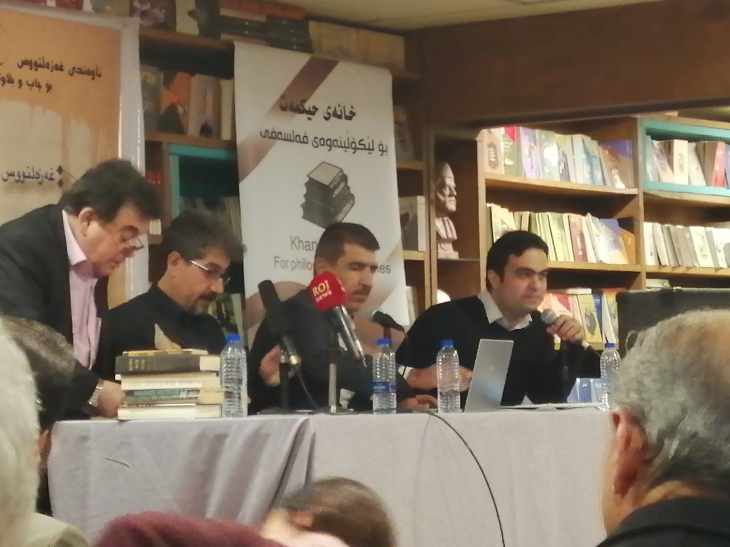
‌
https://www.facebook.com/kmentk/posts/2618012851574575?__xts__[0]=68.ARCvJ5ECBkL8jE2v50MqUznRATlW3Of9RGJSdvSGaeXdvjYrZEalpx_ku3hwnUVkw9I9ZejP77SEqgyBNIYjlHbDW9aYlIK2UbuVgIORC35PYRYg2TrWcs-y6mLfFYu0y2Z534jzMutCHuaGcR905O8WPZ3e66sXpcGxUzUM2i7_GMauW8iOT5JOneWDNVv0YLmtrSq22tqH4VOr1vKD8yKmAcrMbVb4tvmD7F82CmN6wkdSI0vI-sX3WscvWclguuvaDZOCnQRxrDZFVlgzug0WUOwA7oJ6wvy8_IBCECpH2wejcX6w-3C2XHXg2xF70c7bY4xipU-OtaZl8zIaIAP65a7nluD4HoCh1Q&__tn__=-R

كونفرانس ده‌روه‌ی ولات-لوبنان
له‌ مانگی 11\2019 له‌ به‌یروت به‌سترا

