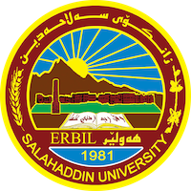
Academic Curriculum Vitae
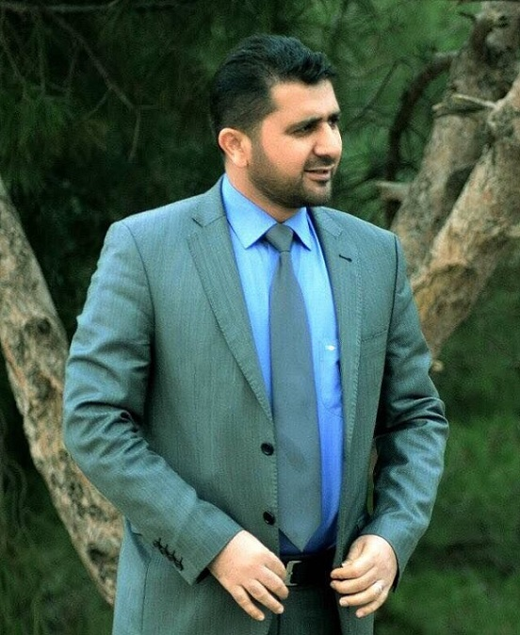
Personal Information:
Full Name:Dr.Kamaran Ali Fathullah
Academic Title:lecturer
Email: (kamaran.fathullah@su.edu.krd)
Mobile:07504554920+ 07824554920

Education:
- Bachelor degree at historical department salahadin university college of arts in 2001
- Master of history in Islamic History Mustansiriyah university, college of Education in 2010
- Holder of Ph in the Islamic History- History Dept./ college of arts/ University of ALMosul 2017

Employment:
- State employment starting from first employment in history depatment of Salahaddin university as teaching assistant researchger .
- Assistant Lecturer in history department of Salahaddin university college of arts

Qualifications
- In computer ( Word , excel , power point)

Teaching experience:
- I continue the process of teaching in the College of Arts, Department of History in all its stages, and participated during the past years as a teacher in a qualifying training course in the Ministry of Education in the Directorate of Training and Rehabilitation Courses for teachers and new teachers.
- State all teaching courses you delivered, stating undergraduate or post graduate
- Courses, trainings, lab supervision, etc.,

- He has a number of researches, in particular, a research on diplomatic relations between the Bahri Kingdoms and the Ilkhanid Mongols, in Tikrit University Journal
The year 2017, and another research on the characteristics of the Kurdish national movement between the two world wars, published in the Journal of Salahaddin University 2019. And in other magazines...Research and publications
- Four of my books have been printed first, in collaboration with the researcher Youssef Saber, in the name of Sultan Salah al-Din al-Ayyubi between the sincerity of his city and criticism of his opponents, and my second book is entitled Diplomacy of Sultan Salah al-Din al-Ayyubi in the light of the letters of the Office of Creation. My third book was printed in the name of Diplomacy in the Bahri Mamluk State and its Relations with Non-Islamic Countries, and my fourth printed book was titled The History of the Abbasid State.
Conferences and courses attended
- I attended of conference about Erbil in Historcal Sources – Read and evaluate 2019/4/
- I participated in a scientific conference of the Faculty of Arts in the year 2023 under the title of the issue of belonging and patriotism in the Kurdistan region. And a number of other dates

Professional memberships
- List any membership you hold of any professional body or learned society relevant to your research or other life activities.

Professional Social Network Accounts:
- I membership in )Historical Cultural Association(

It is also recommended to create an academic cover letter for your CV, for further information about the cover letter, please visit below link:
/

