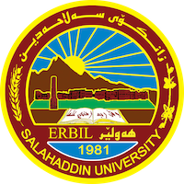
Academic Curriculum Vitae
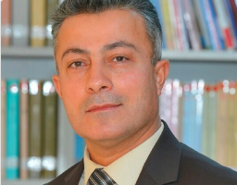
Personal Information:
Full Name:Kamaran Muhammad Haji
Academic Title :Assistant Professor
Email: kamaran.haji@su.edu.krd
Mobile:07504548527

Education:
- Bachelor of Arts and History (7/7/1997), College of Literature, Department of History, Salahaddin University/Erbil.
- Master in Modern History, College of Arts – Department of History (17/6/2006).
- Doctorate in Modern History, College of Arts - Department of History (23/7/2013)

Employment:
_First establishment and location: 28/10/1997, Ministry of Education, Shaqlawa Education Directorate.
- First appointed: 2/11/1997.
- First employment in Salahaddin University and place of establishment: 16/6/2007, College of Arts – Department of History.
Qualifications
- In computer ( Word , excel , power point)
- Teaching qualifications
- IT qualifications
- Language qualifications such as TOEFL, IELTS or any equivalent
- Any professional qualification
- You could put any professional courses you have attended

Teaching experience:
- Great powers, Modern and contemporary history of the Kurds, History of the Ottoman Empire and modern Turkey, History of political thought, History of the Renaissance, Contemporary Iraq history>

Research and publications
-Ottoman Kurdistan in Britain's policy (Nineteenth Century).
-Kurdistan in the circle of the eastern question 1800-1900.
- History of Cyprus until 1974.
- The problem of the Iskandaruna brigade 1915-1939
- Ottoman Kurdistan from the middle of the nineteenth century to 1918.
- Erbil in the Memoirs of European Travelers in the Nineteenth Century /A Study of Urban, Economic and Social Conditions.
- The city of Slemany in the notes of foreign travelers during the nineteenth century.
- Memdouh Selim Beg Wanly (1893-1976).
- The Economic Status of Kirkuk in Foreign Sources in the Nineteenth Century.

Conferences and courses attended
-Erbil in Historical Sources (Reading and Estimation) 10-11 April 2019.
Funding and academic awards
- None

Professional memberships
- Member of the Kurdistan Teachers Union
-Member of the committee collecting and printing the productions of Dr. Kamal Mazhar Ahmed.
-Member of the Kurdistan Encyclopedia Association.

-
Professional Social Network Accounts:

- List your profile links of ReserchGate, LinkedIn, etc.

It is also recommended to create an academic cover letter for your CV, for further information about the cover letter, please visit below link:
https://career-advice.jobs.ac.uk/cv-and-cover-letter-advice/academic-cover-letter/

