University of Salahaddin –Hawler
College of Engineering
Survey Engineering Department

Engineering Economy
Content:
1-Foundations of Engineering Economy.
2- Factors: How Time and Interest Affect Money.
3- Nominal and Effective Interest Rates
4-Present, Future and Annual, Worth Analysis.
References:
1-Engineering Economy, byLeland Blank, P. E.and Anthony Tarquin, P. E., 7th edition ,copyright by McGraw-Hill 2012. (Textbook)
2- Engineering Economy by W.Sullivan,E Wicks,J. Luxhoj, 13th edition,2006.

Foundations of Engineering Economy.
Engineering economy: can be defined as collection of techniques that simplify comparison of alternatives on an economic basis. Usually engineering economy involves formulating, estimating, and evaluating the expected economic outcomes of alternatives designed to accomplish a defined purpose.

Performing an Engineering Economy Study
Alternatives: An alternative is a standalone solution for a given situation.
Cash Flows: The estimated Inflow (Revenues) and Outflows (Costs) of money are called cash flows.
Alternative Selection: Every situation has at least two alternatives. In addition to the one or more formulated alternatives, there is always the alternative of inaction, called the Do Nothing (DN) alternative.
Evaluation Criteria: Whether we are aware of it or not, we use criteria every day to choose between alternatives. For example, when you drive to the faculty, you decide to take the “best” route. But how did you define best? Was the best route the safest, shortest, fastest or cheapest?
Time Value of Money: It is often said that money makes money. The change in the amount of money over a given time period is called the time value of money; it is the most important concept in engineering economy.

Interest rate and rate of return.

- Interest = end amount – the original amount
- Interest rate is interest over a specified time period based on the original amount
- Interest rate (%) = (interest accrued per time unit /original amount) x 100%
Example:
End amount = 108 $ and original amount = 90 $ then,
Interest = 108 – 90 = 18
Interest rate (%) = (18 /90) x 100% = 20%
- Interest period: The time unit of the interest rate is called the interest period. By far the most common interest period used to state an interest rate is 1 year. Shorter time periods can be used, such as 1% per month.
-The term interest rate is more appropriate for the borrower’s perspective, while the Rate of return is better from the investor’s perspective.
-Interest rate and rate of return (ROR) have the same numeric value, but different interpretations.

Economic equivalence: is a combination of interest rate and time value of money to determine the different amounts of money at different points in time that are equal in economic value.
For example; if the interest rate is 5%per year and the total amount today is equal to 100$(present time) is equivalent to 105$ one year from today.

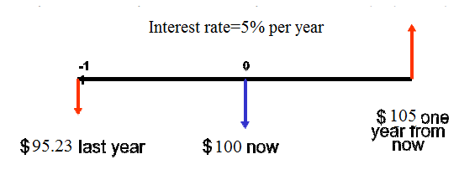
Simple and Compound Interest.
-Simple interest is always based on the original amount, which is also called the principal.

Interest per period = (principal) x (interest rate)
Total interest = (principal) x (n periods) x (interest rate)

Example: Invest $1000 with simple interest at 4% per year compounded; find the interest over 3year.
Solution.
(1)  End of one year | (2)  Amount Borrowed | (3)  Interest | (4)  Amount  Owed | (5)  Amount  Paid
0  1  2  3 | $1000  -  -  - | $40  $40  $40 | $1040  1080  1120 | $0  0  $1120

Interest, year 1 = 1000 (0.04) = $40
Interest, year 2 = 1000 (0.04) = $40
Interest, year 3 = 1000 (0.04) = $40
Interest over 3 years = (40)3 = $120

Compound interest; is based on the principal plus all accrued interest.

Interest per period = (principal + accrued interest) x (interest rate)
Total interest = (principal) x (1+interest rate)^{n periods} – principal
Example: Invest $1000 with a compound interest at 4% per year compounded; find the interest over 3year.

(1)  End of one year | (2)  Amount Borrowed | (3)  Interest | (4)  Amount  Owed | (5)  Amount  Paid
0  1  2  3 | $1000  -  -  - | $40  $41.6  $43.264 | $1040  1081.6  1124.86 | $0  0  $1124.86

Interest, year 1 = 1000 (0.04) = $40
Total amount due after year 1 = 1000+40 = 1040
Interest, year 2 = 1040 (0.04) = $41.6
Total amount due after year 2 = 1040+41.6 = 1081.6
Interest, year 3 = 1081.6 (0.04) = $43.264
Total amount due after year 3 = 1081.6 +43.264= 1124.86
Interest over 3 years = 1124.86–1000 = $124.86

An extra of = 1124.86– 1120 = $4.86 is paid compared to simple interest over the
three-years period

Terminology and Symbols.

P = Value of the amount of money at a time designated as the present or time zero.
Also, P is referred to as Present worth (PW), Present Value (PV). Net Present
Value (NPV), discounted Cash Flow (DCF) and Capitalized Cost (CC).

F = Value of the amount of money at some future time. Also, F is called Future Worth
(FW) and Future Value (FV).

A = Series of consecutive, equal end-of-period amounts of money. Also, A is called
the Annual Worth (AW) and Equivalent Uniform Annual Worth (EUAW); dollars
per year, dollars per month.

N = number of interest periods; year, months, days.
i = interest rate or Rate of Return per time period; percent per year, percent per month, percent per day.

t = Time, stated in periods; years, months, days.

Cash Flows: Their estimation and Diagramming: Cash flows are Inflows and Outflows of money.
Cash inflows are the receipts, revenues, incomes, and savings generated by project and business activity. A plus sign indicates a cash inflow
Cash outflows are costs, disbursements, expenses, and taxes caused by projects and business activity. A negative or minus sign indicates a cash outflow. When a project involves only costs, the minus sign may be omitted for some techniques, such as benefit/cost analysis.
Net cash flow (NCF) = inflow – outflow

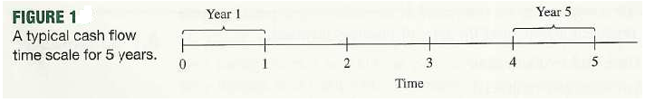
Cash flow diagram t = 0 is the present, and time t = 1 is the end of time period 1. We
assume that the periods are in years for now. The time scale for figure 1 is set up for 5
years. Since the end of the year, convention places cash flows at the ends of years, the “1”
marks the end of year 1.
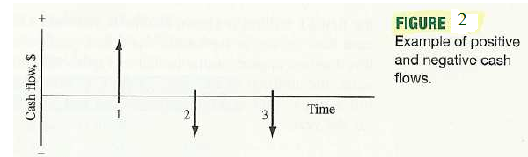
A vertical arrow pointing up indicates a positive cash flow. Conversely, an arrow pointing down indicates a negative cash flow.

Factors: How Time and Interest Affect Money

Cash Flow Conventions: below cash flows

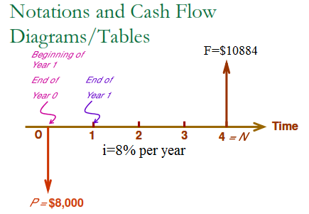

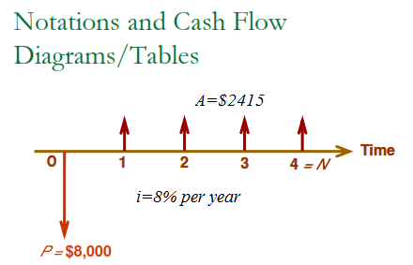

a- Horizontal line represent the time scale.
b-The arrow signify cash flows and are placed at the end of the period.
C-The cash flow diagram is dependent on the viewpoint.

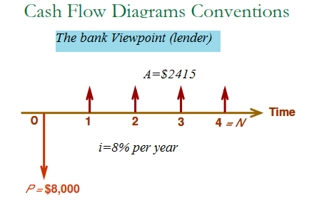

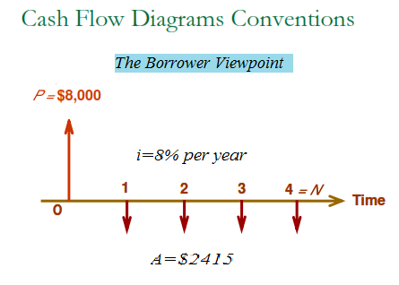

Example:
1- MRK corporation invested of $8,000 that will produce a uniform annual revenue of $2110 for five years. At the end of the fifth year, the market recovery will be $2,000. Annual expenses will be $3,000 at the end of each year for operation and maintenance. Draw a cash flow diagram for the five-year life of the project. Use the corporation viewpoint.

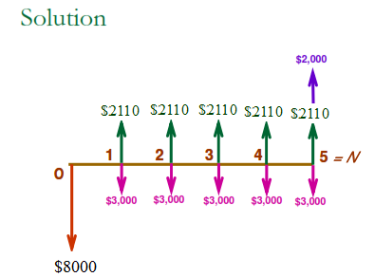

Interest Formulas Relating Present and Future Equivalent Values of Single Cash
Flows:

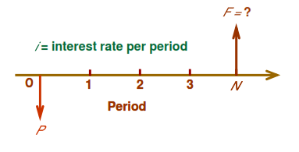
Finding F when Given P:

F₁=P + Pi=P(1+i)
F₂=P (1+i) + P(1+i)i
F₂=P (1+i)(1+i)=P(1+i)²
F₃=P(1+i)³

F=P(1+i)^{N}

Where; the quantity (1+i)^{N} is called compound amount factor. The equation can be expressed as:
F=P(F/P, i%, N)

Example
P = $8,000
N = 4 years
i = 9% per year
Find F
F = P(1+i )^{N} = P (F/P, 9%, 4)
= $8,000 (1.4116) = $11,292.7

Finding P when Given F:

F = P(1+i )^{N}
Solving for P
P = F(1+i )^{-N}
Where; the quantity (1+i)^{-N} is called payment present worth factor. The equation can be expressed as:
P=F (P/F, i%, N)

Example
An Investor (owner) has an option to purchase a tract of land that will be worth $10,000 in the fifth year. If the value of the land increases at 9% each year, how much should the investor be willing to pay now for this property?
Sol.
F = $10,000
N = 5 years
i = 9% per year
Find P
P = F(1+i )^{-N}
= $10,000 (P/F, 9%, 5)
= $10,000 (0.65) = $6,500
Interest formulas relating a uniform series (annuity) to It is present and future equivalent values.

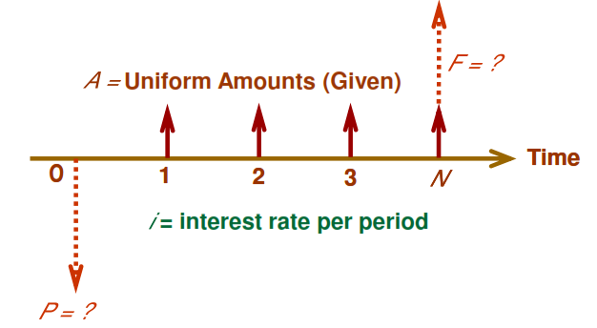

Finding F when Given A:

F=A(1+i)^{N-1}+A(1+i)^{N-2}+….+ A(1+i)²+ A(1+i)+A ---------1
F(1+i)=A(1+i)^{N}+A(1+i)^{N-1}+….+ A(1+i)³+ A(1+i)²+A(1+i) ---------2

Subtract EQ.1from EQ.2

F(1+i)-F=A(1+i)^{N}-A
Fi=A[(1+i)^{N}-1]

$$F=A[\frac{{\left(1+i\right)}^{N}-1}{i}]$$

$$the quantity \left[\frac{{\left(1+i\right)}^{N}-1}{i}\right] is Called Uniform Series Compound Amount Factor$$
The equation can be expressed as:
F=A(F/A, i%, N)
Example:
Suppose you make 15 equal deposit of $2,000 each into a bank account paying 8% interest per year. The first deposit will be made one year from today. How much money can be withdrawn from this bank account immediately after the15th deposit?

Sol.

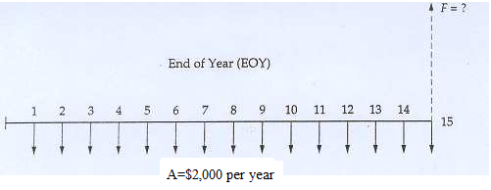
F = A (F/A, i %, N)
F = $2,000 (F/A, 8%, 15)
F = $2,000 (27.152) = $54304

Finding P when Given A:

$$F=A[\frac{{\left(1+i\right)}^{N}-1}{i}]$$
$$P(1+i)^{N}=A[\frac{{\left(1+i\right)}^{N}-1}{i}]$$

$$P=A[\frac{{\left(1+i\right)}^{N}-1}{i(1+i)^{N}}]$$

$$The quantity \left[\frac{{\left(1+i\right)}^{N}-1}{i(1+i)^{N}}\right]is called Uniform Series Present Worth Factor$$

The equation can be expressed as:

P=A(P/A, i%, N)

Example:
If a certain machine undergoes a major overhaul now. Its output can be increased by 20%. Which translates into the additional cash flow of $15,000 at the end of each year for five years? If i = 13% per year, How much can we afford to invest to overhaul this machine?
Sol.
A = $15,000
N = 5 years
i = 13% per year
Find P
P = A(P/A, 13%, 5)
= $15,000 (3.517) = $52758

Finding A when Given F:

$$F=A[\frac{{\left(1+i\right)}^{N}-1}{i}]$$

$$A=F[\frac{i}{{\left(1+i\right)}^{N}-1}]$$
$$The quantity of \left[\frac{i}{{\left(1+i\right)}^{N}-1}\right]is called Sinking Fund Factor$$

The equation can be expressed as:

A=F(A/F, i%, N)

Example:
An enterprising student is planning to have personal savings totaling $2,000,000 when she retires at age 65. She is now 20 years old. If the annual interest rate will average 7% over the next 45 years on her savings account. What equal end-of-year amount must she save to accomplish her goal?

Sol.
F = $2000,000
N = 45 years
i = 7% per year
Find A
A = F
(A/F, 7%, 45)
= $2000,000 (0.0035) = $7000

