Building Materials and Building Construction
References:
1-Building Materials by GURCHARAN SINGH, Fourth Edition.
2-Building Design and Construction Handbook by FREDERICK S. MERRITT&JONATHAN T. RICKETTS.
3-Building Construction by Dr. PUNMIA.
4-Concrete Technology (Theory and Practice) by M.S. SHETTY –New Delhi India-2010.
5-Concrete Technology by A.M. Neville, second edition.
6-Properties of Concrete by A.M. Neville, fourth edition.

Items of course:
- Building Materials content:
1- Cement
2- Aggregate (Sand, and gravel).
3- Concrete.
4-Gypsum.
5-Tiles.
6- Steel and its Alloy.
7- Woods and Glasses.
8-Paints and other Coating.
9- Asphalt and Bituminous Product.

- Building Constructions content:
10-Foundations and type of foundations.
11- Masonry and types of masonry, stone, brick, and concrete block masonry.
12-Load bearing walls.
13-Cavity walls.
14- Partition walls.
15- Floors and types of floors.
16-Upper floors types.
17-Plastering with Gypsum and with cement mortar.
18- Shoring, underpinning and scaffolding.
19-Formwork.
20- Thermal insulation.
Cement
Cement can be described as a material with adhesive and cohesive properties which make it capable of bonding mineral fragments into a compact whole. The use of cementing materials is very old. The ancient Egyptians used calcined impure gypsum. The Greeks and the Romans used calcined limestone and later learned to add to lime and water, sand and crushed stone or brick and broken tiles.
Manufacture of Portland cement
The raw materials required for manufacture of Portland cement are calcareous materials, such as limestone or chalk, and argillaceous material such as shale or clay. Cement factories are established where these raw materials are available in plenty. The process of manufacture of cement consists of grinding the raw materials, mixing them intimately in certain proportions depending upon their purity and composition and burning them in a kiln at a temperature of about 1300 to 1500ºC, at which temperature, the material sinters and partially fuses to form nodular shaped clinker. The clinker is cooled and grind to a fine powder with addition of about 3 to 5% of gypsum.
Chemical composition
The raw materials used for manufacture of cement consist mainly of lime, silica, alumina, and iron oxide. These oxides interact with one another in the kiln at high temperature to form more complex compounds. The relative proportions of these oxide compositions are responsible for influencing the various properties of cement; in additions to rate of cooling and fineness of grinding. The below table shows the approximate oxide composition limits of ordinary Portland cement.
Oxide | Percentage content
CaO | 60-67
SiO₂ | 17-25
Al₂O₃ | 3.0-8.0
Fe₂O₃ | 0.5-6.0
MgO | 0.1-4.0
Alkalies(K₂O,Na₂O) | 0.4-1.3
SO₃ | 1.3-3.0
The identification of the major compounds is largely based on R.H.Bogue's work and hence it is called "Bogue's Compounds". The four compounds usually regarded as major compounds are listed below table:
Name of compound | Formula | Abbreviated Formula
Tricalcium silicate | 3CaO.SiO₂ | C₃S
Dicalcium silicate | 2CaO.SiO₂ | C₂S
Tricalcium aluminate | 3CaO.Al₂O₃ | C₃A
Tetracalcium aluminoferrite | 4CaO.Al₂O_{3.}Fe₂O₃ | C₄AF

It is to be noted that for simplified represent:
C=CaO, S=SiO₂, A=Al₂O₃, F=Fe₂O₃ and H for H₂O .
The equations suggested by Bogue for calculating the percentages of major compounds are given below.
C₃S= 4.07 (CaO) - 7.60(SiO₂)-6.72(Al₂O₃)-1.43(Fe₂O₃)-2.85(SO₃)
C₂S=2.87(SiO₂) – 0.754(3CaO.SiO₂)
C₃A=2.65(Al₂O₃) - 1.69(Fe₂O₃)
C₄AF=3.04 (Fe₂O₃)
The terms in brackets represent the percentage of the given oxide in the total mass of cement. In addition to the four major compounds, there are many minor compounds formed in the kiln. The influence of these minor compounds on the properties of cement is not significant. Two of the minor oxides namely K₂O and Na₂O referred to as alkalis in cement are of some importance. The oxide composition of typical cement and the calculated compound composition obtained by means of Bogue's equations are shown the below table:
Typical oxide composition  percent |  | Calculated compound  Composition by  Bogue's equation
CaO | 63 | C₃A | 10.8
SiO₂ | 20 | C₃S | 54.1
Al₂O₃ | 6 | C₂S | 16.6
Fe₂O₃ | 3 | C₄AF | 9.1
MgO | 1.5 | Minor compounds | -----------
SO₃ | 2
K₂O | 1
Na₂O
Others | 1
Lost on ignition | 2
Insoluble residue | 0.5
It is necessary to know ratio of percentage of lime to percentage of silica, alumina and iron oxide, known as lime saturation factor, which calculated as:
$$Lime saturation factor=\frac{CaO-0.7{SO}_{3}}{2.8{SiO}_{2}+1.2{Al}_{2}O_{3}+0.65F_{e2}O_{3}}$$
Ratio of lime saturation should be within the range (0.66-1.02).
It is known that increase of lime saturation factor from the above limit cause crack in concrete and decrease the percentage cause decreasing lime and alkalis materials.
Q1- Find the major compound of cement for the following types:
Oxide | Type 1 | Type 2 | Type3
CaO | 64 | 61.9 | 62.4
SiO₂ | 21.3 | 25.4 | 21.2
Al₂O₃ | 6.06 | 4.57 | 4.03
Fe₂O₃ | 2.77 | 2.07 | 5.6
MgO | 4 | 1.5 | 3
SO₃ | 1.6 | 2.2 | 2.4

Q2-What is the effect of alkali oxides (K₂O and Na₂O) in cement?
ANS2.
If cement contain such oxides more than 1% cause the alkaline reaction in the aggregate where they combine these alkaloids with the silicate and its conversion to a substance that causes increase in volume of the concrete, in case that if this occurs in the solid state, they lead to cracking and fragmented the concrete. The reasonable ratio for these oxides in the cement it is about (0.1-0.4) %.
By using a powerful electron microscope capable of magnifying 50,000 times or more we can see the structure of cement as shown below.

The cement and hydration of Portland cement can be schematically represented as below:

Hydration of cement.
Anhydrous cement does not bind fine and course aggregate. It acquires adhesive property only when mixed with water. The chemical reactions that take place between cement and water cause hydration of cement. Anhydrous cement compounds, when mixed with water, react with each other to form hydrated compounds of very low solubility. The reaction liberates a considerable quantity of heat. The study and control of heat hydration become more important with a mass concrete structure such as dams. The below figure shows the pattern of the liberation of heats from setting cement and during the early hardening period.

Different compounds of cement hydrate at different rates and liberate different quantities of heat. The below figure shows the rate of hydration of pure compounds.
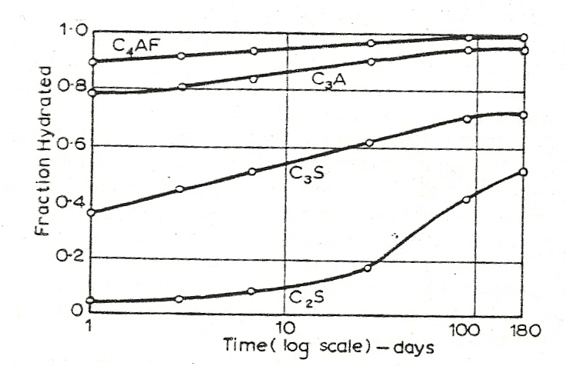

Typical hydration of pure compounds.

Water required for hydration.
For chemical reactions of Portland cement compounds, the average requires of water is about 23% by weight of cement. This 23% of water chemically combines with cement and, therefore, it is called bound water. A certain quantity of water is imbibed within the gel-pores. This water is known as gel-water. If the quantity of water is inadequate to fill up the gel-pores, the formations of gel itself will stop. It has been further estimated that water about 15% by weight of cement is required to fill up the gel-pores. Therefore, a total 38% of water by weight of cement is required for the complete chemical reactions and to occupy the space within the gel-pores.it is noted that if more than 38% of water by weight of cement used, then the excess water will cause undesirable capillary cavities. The diagrammatic representation of the progress of hydration is shown in the below figure.

Types of cement:
Generally, Cement can be classified as the following types
1- Ordinary Portland cement:
Development of strength comes gradually and reaches most of the maximum value at 28 days, while 75% of maximum values obtained during 7days. The fineness of this type of cement is about 300 m²/kg.
2- Rapid hardening cement. Rquired for all
As the name indicates it develops strength rapidly due attributed to the higher fineness of grinding (specific surfaces not less than 325m²/kg) and higher C₃S and lower C₂S content. A higher fineness of cement particles exposes greater surface area for reaction with water and also higher proportion of C₃S results in quicker hydration.
The use of rapid hardening cement is recommended in the following situation:
a- In pre-fabricated concrete construction.
b- Where formwork is required to be removed early.
c- Road repair works.
d- In cold weather concrete where the rapid rate of development of strength reduces the vulnerability of concrete to the frost damage.
3- Extra rapid hardening cement. is obtained by intergrinding calcium chloride with rapid hardening cement. The normal addition of calcium chloride should not exceed 2% by weight of rapid hardening cement. It is necessary that the concrete made by using extra rapid hardening cement should be transported, placed and compacted and finished within about 20 minutes. It is also necessary that this cement should not be stored for more than a month. the strength of extra rapid hardening cement is about 25 per cent higher than that of rapid hardening cement at one or two days and 10-20 per cent higher than at 7 days. Rapid hardening cement cause a small amount of initial corrosion of reinforcement, but in general the effect does not appear to be progressive and such there is no harm in using extra rapid hardening cement in reinforce concrete work.

4- Sulphate resisting cement. Required for all
Ordinary Portland cement is susceptible to the attack of sulphates, in particular to the action of magnesium sulphate. Sulphates react both with the free calcium hydroxide in set- cement to form calcium sulphate and with hydrate of calcium aluminate to form calcium sulphoaluminate, the volume of which is approximately 227% of the volume of the original aluminates. Their expansion within the frame work of hardened cement paste results in cracks and subsequent disruption. To remedy the sulphate attack, the use of cement with low C₃A content is found to be effective. Such cement with low C3A and low C₄AF content is known as Sulphate Resisting Cement. Sulphate resisting cement is recommended under the following cases:
- In marine structure.
- Concrete to be used in foundation and any parts of construction which is attack to soil containing sulphate.
- Concrete to be used in the construction of sewage treatment work.
- Low Heat Cement.
Low heat cement obtained by reducing the percentage content of C₃S and C₃A and increasing the percentage of C2S of Portland cement. Usually low heat cement used in mass concrete structure such as dams. The early heat hydration and strength of low heat cement is less than of that of Portland cement due to fewer amounts of C3S and C₃A. In other hand, the ultimate strength of low-heat cement is the same as that of ordinary Portland cement.

5-Oil-Well Cement.
Oil-well are drilled through stratified sedimentary rocks through a great depth in search of oil. It is likely that if oil is struck, oil or gas may escape through the space between steel casing and rock strata and also to seal off any other fissures or cavities in the sedimentary rock layer. The cement slurry has to be pumped into position, at considerable depth where the prevailing temperature may be up to 175º C. the slurry should remain sufficiently mobile to be able to flow under these conditions for several hours and then hardened fairly rapidly. It may also have to resist corrosive conditions from Sulphur gases or waters containing dissolved salts.
The desired properties of oil- well cement can be obtained in two ways: by adjusting the compound composition of cement or by adding retarders to ordinary Portland cement.
6- Super Sulphated Cement.
Super sulphated cement is manufactured by grinding together a mixture of (80-85%) granulated slag, (10-15%) hard burned gypsum (CaSO₄), and about 5% of Portland cement. The specific surface must not be less than 4000cm²/gm. Usually super sulphate cement uses in marine structure where sea water contains of sulphate more than 1%. Water cement ratio to be used with super sulphate cement should not be less than 0.5.
7- Quick Setting Cement.
This cement as the name indicates sets very early. The early setting property is brought out by reducing the gypsum content at the time of clinker grinding. This cement is required to be mix, placed and compacted very early. It is used mostly in under water construction where pumping is involved. Quick setting cement may be also finding its use in some typical grouting operation.
8- Portland Pozzolana cement.
Portland pozzolana cement (PPC) is manufactured by the intergrinding of ordinary Portland cement (OPC) clinker with (10-25) % per cent of pozzolanic material. A pozzolanic material is essentially a silicious or aluminous material. A pozzolanic material in the presence of water reacts with calcium hydroxide, liberated in the hydration process, at ordinary temperature, to form compounds possessing cementitious properties. The common pozzolanic materials used in PPC cement are calcined clay or fly ash. Fly ash is defined as the waste material generated in the thermal power station, when powdered coal is used as a fuel. The use of fly ash performs such a role. The pozzolanic action is shown below:
Calcium hydroxide + pozzolana +water= C – S - H (gel)
Pozzolana cement produces less heat of hydration and offers greater resistance to the attack of aggressive waters than ordinary Portland cement. Practically it is useful to use it in marine and hydraulic construction and other mass concrete constructions.
9- Coloured Cement (White Cement).
For manufacturing various coloured cements either white or gray Portland cements are used as a base. The gray Portland cement is used in manufacturing red or brown cement. Generally, the use of white cement as a base is costly, hence coloured cement manufactured from combination of Portland cement with (5-10) per cent of pigment. The pigments cannot satisfactory distributed throughout the cement by mixing, and hence, it is usual to grind the cement together with pigments. The properties required of a pigment to be used for coloured cement are the durability of colour under exposure to light and weather, and not contain soluble salts. The process of manufacturing of white Portland cement is nearly same as OPC except that the raw materials used are high purity limestone (96%CaCO₃ and less than 0.07% iron oxide). White cement usually more expensive than OPC.

10- Expansive Cement.
Concrete made with ordinary Portland cement shrinks while setting due to loss of free water. Concrete also shrinks continuously for a long time. This is known as drying shrinkage. Expansive Cement used for grouting anchor bolts, machine foundations or grouting the prestress concrete ducts. Expansive cement known as the cement which had no overall change in volume on drying stage. Cement of this type has been developed by using expanding agent and stabilizer very carefully. Proper materials and controlled proportioning are necessary in order to obtain the desired expansion cement. In order to get desired properties of expansive cement, about 8-20 parts of the sulphoaluminate clinker mixes with 100 parts of Portland cement and 15 parts of the stabilizer.
11-High Alumina cement.
High alumina cement (HAC) is obtained by fusing suitable proportions of alumina and calcareous materials and grinding the resultant product to fine powder. The raw materials use for the manufacture of HAC are limestone and bauxite. The raw materials with the required proportion of coke were fired in furnace at temperature of a bout (1550-1600ºC).The product after cooling grind into fines of about 3000cm²/g. The important reaction during the setting of the high alumina cement (HAC) is the formation of monocalcium aluminate decahydrate (CAH₁₀), dicalcium aluminate octahydrate (C₂AH₈) and alumina gel (AH_{n}). These aluminates give high strength to HAC concrete but they are metastable and at normal temperatures convert gradually to tricalcium alumina hexahydrate (C₃AH₆) and gibbsite which is more stable. The change in composition is accompanised by a loss of strength and a change in crystal form hexagonal to cubical form with the release of water which results in increased porosity of concrete. The change in composition accompanied by loss of strength and change in crystal form is usually depend on the temperature, w/c ratio and chemical environment, and this operation is called conversion. Experimental studies showed that the rate of conversion increases with increasing temperatures and increasing w/c ratio.
12- Very high strength cement. Required for all
Can be classified as below:
a- Macro-defect- free cements (MDF).MDF refers to absence of relatively large voids or defects which are usually present in conventional mixed cement pasts duo to entrapped air and inadequate dispersion. MDF can be obtained by adding (4-7%) of one of several water-soluble polymers (such as hydroxypropylmethyle cellulose, polyacrylamide of hydrolysed polyvinylacetate) to reduce the w/c ratio needed for mixing cement. With this process strength of 300Mpa can be obtained for calcium aluminate system and 150 Mpa for Portland cement system.
b- Density packed system (DSP).
This system obtained by mixing Portland cement together with ultra-fine silica fume. The size of cement particles may vary from $0.5-100μ$ while the silica fume varies from$0.005 to 0.5μ$. Silica fume is usually added from 5 to 25%. Compressive strength of 270 Mpa has been achieved with silica fume. The formation of a typical DPS is represented in the below figure.
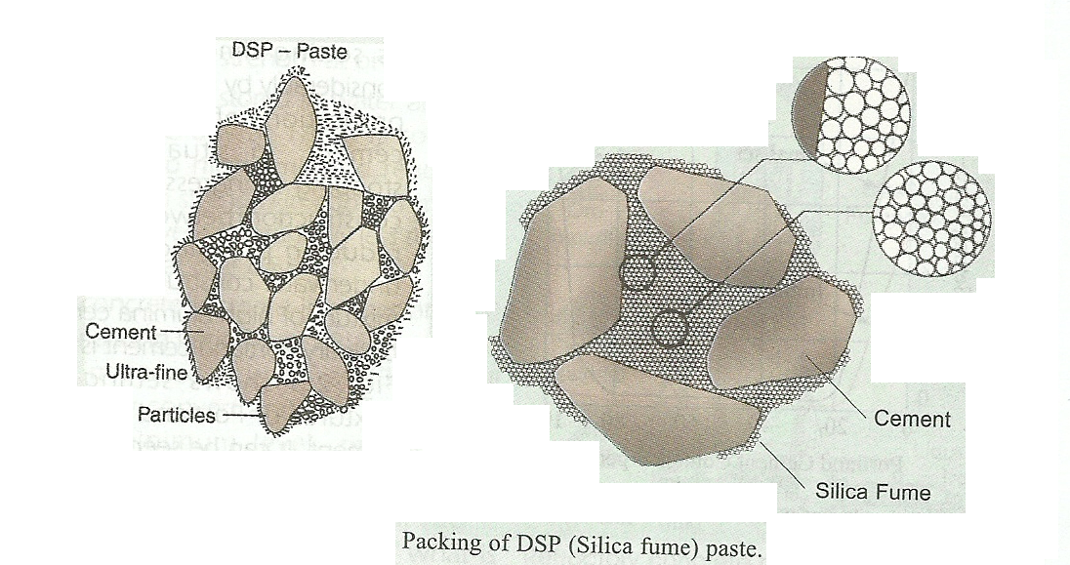
c- Pressure Densification and Warm Pressure.
Usually the porosity of normal cement paste after hardening is about 20-30%. With applying heat and pressure simultaneously to the cement past, the strength of cement increased rapidly and reaches 650 Mpa, also porosity of cement reduced up to 1.7%.
d- High Early Strength Cement. Development of high early strength becomes an important factor, sometimes, for repair and emergency work. Lithium salts have been effectively used as an accelerator in high alumina cement. This has result in very early strength in cement. For 1 hour, the strength of 4 Mpa can be obtained with this type of cement, moreover, for 3 hours a 27 Mpa can be obtained and with one day, the strength of high early strength cement can reach 49Mpa.

