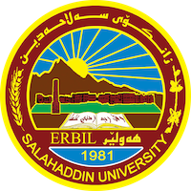
Academic Curriculum Vitae
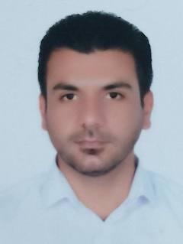
Personal Information:
Full Name: Kamaran Mustafa Taha
Academic Title: Lecturer
Email: Kamaran.taha@su.edu.krd
Mobile: 009647504256447

Education:
- 2013-2015: (M.Sc. in Animal Molecular genetics). Department of Animal Resources, College of Agricultural Engineering Sciences, Salahaddin University-Erbil, Kurdistan, IRAQ.
- 2007-2010: (B.Sc. in Animal resources). Department of Animal Resources, College of Agricultural Engineering Sciences, Salahaddin University-Erbil, Kurdistan, IRAQ.

Employment:
- 2021- to the date Lecturer of Molecular genetics, in Animal resources department at College of Agricultural Engineering Sciences college - Salahaddin University Erbil.
- 2018-2021Assist. Lecturer of Molecular genetics, in Animal resources department at College of Agricultural Engineering Sciences college - Salahaddin University Erbil.
- 2016 – to the date Reporter of Animal resources department at College of Agricultural Engineering Sciences college - Salahaddin University Erbil.
- 2011- 2013 Administrator in Animal resources department at College of Agricultural Engineering Sciences college - Salahaddin University Erbil.
- Supervised fourth year under graduation projects (5 students).

Teaching experience:
- Molecular Genetics.
- Animal Genetics
- Animal Biotechnology
- Poultry Breeding
- Animal Breeding
- Student Projects
- Courses, trainings, lab supervision, etc.,

Research and publications
- Molecular Characterization of FeCB, FeCX and FecGX Mutations in Iraqi Sheep Breeds Using RFLP-PCR Technique. Malaysia Applied Biology 46(2) (2017).
- PCR-RFLP Technique for identification of Species Origin of Meat Products. Mesopotamia J. of Agric. Vol. (48) No. (4) 2020
- Identification and Differentiation of Poultry Meat and products Using PCR-RFLP Technique. Mesopotamia J. of Agric. Vol. (41) No. (1) 2021

Conferences and courses attended
- Characterization of Polar Over Dominance Contributing to the Callipyge Phenotype in Sheep. Wasaw University of Life. The Book of Abstracts. First scientific International Conference for Students, Animal Science & Aquaculture - Challenges and Researches. Pp, 39.

Professional memberships
- Agricultural Engineers Syndicate- Iraq - Kurdistan
- Kurdistan teachers Union – Kurdistan - Erbil.
- Durbeen Organization for economic and politician.

Scopus Author ID: 57194697473
ORCID ID: 0000-0002-4777-8587
Academic Profile: https://academics.su.edu.krd/kamaran.taha
Scholar Account: https://scholar.google.com/citations?hl=ar&user=l1Lo3LsAAAAJ

