Q1/ If you have a polypeptide sequenced as (start amino acid, Glutamic, Alanine, Glycine)
What is the sequence of the mRNA and DNA for this polypeptide, and then if a second C deleted in the DNA sequence write down the new DNA, mRNA and polypeptide chain sequences. Use this table for your answer (10 Marks)
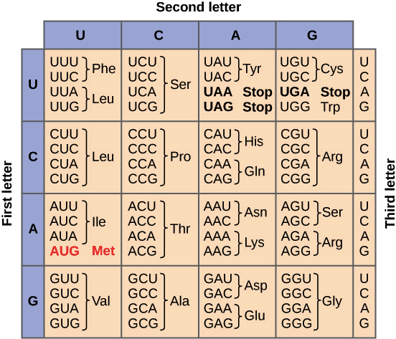

Q2/ A/ Numerate types of markers, and describe molecular markers in detail. (10 marks)

B/ What is protein and describe structure of proteins in short? (10 Marks)

Answers
Q1/ mRNA; AUG GAA GCA GGA

DNA; TAC CTT CGT CCT

Deletion in the second C the sequence of
DNA; TAC TTC GTC CT
mRNA; AUG AAG CAG GA
amino acid (polypeptide); Methionine, Lysine, Glutamine,

Q2/ A/ types of marker:
- Morphological markers
- Cytological markers
- Biochemical markers
- Molecular markers (DNA markers)
Molecular markers are nucleotide sequences and can be investigated through the polymorphism present between the nucleotide sequences of different individuals. Insertion, deletion, point mutations duplication and translocation are basis of these polymorphisms; however, they do not necessarily affect the activity of genes.
Classification of molecular markers
Molecular markers are classified into various groups on the basis of:
(1) Mode of gene action (co-dominant or dominant markers);
(2) Method of detection (hybridization-based molecular markers or polymerase chain reaction (PCR)- based markers);
(3) Mode of transmission (paternal organelle inheritance, maternal organelle inheritance, bi-parental nuclear inheritance or maternal nuclear inheritance)

B// Protein

Proteins are the large, complex molecules that are critical for normal functioning of cells. They are essential for the structure, function, and regulation of the body’s tissues and organs. Proteins are made up of smaller units called amino acids, which are building blocks of proteins. They are attached to one another by peptide bonds forming a long chain of proteins.

Structures
- Primary Structure; The simplest level of protein structure, primary structure is simply the sequence of amino acids in a polypeptide chain.
- Secondary structure; secondary structure, refers to local folded structures that form within a polypeptide due to interactions between atoms.
- Tertiary structure; The overall three-dimensional structure of a polypeptide is called its tertiary structure. The tertiary structure is primarily due to interactions between the R groups of the amino acids that make up the protein. Important to tertiary structure are hydrophobic interactions, in which amino acids with nonpolar, hydrophobic R groups cluster together on the inside of the protein, leaving hydrophilic amino acids on the outside to interact with surrounding water molecules.
- Quaternary structure; When multiple polypeptide chain subunits come together, then the protein attains its quaternary structure. An example for quaternary structure is hemoglobin. The hemoglobin carries oxygen in the blood and is made up of four subunits, two each of the α and β types.

