Rainwater Harvesting (RWH) Techniques
Some of the common RWH techniques include:

1. Surface Runoff Harvesting
This involves diverting rainwater from roads, pavements, and open areas into storage structures such as ponds or tanks, recharging groundwater, and preventing runoff wastage.

2. Roof-top Rainwater Harvesting (RRH)
Roof-top rainwater harvesting involves diverting and recharging (or) storing part of the rainwater that falls on the roof of a house. The harvested water is directly stored in storage tanks for later use for domestic or irrigation purposes.

3. Dams
Dams are barriers that are designed to trap water. Rainwater can accumulate directly in them, or drainage systems can be created to direct water into them. This technique is mostly used for irrigation or treated and then distributed for domestic use.
How they are modeled can also be used to harvest a lot of water. Unlike ponds, measures are applied to reduce the amount of water draining into the ground.

4. Underground Tanks
These are constructed by digging into the ground and creating a space that is then cemented to reduce water infiltration. The top is also sealed, and water is obtained through pipes directed into the tank. Pumps are used to get water out.
Underground tanks are wonderful for harvesting rainwater because since they are located underground where sunlight does not really penetrate, the rate of evaporation is reduced.
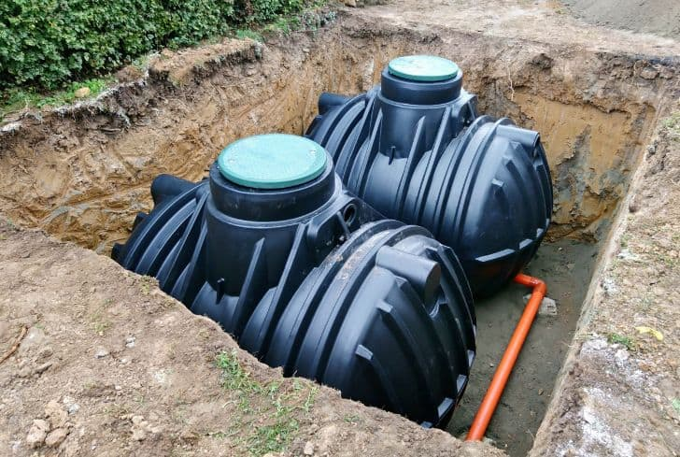

5. Rain Saucer
In this technique, rainwater is directly collected using a rain-saucer as it falls from the sky. Rain saucers look like upside-down umbrellas or big funnels and are usually attached to a pipe so that the collected water is directed elsewhere. The collecting container is sometimes placed underground with only the rain-saucer above the ground. It is a simple yet effective method.

6. Water Collection Reservoirs
In this case, rainwater is harvested from roads and pavements. Water collected through this method is not really clean and may be contaminated. However, it can still be used for crop irrigation.

7. Barrage
A barrage is a dam with several openings that can be closed or opened to control the quantity of water that passes through it. It is usually large and can collect a lot of water.

8. Slopes
Rainwater is collected at the bottom of slopes when it flows on the ground. This is a simple and natural way to harvest rainwater.

9. Trenches
This is another traditional method to harvest rainwater for irrigation that is still used today. When it rains, the water is directed to the farm using trenches.

10. Rain Barrels
These are specifically designed for this purpose and can be purchased from retail stores. Rain barrels are used for harvesting rainwater that falls on roof tops.

How does rainwater compare to normal tap water?

Tap water is treated with chlorine and other chemicals that help to remove parasites, bacteria, and viruses. But it also can contain a multitude of contaminants, including aluminum, lead, arsenic, and mercury. Rainwater doesn't contain these chemicals and is therefore softer and purer—great for watering the garden. On the flipside, it also doesn't contain fluoride, which helps prevent tooth decay.

Types of Water Harvesting
In India, generally three type of WH techniques are practiced as described here-
- Inter-row water harvesting– this technique is practiced in arid areas where annual rainfall is less than 750mm. crops are grown in narrow strips between wide intervals that are ridged as artificial miniature watersheds. Later on these are compacted to increase runoff to the crop rows. There is no sacrifice of land in this technique. Inter-row systems, also called “roaded catchments”, may be the best technique to apply on flat lands. Triangular cross sectional bunds or levees are constructed along the main slope of the land. The height of bunds are ranges from 40 to 100 cm, built at distances of 2-10 m, runoff flowing down the slope is collected between the ridges and either directed to a reservoir at the end of a feed canal or to a crop cultivated between the ridges.
- Inter-plot or Micro plot water harvesting– water is harvested in the passages or furrows between the plots when rainfall is rather more. In this case runoff from the sloping area supplements rainfall for growing crops on level land.
- WH in farm pond & Reservoirs– Farm ponds are small tanks or reservoirs constructed for the purpose of storing water essentially from surface runoff. Farm ponds are useful for life saving irrigation, water supply for the cattle, fish production etc. It is usually of 3 ft. depth with width and length varying depending upon the farmer’s land and catchment water potential in his field. Depending on the source of water and their location with respect to the land surface, farm ponds are grouped into four types- Dugout ponds, Surface ponds, spring or Creek fed ponds and Off-stream storage ponds. For controlling seepage loss, waterborne asphalt emulsion is used.
- Advantages of implementing rain-water harvesting:
- Reduced Water Bills
Rainwater harvesting systems are cost-effective, provide high-quality water, lessens dependence on wells and are considerably easy to maintain since they are not utilized for drinking, cooking or other sensitive uses. The all-around expenditures used in setting up harvesting methods are much cheaper compared to other purifying or pumping means. The cost of recharge to the subsurface reservoir is also lower than the surface reservoirs.
- Ecological benefit
Storing water underground is environment-friendly. The ecological benefits of rainwater harvesting are immense. It minimizes the impacts of flooding by funneling the off water into large tanks for recycling and helps reduce the load placed upon drainage systems. No land is wasted for storage purpose and no population displacement is implicated therefore, groundwater is not directly exposed to evaporation and pollution. Additionally, it helps minimize the possibility of rivers drying up.
- Reduces erosion and flooding around buildings
It reduces soil erosion and flood hazards by collecting rainwater and reducing the flow of stormwater to prevent urban flooding. Most buildings that utilize rainwater harvesting systems have a built-in catchment area on top of the roof, which has a capacity of collecting large volumes of water in case of rainstorms.
- An adequate means for Irrigation purpose
Harvesting rainwater allows the collection of large amounts of water and mitigates the effects of drought. Most rooftops provide the necessary platform for collecting water. Rainwater is mostly free from harmful chemicals, which makes it suitable for irrigation purposes.
- Reduces demand on Ground Water
Another vital benefit is that it increases the productivity of aquifer resulting in the rise of groundwater levels and reduces the need for potable water. It is extremely essential, particularly in areas with low water levels.

